
Machine Translated by Google

SUPPORT DOCUMENT (TOPIC 1)

Subject: Introduction to Physical Education Qualification: Degree in Primary Education with Mention in Physical Education

©2022 José Manuel Delfa de la Morena, Juan José Mijarra Murillo, Nuria Romero Parra, Adirán Solera Alfonso and Elena María Cáceres López De Andújar Some rights reserved This document is distributed under the Creative Commons “Attribution-ShareAlike 4.0 International” license, available at https:/ /creativecommons.org/licenses/by-sa/4.0/deed.es

UNIT 1. INTRODUCTION TO PHYSICAL EDUCATION

- GENERAL CONCEPTS

  - DEFINITION

Physical Education currently lacks an agreed definition in the field

academic for several reasons:

    - The utility that may be conferred on it, be it educational, therapeutic, recreational, social, expressive or competitive.
    - The degree of influence it receives from different sciences.

    - The constant redimension of its goals and objectives by virtue of its continuous evo
solution.

We highlight some of the definitions that various authors have given to Education

Physical.

According to Calzada (1996), Physical Education is the "comprehensive development of the human being through

through movement. This definition makes it clear that it is not just a question

physical, but comprehensive.

According to Pineau (1990), Physical Education is the "teaching subject that allows acquisition and construction of knowledge allowing the management of physical life through the different ages of its existence, as well as access to the culture that constitutes
sports practices”.

According to Solas (2006), Physical Education is “the education of health, of the body-mind.
Values must be taught so that the student, a future social worker, has the
minimum knowledge that allows you to take care of your body and maintain your health. What second concept, I add that physical education has to give the motor bases


common to all sports so that students if they decide their athletes of competition arrive with some basic motor knowledge to all sports”.
In addition, as stated in the regional legislation, Physical Education "has as objective is the development of motor skills, the acquisition of healthy habits and
behavior and the practice of physical, sports and artistic activities" and "contributes to education in health care and safety through knowledge of the
own body” (BOCM 175, July 25, 2014).

  - TYPES

There are different types of classification of Physical Education. We highlight the following:
    - Formal Physical Education: the one that takes place within the structure of the system.
but educational

    - Non-formal physical education: the one carried out within organizations goes rias, but outside the educational system.
    - Informal Physical Education: that which is acquired through social interaction without being the
previous.

  - RELATED TERMINOLOGY

In the field of Physical Education there are many related terms that can give place to confusion. We define them below for further clarification.
concepts:

    - Physical activity: “body movement produced by the skeleton muscles. letics and that produces an energy expenditure” (WHO).
    - Physical exercise: “planned and structured physical activity, repetitive and whose fine ality is the maintenance or improvement of physical fitness” (WHO).


    - Sport: “any activity, organized or not, that implies movement during the game in order to overcome or win individually or as a group” (Romero Granados, 2021).
    - Gymnastics: “a system of specifically chosen physical exercises and methods all scientifically elaborated aimed at solving the problems of comprehensive physical development and improvement of motor skills and health status of those who exercise them” (Birkina, 2008).
    - Physical culture: “set of values, knowledge, habits, techniques and bodily uses
of a society and that are transmitted through the processes of socialization and educational activities” (B. Vázquez, 2006).

- BODY AND MOVEMENT

The body is our greatest work tool in Physical Education and is based on the movement, which is the change in position of the body in a given space. According to Cagigal (1966), we distinguish the following:
  - Objective body: It is understood as the biological reality, that is, the organs, functions, etc. and which is the subject of medical sciences.
  - Subjective body: Or own body, is understood as the relationship of the body with the medium, transmission of expressions, emotions...
  - Reflex movement: These are simple and involuntary motor behaviors, fast and depend on the intensity of the stimulus that triggers it. For example: remove
your hand if you get burned.

  - Voluntary movement: are those that are coordinated by the brain and by so we are aware of them. For example: running, jumping, etc.

- PARADIGMS OF HUMAN MOVEMENT

Physical education uses movement to achieve some different end or goals.


Depending on these purposes, four paradigms are created:

  - Biomotor: treats the body like a machine. Leads to physical education sports (acrobatic body) (Vázquez, 1989).
  - Psychomotor: treats the body as a psychosomatic entity. Gives rise to the Edu Psychomotor cation: (thinking body) (Vázquez, 1989).
  - Expressive: derives from the concept of expressive body. Give rise to education Physical-expressive tion (communicative body) (Vázquez, 1989).
  - Sociomotor: motor skills in relation to peers and mainly developed. mainly in the games (Parlebás, 1981).

- TAXONOMIES OF THE MOVEMENT

A taxonomy is the systematic and orderly classification. It is distributed in three areas of knowledge: cognitive, affective and psychomotor.
  - BLOOM'S TAXONOMY

Theory designed in 1956. It focuses on the cognitive field and allows hierarchizing the cognitive processes at different levels. It consists of a series of levels
They focus on three areas:

    - Cognitive or intellectual.
    - It affects the attitudinal.

    - Psychomotor or procedural.

  - KRATHWOHL TAXONOMY

Theory designed in 1964. It focuses on the affective field and describes categories and subcategories of expected behaviors in every human being living in society,
in response to intentional stimuli received in their social interaction. distinguish various situations:
    - Negative influence on your group.



Attitude of contained aggressiveness.
Anxiety that distorts the class.
Overly competitive.

4.3 HARROW'S TAXONOMY

Theory designed in 1972. It focuses on the psychomotor field and establishes a series of hierarchical levels where the acquisition of the lower level is necessary to access the immediately above. It is the most complex and the one that best suits our
conception of Physical Education, which includes the three currents: physical-sports,
psychomotor and expressive The levels are as follows:
- Reflex movements.
- Fundamental movements.

- Perceptual-motor skills
- Basic physical abilities:
- Dexterity of movements

- Non-discursive communication

- IMPORTANCE OF PHYSICAL EDUCATION

Physical Education is considered a compulsory area within the school environment. It has been constituted as a fundamental discipline for the education and integral formation of the
human, especially if it is implanted at an early age, because it makes it possible in the child develop motor, cognitive and affective skills essential for their daily lives
and as a process for their life project (Loprinzi, 2015). through education
Physical the child expresses his spontaneity, encourages his creativity and above all allows know, respect and value oneself and others (Collado, 2018).
Through the Physical Education class, children learn, execute and create new forms of movement with the help of different forms played, playful, recreational and sports (Belando, 2019).
In these classes the child can develop, be creative and show his spontaneity

as a being who wants to discover many alternatives that may be applicable in a future in their social life and that they cannot easily achieve it in other subjects of the knowledge. For all this we can say that we find physical benefits,
psychological, social and cognitive.

- BIBLIOGRAPHICAL REFERENCES

Belando (2019). Neuroscience applied to Physical Activity and Sports Sciences.

Birkina (2008). Know to teach. UNEGymnastics.

Cagigal, JM. (1966). Sport, pedagogy and humanism. Spanish Olympic Committee. Madrid.

Loprinzi, P. D., Cardinal, B. J., Loprinzi, K. L., & Lee, H. (2012). Benefits and envi ronmental determinants of physical activity in children and adolescents. Obesity Facts, 5(4), 597–610. https://doi.org/10.1159/000342684

Medina, A. (1994). Curriculum and teaching for adults. Pedago Editions gic. Madrid.

Parlebas, P. (2001). Lexicon of motor praxiology, games, sport and society. Paidotri bo. Barcelona.

Rico, I. (2008). Notes on Methodology for the teaching of physical activity and bearing. INEF. Madrid.

Romero Granados (2021). Contents of Physical Education at school. Wanceulen,
S.L.

Siedentop, D. (1998) Learning to teach Physical Education. Inde Publications. Bar celon

Vazquez, B. (2006). Notes of Pedagogy of the Physical Activity and the sport. INEF. Madrid.

Vazquez, B. (Coord.) (2001). Educational bases of physical activity and sport. Ed. Synthesis. Madrid

Vazquez, B. (2011). Contemporary pedagogical currents and teaching styles nance in Physical Education.

Wilson, L. O. (2016). The three domains of learning: Cognitive, affective, and

psychomotor/kinesthetic. Llford, UK: London School of Management and Education.
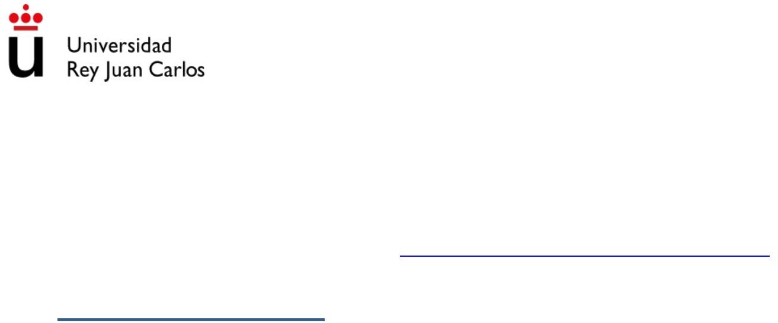
Machine Translated by Google

SUPPORT DOCUMENT (TOPIC 2)

Subject: Introduction to Physical Education Qualification: Degree in Primary Education with Mention in Physical Education

©2022 José Manuel Delfa de la Morena, Juan José Mijarra Murillo, Nuria Romero Parra and Elena María Cáceres López
De Andújar Some rights reserved This document is distributed under
the Creative Commons “Attribution-ShareAlike 4.0 International”
license, available at https:/ /creativecommons.org/licenses/by-sa/4.0/deed.es

UNIT 2. OBJECTIVES

- GENERAL CONCEPTS

  - DEFINITION

The objectives are defined in RD 157/2022 as the achievements that the
students have reached at the end of the stage and whose achievement is linked to the acquisition of key skills.
“The objectives help us to see what needs to be taught (content). They also tell us the result we intend to reach (results or learning standards). The
The way to reach these results is through a methodology. In this way, the programming is threaded and acquires a global meaning” (Antúnez, 1999).
“The objectives are, on the one hand, the learning to be achieved in the future and,
on the other hand, the type of person the system wants the student to be at the end of the educational process" (Viciana, 2002).

  - UTILITY

Objectives help the teacher to:
ÿ Know what you want to achieve from your students: the objectives are established for to know what we want students to internalize, improve or learn.

ÿ Choose the most appropriate content: each course and each group of students is different, so each of them will work on content that adapts
to your needs.

ÿ Apply the most effective methodology: as in the previous point, there will always be to adapt a methodology to the activity that is being worked on with the students.


us so that the contents can be worked on in the most efficient way possible and Consequently, the set objectives are reached.

ÿ Develop the most motivating evaluation: to know if our students have
achieved the objectives that we have set for ourselves, you can use different ti after evaluations that are motivating, such as contests, exhibitions,
etc. Even we will evaluate without them being aware that it is.
we are doing

- TYPES OF OBJECTIVES

We can distinguish different types of goals depending on different levels of concretion:

Stage Generals:
FOR ITS LEVEL OF ABSTRACTION
They are collected by the Law (RD 157/2022)
“Valuing hygiene and health, knowing and respecting the human body and using Education Physics and sport as means to favor personal and social development”.
Area Generals:
The regulations do not include specific objectives in the area of Physical Education.
cycle generals
They include the most global aspects of the educational programming to work on.
Didactic or specific
They pursue the achievement of specific skills.
It explains the type and degree of learning that students have to achieve. They are prepared by the teacher for programming and teaching units.
- Specific teaching unit
It is based on reflecting what is going to be worked on in a given didactic unit. It corresponds to the level.
“Improve basic physical abilities.”
- Session specific
It reflects what is going to be worked on in a given session.
"Improve endurance."
- Activity specific
It reflects what is going to be worked on in a given activity.
“Improve reaction speed.”
Operative
Playful objective that the child has to fulfill within the activity as a task or challenge.

"Give the greatest number of jumps in the shortest time possible."

minimums
FOR ITS LEVEL OF REQUIREMENT
The ones the whole group should get.
optional
The ones you offer are not mandatory.
magnification
The ones you offer to more advanced students.

BY ITS LEVEL OF TIMING
Long-term
Final and general objectives.
medium term
Specific objectives
Short term
Operational objectives.

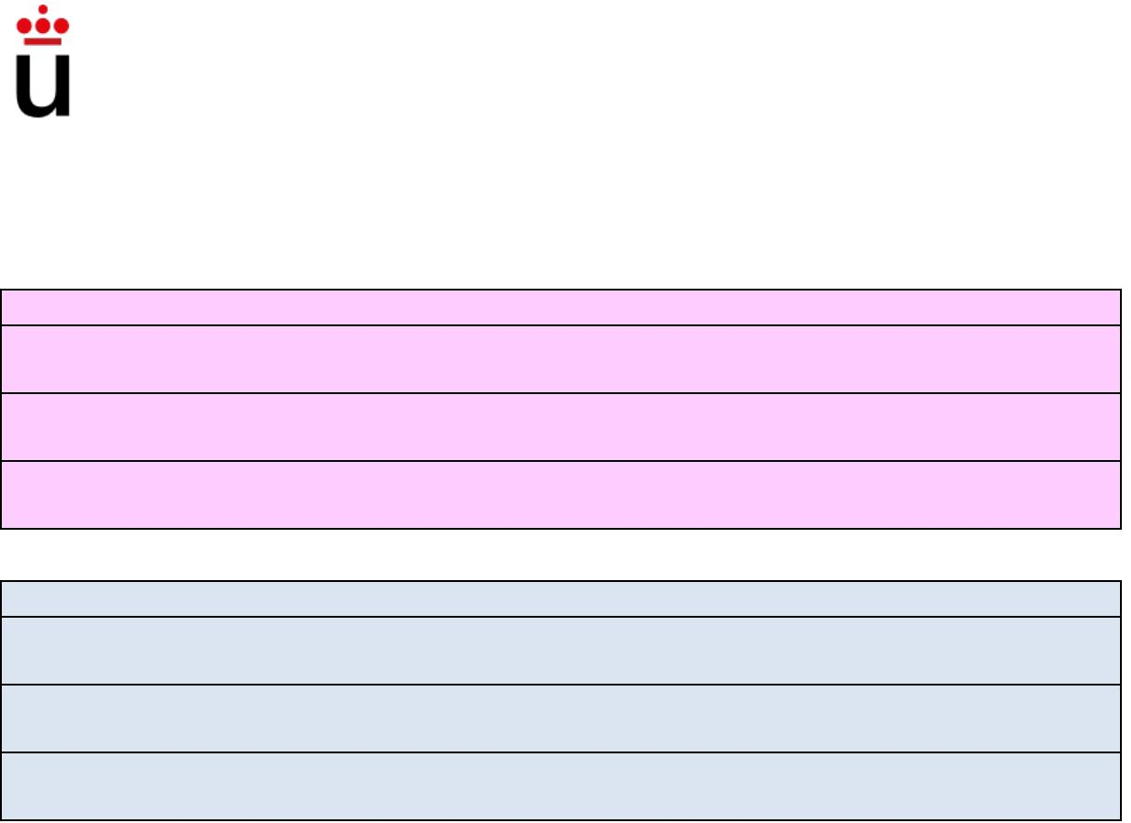
- FORMULATION OF OBJECTIVES

ÿ Objectives will ALWAYS be formulated in the infinitive.
ÿ They should be consistent with the level of specificity.

ÿ The activity objectives will be related to the session objectives; session with

those of the didactic unit and the operative objectives are formulated in the same way manner in which instruction is given to students.
ÿ They should be explicit and concrete.

ÿ Each stage objective can be related to the different area objectives.

ÿ The same stage objective can encompass several general objectives of the area.

ÿ All the general objectives of the area are related to at least one objective. general stage effect.
ÿ The general objectives of the area of Physical Education contribute to the development

of the general objectives of the Primary Education stage.

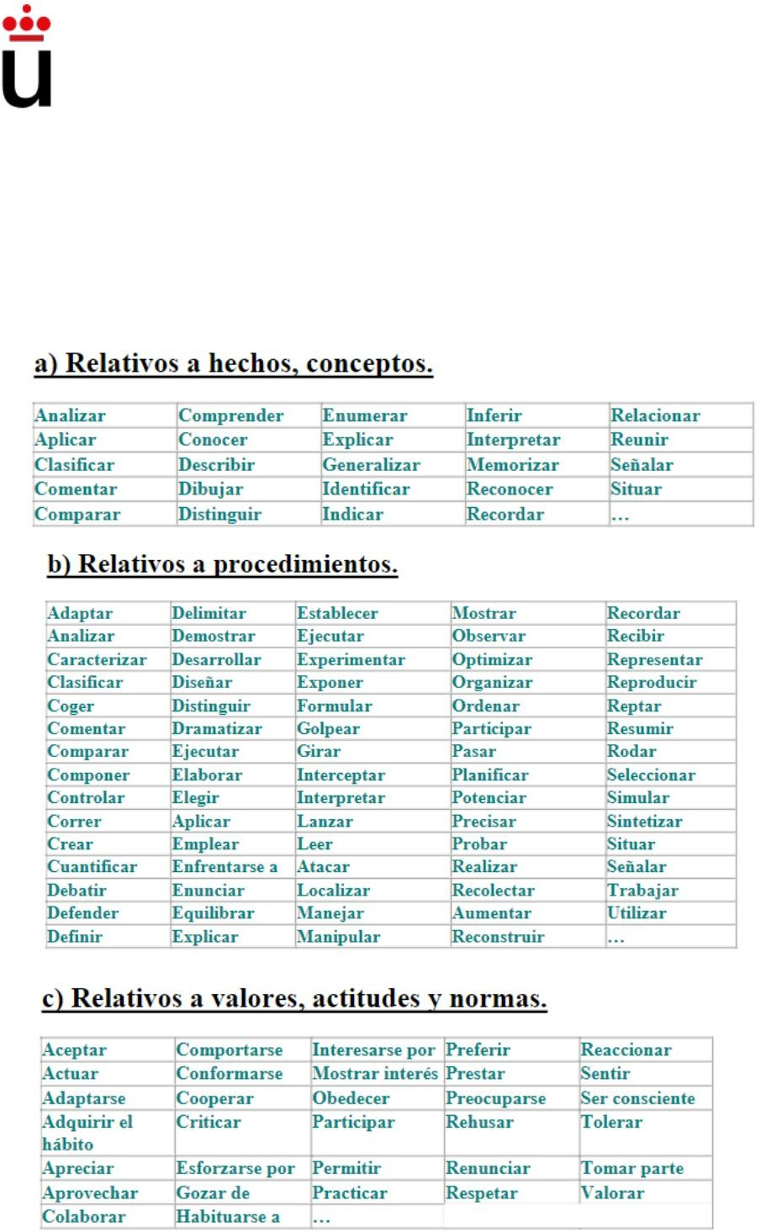
- EXAMPLES OF VERBS TO FORMULATE OBJECTIVES

- BIBLIOGRAPHICAL REFERENCES

Antunez, S., (1999). From the Educational Project to the Classroom Programming. The what, the when and the how of the instruments of the didactic planning. Spain, Barcelona: GRAÓ.

Coll C. (1992). Psychology and Curriculum. Ed. Lana. Barcelona.

Hebrard A. (1986). EF, reflections and perspectives. EPS. Paris.

Klein G. (2000). A matter of discipline”. French journal of pedagogy. Paris.



Organic Law 3/2020, of December 29, which modifies Organic Law 2/2006, of May 3, on Education (LOMLOE).
Marsenach J. (1991). EF, what to teach? NPRI. Paris.

Perona, M. (2009). Notes of Methodology II of the teaching of physical activity and sport. INEF. Madrid.

Royal Decree 157/2022, of March 1, which establishes the organization and the minimum teachings of Primary Education.

Rico, I. (2008). Notes on Methodology I of the teaching of physical activity and sport. INEF. Madrid.
Viciana, J. (2002). Planning in Physical Education. Barcelona INDIA.
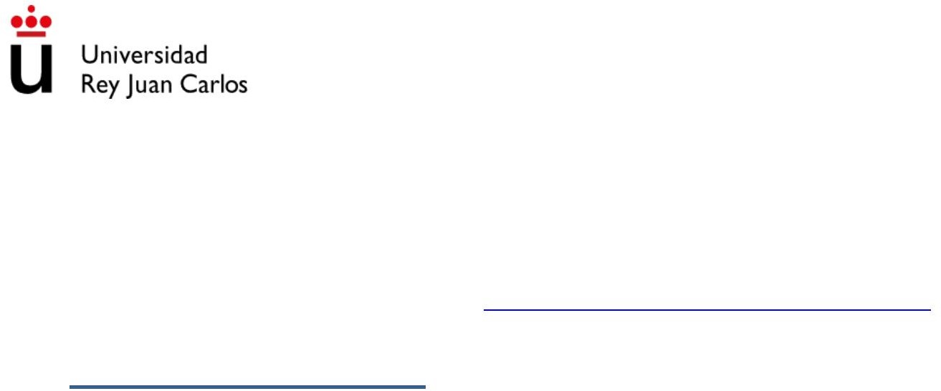
Machine Translated by Google

SUPPORT DOCUMENT (TOPIC 3)

Subject: Introduction to Physical Education Qualification: Degree in Primary Education with Mention in Physical Education

©2022 José Manuel Delfa de la Morena, Juan José Mijarra Murillo, Nuria Romero Parra and Elena María Cáceres López
De Andújar Some rights reserved This document is distributed under
the Creative Commons “Attribution-ShareAlike 4.0 International”
license, available at https:/ /creativecommons.org/licenses/by-sa/4.0/deed.es

UNIT 3. CONTENTS

- GENERAL CONCEPTS

  - DEFINITION

According to DECREE 61/2022, the contents are the knowledge, skills and attitudes whose learning by students is necessary for the acquisition
of the specific competences of each area.

According to Cesar Coll: “a set of duties and cultural forms whose assimilation and appropriation by students is considered essential for their development and socialization”.

For Vázquez (2001), the contents are a "set of knowledge, knowledge or
cultural forms that are considered essential for the development and socialization of students, and whose assimilation and appropriation fully and correctly needs help specific".

  - TYPES

    - According to its level of abstraction:

      - General contents of Physical Education

In Annex II of Royal Decree 157/2022, the contents set out in the form
of basic knowledge that is established for each cycle in each of the areas.
Specifically in the area of Physical Education, this basic knowledge is grouped into six blocks that we name below:
        - Active and healthy life.

        - Organization and management of physical activity.

        - Troubleshooting in motor situations.

        - Emotional regulation and social interaction in motor situations.
        - Manifestation of motor culture.

        - Efficient and careful interaction with the environment.

      - Specific content

These are the contents that are going to be worked on in each of the Education courses.
Primary and in each of the Didactic Units. Depending on the course in which we find will have one difficulty or another. These contents are more explicit and
They will tell you what to work on concretely. An example of specific content would be “the
speed."

    - According to its nature:

      - Knowledge

Alavi and Leidner (2003) define knowledge as the information that the individual possesses in his mind, personalized and subjective, related to facts, procedures, concepts, interpretations, ideas, observations, judgments and elements that can be or not useful, precise or structural.
      - Skills

We observe that authors such as Corpas, Toro and Zarco (1991), point to skill as
a capacity, talent, disposition, aptitude, suitability or set of knowledge that possesses a person to carry out and fulfill an action of a perceptual, sensory, motor,
manual, intellectual, attitudinal or social.

      - Attitudes
According to the WHO, attitude is the relatively stable psychic disposition that predisposes the individual to react (think, feel and act) in a certain way
before the environment (objects, people, facts and situations).

- BLOCKS OF CONTENT

Following the Taxonomy of Anita Harrow (1972), six hierarchical levels are established, of which, the last four currently serve us to classify the contents of
physical education.

Level 1. Reflex movements.
They are simple and involuntary motor behaviors, fast and depend on the intensity of the triggering stimulus.
In the child there are primitive reflexes that disappear with motor development (reflex de moro, tonic cervical reflex a, plantar grasp reflex, gait reflex
automatic).
They can be segmental (single spinal segment), intersegmental (several segments spinal cord and brainstem) and suprasegmental (influence of higher centers
such as basal ganglia and cerebellum)

For example: remove your hand if you get burned.

Level 2. Fundamental movements.

It is reached in the first years of life (crawling, crawling, standing, walking,

handling). They are objectives to be addressed fundamentally in Early Childhood Education and will constitute

the basis of the most complex and specialized movements. are those movements "that are acquired alone".
- Locomotor movements: crawling, crawling, walking, jumping.

  - Crawling (end of 9th month).

  - Acquisition of crawling (end of the 12th month).

  - Walking without support (end of the 15th month).

- Non-locomotor movements: movements around an axis (turns and turns).

- Manipulative movements: reaching, grasping and carrying objects.

  - Hand-mouth coordination (end 4th month).

  - Palm grip (end 6th month).

  - Pincer grip (end 10th month).

  - Pincer grip (end 11th month).

Level 3. Perceptive attitudes.
At this level, educational influence on the child's development begins, since the first two are acquired innately.
These contents allow the integration of information from the environment and from the body itself. (visual, kinesthetic, auditory and tactile stimuli) that are selected and interpreted in
the higher brain centers.
The components that we find in this level are the following:

- Body schema: (recognition of body parts, laterality, balance brio and postural control, states of tension and relaxation).
- Relationship of the body with the objects that surround it and perception of space.

- Perception of temporal sequences.

- Visual discrimination, auditory discrimination, tactile discrimination.

- Coordinate skills (eye-hand coordination, eye-foot coordination).

Level 4. Physical aptitudes.
The improvement of Physical Qualities constitutes a fundamental objective at this level, understanding that with its development it will be possible to access higher levels of movement (mastery of complex movements): endurance (muscular and cardiovascular), strength, flexibility and agility (change of direction, initiation and
arrest, reaction-response time).

Level 5. Dexterity of movements.

This level is nothing but the culmination of the previous levels and the adaptation of these to more or less complex situations. We would be talking about the so-called skills

and different degrees of mastery can be achieved: simple adaptive skill (manages own body), compound adaptive (introduces an external object) and adaptive complex (introduced in a specific context). Through motor learning,
skills become skills.

Level 6. Non-discursive communication.

As a culmination of this hierarchy, the student uses all his skills, all
their qualities, to express themselves and even to create expressive movements (posture and
bearing, gestures, facial expressions) and/or interpretive movements (movement

aesthetic and creative).

- BIBLIOGRAPHICAL REFERENCES

Decree 22/2007 of the LOE.

Decree 61/2022, of July 13, which establishes for the Community of Madrid the

organization and curriculum of the Primary Education stage. (LOMLOE)

Decree 89/2014 BOCM

Harrow, A. (1972). A Taxonomy of the Psychomotor Domain: A Guide for Developing

Behavioral Objectives. Longman Group. United Kingdom

Organic Law of 8/2013, of December 9, on the Improvement of Educational Quality.

Perona, M. (2009). Methodology II of the teaching of physical activity and sport. INEF. Madrid.

Royal Decree 1513/2006, of December 7, which establishes the teachings

minimum of primary education.

Royal Decree 126/2014 of February 28, which establishes the basic curriculum of the Primary education.

Rico, I. (2008). Methodology I of teaching physical activity and sport. INEF. Madrid.

Machine Translated by Google

SUPPORT DOCUMENT (TOPIC 4)

Subject: Introduction to Physical Education Qualification: Degree in Primary Education with Mention in Physical Education

©2022 José Manuel Delfa de la Morena, Juan José Mijarra Murillo, Nuria Romero Parra and Elena María Cáceres López
De Andújar Some rights reserved This document is distributed under
the Creative Commons “Attribution-ShareAlike 4.0 International”
license, available at https:/ /creativecommons.org/licenses/by-sa/4.0/deed.es

UNIT 4. METHODOLOGY

- CLARIFICATION OF CONCEPTS
  - DEFINITION

The methodology answers the question “how to teach”. For Delgado-Noguera, the methodology is the path that leads to learning; that is, to meet the objectives
of teaching. The methodology is, then, the link between the teacher, the
student and content (Delgado-Noguera, 1991). There are a number of concepts that have to be clear when talking about methodology:

ÿ Didactic intervention: Global term, with which we want to indicate all actions
tion of the teacher, with the intention of educating and teaching. the teacher acts as a mediator and aid to student learning (DRAE, 2009).

ÿ Pedagogical strategy: Art of directing the operations of teaching (form of adaptation to teaching). It intervenes from global strategies of ac
tuation what makes up a teaching style. Therefore, pedagogical strategy it is similar to teaching style (Wittrock, 1974).

ÿ Method: These are the paths that lead us to achieve student learning. us, that is, to achieve the objectives of teaching. A teaching method
is a set of moments and techniques, logically coordinated, to direct the student learning, towards certain objectives (Delgado, 1991).

ÿ Procedures: It is the practical and punctual realization of a method, using consequent and coherent means and processes (RD 243/2022).


ÿ Teaching resource: It is the particular way of approaching a certain moment. teaching swim. It can affect the way of communicating (a technological resource logical: video) the use of material (minitramp…) Making it easy to communicate
tion of what is intended to be taught, adapting it to the repertoire and age of the students.

ÿ Teaching technique: It is the set of teaching procedures and resources. whoa The fundamental objective of the teaching technique is to select the correct way of transmitting what we want our students to do: mo
stimulate and maintain their interest, provide feedback, avoid failure…

ÿ Teaching style: “Relatively stable way, in which the teacher manages
reflexively, adapts its teaching to the context, the objectives, the content and the students, interacting with each other and adapting decisions to the moment
of the teaching and learning of their students” (Delgado, 1991). is the
peculiar way that each teacher has to elaborate the program, apply the method do, organize the class and interact with the students; that is, "it is the way of take the class” It's like a stamp of personality. teaching styles
show how teacher-student interaction develops in the process of teaching-learning.
- Communicative type: teaching technique.
- Organizational: organization-control of the activity.
- Socio-affective type: communication and relationship.

ÿ The strategy of practice: It is the way of executing the motor skill that is learn.
- Global Strategy: It occurs for simple elements of the unit.
- Analytical strategy: It is given for complex elements of the unit.

ÿ Types of teaching: depending on the group of students with which we find

courses in class, the content to be taught and the situations

that may be presented, two types of teaching will be taken into account:

- Mass teaching: homogeneous groups, outstanding teacher position,

student attention centered on the teacher, rate of group progression,

that is, if someone progresses more slowly, they should practice outside the

classroom.

- Individualized teaching: heterogeneous groups, position of the teacher

undifferentiated, student attention focused on the task, rate of progress individual session.

- TEACHING STYLES

According to Muska Mosston (1966), there is no teaching style that can

be considered the best. Each style has its importance. cannot be generalized

with the certainty of achieving the best results. It has to be adapted to the teacher, the

students and interactions. The effective teacher must master different styles of

teaching and must apply them according to a previous analysis of the situation. On what basis to choose a style?
  - Always think about the teaching-learning-objectives relationship.

  - Think about the characteristics of the activities that have been designed.

  - Think about the behavior we want the student to develop.

  - CLASSIFICATION OF TEACHING STYLES ACCORDING TO MUSKA MOSSTON

    - Direct command: There can be no freedom. Do it with them.

    - Assignment of tasks: They already have a margin of freedom. isolated tasks. You do no more.
    - Individual programming: training/diet table for the client.

    - Reciprocal teaching: correct each other in pairs.

    - Small group: The same, but 3 or more.

    - Guided discovery: clues to achieve the goal

    - Troubleshooting: On the side of the slopes.

    - Creativity. Whatever comes out of you will always be fine.

- DIDACTIC INTERACTIONS

Didactic interaction refers to intentional, structured and

specialized for the teaching and learning of school knowledge (Villalta and Martinic, 2009).
  - TYPE OF COMMUNICATION

According to Antonio Hernández and Óscar Garay, “communication is a process of social interaction of a verbal or non-verbal nature, with the intention of transmitting and that can influence, intentionally and unintentionally, the behavior of people who are
in the coverage of said emission”. In the teaching-learning process the Communication is a basic requirement.

In every communicative process there is an issuer (the one who communicates); a message (whatever wants to communicate), and a receiver (to whom the communication is addressed): the teacher selects, organizes, elaborates and emits a message that the student receives, perceives, assimilates and retains.

The teacher must ensure that the message transmitted is totally related to the task

what is to be taught. The effectiveness will depend on the wide and objective information of the teacher on the subject. It is not worth just understanding the message. It is necessary the action, physical execution.

The channels available to the teacher for communication are:

- Visual: Through gestures and actions. It is what we show the student.


- Auditory: Through language and sounds. It is what we say to the student.

- Kinesthetic-tactile: Through touch. It is what we contact with the student.

  - SOCIO-AFFECTIVE TYPE

The climate of the class is the relationships that are established in the teaching situation learning by the behavior conditions of the group. It is determined by the
teacher-student and student-teacher interaction. In addition, the classroom climate conforms through classroom management (control), discipline (rules), and use of the reinforcement. “Children tend to repeat behaviors for which they have been rewarded positively and avoid those others for which they have been punished.” (Ruiz et al.
2001).

For the use of reinforcement to be effective, several aspects must be taken into account:

    - For reinforcement to be educational, it must be balanced.

    - His perseverance causes greater fixation in the student.

    - Better to use positive reinforcement than negative.

    - Positively reinforcing attitudes makes you want to improve.

    - Frequently reinforce, especially at the beginning.

    - Avoid allowing too much time to elapse between the occurrence of the behavior and the use reinforcement.

  - TYPE OF ORGANIZATION AND CONTROL

The organization is a methodological factor whose objective is to facilitate the conditions of teaching and learning, offer students the maximum possibilities of
participation and seek the best security conditions. “Good control ensures adequate work in class and, consequently, achieve the objectives set" (Pierón,
1992). Student control is achieved if the student has a positive attitude towards the subject and great involvement in the activity.

To maintain good control and organization of the class, it is essential, among other things, aspects, keep in mind the following:

    - The type of organization of the student body, distinguishing between formal organization, the one in which the teacher makes the groups in class and non-formal organization, one in which the students themselves form the groups. Is usually
associate formal organization with better class organization and control

    - The use of norms and rules: Isabel Delgado (2012) distinguishes between norms and re gla, saying that norms are those collective consensuses created to regulate
regulate different behaviors. A rule, on the other hand, is a guideline. of a social or legal nature whose non-compliance is penalized. For the
Therefore, according to it, we could say that the rule is more specific than the rule. The norm refers to all the guidelines or guidelines that govern the conduct or behavior of a community, and the rules tell us what
must be done and what is not allowed, as well as the respective "sanctions" in case they are not met.

- BIBLIOGRAPHICAL REFERENCES

Hernandez, A., and Garay, O. (2005). Communication in the sports context. Wanceulen Editorial Deportiva, SL, 2005.

Delgado, M.A. (1991). Towards a conceptual clarification of didactic terms
of Physical Education and Sport. Journal of Physical Education. Renewal of the Theory and Practice. No. 40. Special number.

Slim, Elizabeth (2012). Technical reviews on the norms and rules in the sport. Monteavila.

Mosston, M. & Ashworth, S. (1993). The teaching of Physical Education. Reform of Teaching Styles. Barcelona: European Hispanic.

Perona, M. (2009). Notes of Methodology II of the teaching of physical activity and the deport. INEF Madrid.

Pieron, M. (1999). For effective teaching of physical-sports activities. Indian. Madrid

Rico, I. (2008). Notes of Methodology I of the teaching of physical activity and the deport. INEF Madrid.

Ruiz, LM, Navarro, F., Gutiérrez, M. Graupera, JL and Linaza, JL (2001). development, Motor Behavior and Sport. Madrid, Editorial Synthesis.

Sánchez Bañuelos, F. (1984): Bases for a didactics of physical education and sport. Ed. Gymnos. Madrid.

Sánchez Bañuelos, F. (1996): Physical activity oriented towards health. Library Ed. New. Madrid

Machine Translated by Google

SUPPORT DOCUMENT (TOPIC 5)

Subject: Introduction to Physical Education Qualification: Degree in Primary Education with Mention in Physical Education

©2022 José Manuel Delfa de la Morena, Juan José Mijarra Murillo, Nuria Romero Parra and Elena María Cáceres López
De Andújar Some rights reserved This document is distributed under
the Creative Commons “Attribution-ShareAlike 4.0 International”
license, available at https:/ /creativecommons.org/licenses/by-sa/4.0/deed.es

UNIT 5. EVALUATION

- CONTEXTUALIZATION

  - DEFINITION

The evaluation according to Blázquez (1990), is the systematic process that aims to determining to what extent the objectives have been achieved.

The RAE defines evaluation as: "Attribution or determination of the value of something or someone” and the “Assessment of knowledge, attitude and performance of a person or
a service".

RD 157/2022 only establishes that the evaluation must be continuous, global and formative.

  - WHAT TO EVALUATE?

    - The learning process: Assess the degree of development that students have at

achieved according to programmed objectives.

    - The teaching process: It is also important to evaluate taking into account the different factors and elements that participate in the process: center, context, family etc
    - Teacher: is one of those who most influences the learning process of students. students.

  - HOW TO EVALUATE?

The first thing to have established are some evaluation criteria, which,


according to Order EFP/678/2022, of July 15, they are “References that indicate the levels of performance expected in the students in the situations or activities to which they are refer to the specific competences of each area at a given moment of their
learning process".

The evaluation criteria are closely related to the competencies specific. In fact, for each of the five specific competencies in the area of
Physical Education in Primary Education establishes various evaluation criteria

for each of the cycles. The evaluation criteria must be measurable, since they must allow teachers to verify the acquisition of said competences. For
assess whether students are able to adequately perform each evaluation criterion, we must have an objective measurement instrument that gives us this information.

These measuring instruments are the evaluation instruments, which according to Rodríguez and Ibarra (2011, p. 71-72), are "Real and tangible tools used by
the person who evaluates to systematize their evaluations on the different aspects".
For example: checklists, class diary, exams, follow-up sheets, rubrics assessment, ICTs, etc.

The evaluation mechanisms comprise all the activities that allow to measure the learning level of the students. Among them we can find: the observation everyday, systematic, experimental and indirect.

- TYPES OF EVALUATION

Depending on the moment in which we evaluate, we distinguish:

  - Initial: It is carried out at the beginning of the educational process. Indicates the status of student regarding the learning to be acquired.
  - Final: It is carried out at the end of the educational process. Thus, information can be obtained

information about the achievement or not of the programmed objectives for the students.


  - Continuous: It is carried out throughout the educational process. According to Cerda Gutierrez (2003), is a way of progressively valuing the learning and teaching of the
student throughout the entire process because it allows the study to be retro fed through individualized monitoring by teachers.
  - Punctual: It is understood as an evaluation that is carried out at different times before starting a teaching sequence or segment belonging to a
finished course.

According to the purpose, we distinguish:

  - Formative: they indicate the evolution of learning with the possibility of introducing induce corrective mechanisms. That is, it is the improvement of the teaching process. learning progressively, managing to correct and improve procedures
carried out in it.

  - Summative: they allow us to assess the promotion or not of a student. set ba reliable casts of the results obtained at the end of a teaching process learning.

According to the agent:

  - External: It is performed by someone outside. It entails a series of advantages such as independence

dependence and objectivity, credibility, contextualization and comparison, etc.

  - Internal: It is carried out by someone who is not an outsider. They are of three types. Focusing on the

student there would be the one that the teacher makes to the student, the one that the student makes of himself

himself and the one made by the student towards another student. Consider all three tions at the same time when evaluating offers an enriching interpretation
based on the exchange of information and observations between students and
the teacher and the search for agreements on the result of this process evaluates had

According to the content:


  - Global: is the one where the student learns as a unit, explaining their progress as the behavior of his entire personality in relation to the guys around him.
  - Analytics: evaluate different aspects separately.

- BIBLIOGRAPHICAL REFERENCES
Escamilla and Llanos, E.(1993). The evaluation of learning and teaching in the classroom.

Casanova, Mª A. (1996). Educational evaluation manual. Madrid: The wall.

Cerda Gutierrez, H. (2000). The evaluation as a total experience. Bogota: Teaching

López-Pastor (Coord.) (2009). Formative and shared evaluation in Education Superior: proposals, techniques, instruments and experiences. Madrid: Narcea

Rico, I. (2008). Notes of Methodology I of the teaching of physical activity and the deport. INEF Madrid.

Rodriguez, E. (2008). A global evaluation proposal in the context of the social science teaching. University Educational Magazine Gr., 21:1
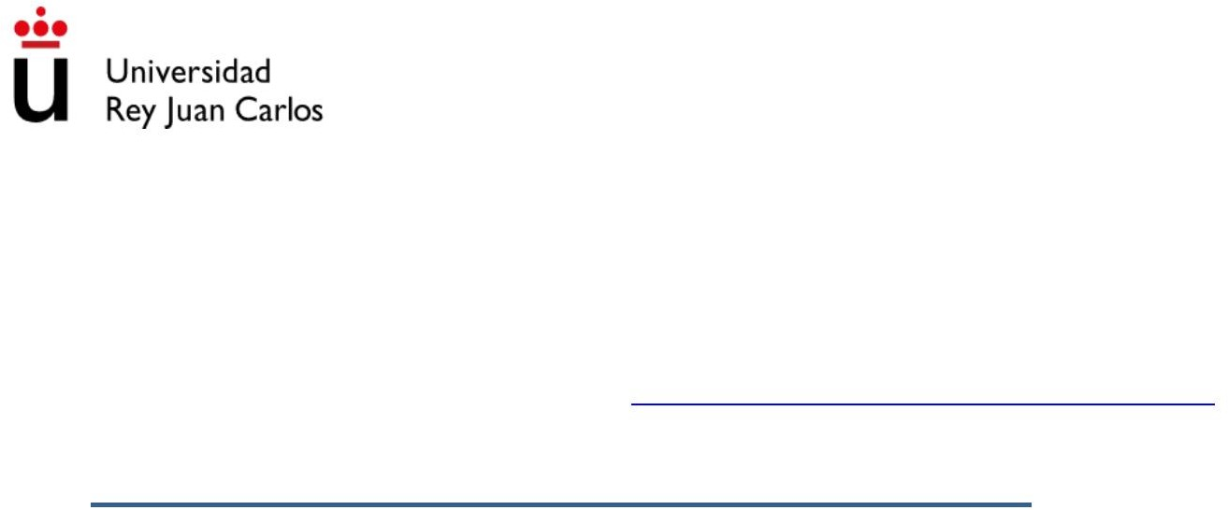
Machine Translated by Google

SUPPORT DOCUMENT (TOPIC 6)

Subject: Introduction to Physical Education Qualification: Degree in Primary Education with Mention in Physical Education

©2022 José Manuel Delfa de la Morena, Juan José Mijarra Murillo, Nuria Romero Parra and Elena María Cáceres López
De Andújar Some rights reserved This document is distributed under
the Creative Commons “Attribution-ShareAlike 4.0 International”
license, available at https:/ /creativecommons.org/licenses/by-sa/4.0/deed.es

UNIT 6. PLANNING AND PROGRAMMING

- PLANNING
  - DEFINITION

According to DECREE 61/2022, planning are the strategies that allow the improvement of production, both formal and informal, in Primary Education.

Alvarado, Cedeño, Beitia and García (1999) refer that "educational planning is a technical tool for decision making, whose purpose is to facilitate the organization of elements that guide the educational process.”

It is important to plan to take into account where you start with the students and as far as you want to go. You also have to meet the students in advance.
in order to adequately address diversity.

- PROGRAMMING
  - DEFINITION

According to the BOE, the programming will refer to the curriculum of an area, subject or module related to the specialty for which they participate, in which they must
specify the objectives, contents, evaluation criteria and methodology, as well as attention to students with specific educational needs.

According to Pino Yuste and Mayo (2011), the didactic programs are the instrument pedagogical-didactic that articulates the set of actions of the teaching team and pursues the achievement of the competencies and objectives of each of the stages.

  - Schedule for:

- Make work easier.

- Do not improvise on the fly.

- Establish an appropriate progression.

- Avoid repetitions.
- Provide information to students.

- BASIC CRITERIA FOR PROGRAMMING

- General principle in Physical Education.
- Selection of tasks from less to greater complexity.
- Relate content with objectives.
- The importance of meaningful retention.
- Progression in terms of qualitative/quantitative factors.
- Appropriate use of the transfer.

  - General principle in Physical Education

"The use of the body precedes knowledge." In Physical Education, to reach
a correct elaboration of the Corporal Schema (mental image of the body) is necessary having previously used our body and its members in a multitude of activities and games.)
  - Relate content with objectives

A teaching content is justifiable on the assumption that through its
assimilation, the student will reach the objective. There must be a selection process contents and will vary depending on some variables:
- Situation where teaching takes place.

- Motivation level of the students.

- Resources available.

  - Selection of tasks from least to greatest complexity

The difficulty of the task is determined according to the mechanisms of Perception, Decision and Execution.
In Infant and Primary we are interested in working on the first two since at these ages it will be more interesting the development of psychomotor factors than the actual execution of
certain gestures.

  - Proper use of transfer

Transfer A transfer occurs when an active process occurs by
part of the student body in which previous learning is used to facilitate new learnings.

  - Progression in terms of qualitative/quantitative factors.
……………

  - The importance of meaningful retention

Retention will be higher when: higher is the initial level, higher is the level of learning, the time allocated to practice is sufficient, the practice is significant, the activities are varied and fun and there is over-learning.

- STRUCTURE OF A SESSION

A session is the set of activities that work on the same content and that, therefore, So they have a common goal.
The components of a session are:

- Name: eye-catching for the student. "The Jungle Book"

- Age: to which the session is directed.

- Material: what we are going to use throughout the session.

- Objectives: what we want to achieve with our session.

- Content: what are we going to work on.

- Methodology: how we are going to put it into practice.

- Place: where it will take place.
- Duration: how long it will last.

We can distinguish three fundamental parts in a session:

- Initial part: moment of the session that is used to prepare the body for what that will come in terms of intensity.
- Intermediate part: this is the part of the session in which we work more intensively. tense, since we have already prepared for this moment.
- Final part: this moment of the session is used to bring the body to a more relaxed state without being abrupt.

- STRUCTURE OF AN ACTIVITY

As we have said before, a session is made up of several activities. The Activities should have the following structure:
- Name: eye-catching for the student.

- Intensity: Indicates where you are in the session.

- Material: what are we going to use to carry out the activity.

- Objective: what we want to achieve with the activity.

- Description: What the activity consists of. It has to be concrete and concise. Yes a teacher replaces us, he has to understand what it consists of easily.
- Rules: what the students will have to take into account to perform correctly activity. It is important to name them for correct operation.
- Variants: modifications of the description to avoid falling into monotony and for there to be a methodological progression.

- Time: How long the activity will last.

- Spatial arrangement: how the students will be organized by space.

- BIBLIOGRAPHICAL REFERENCES

Alvarado, F. Cedeno, M. Beitia, L. Garcia, O. (1999). Teacher Planning in the
Preschool level. Caracas: Ministry of Education.

Blazquez Sanchez, Domingo. (2010). "Physical Education Didactics". step Barcelona.

Canton Mayo, I.; Pino Juste, M. (2011) Design and development of the curriculum. alliance Editorial. Madrid.

Gonzalez, M. (2007). Notes on Didactics of Physical Education. UAM Madrid.
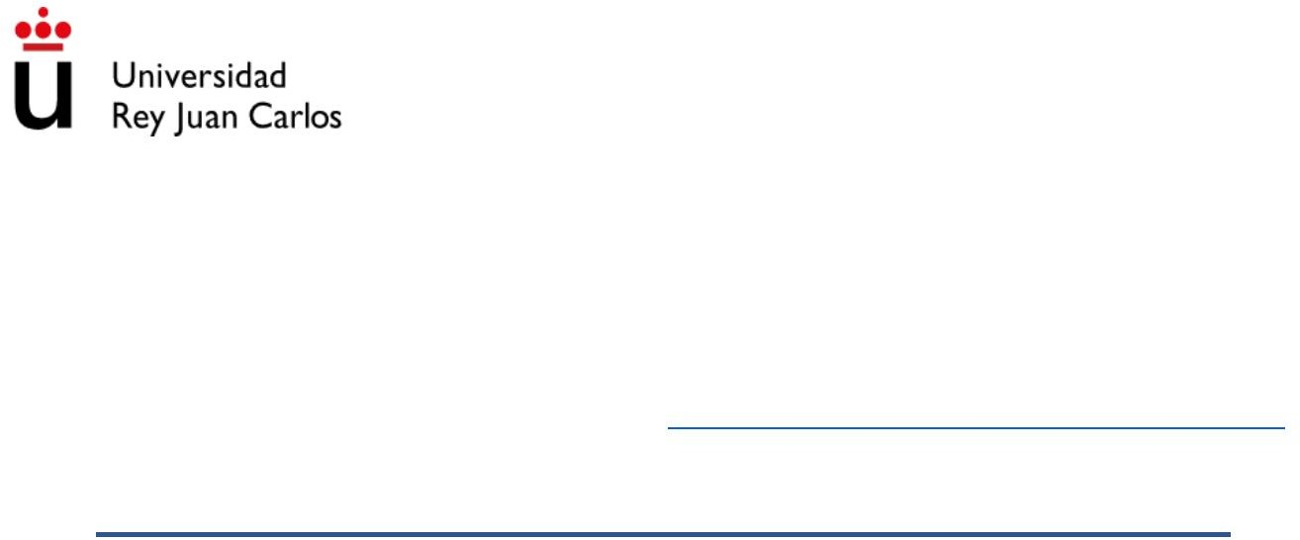
Machine Translated by Google

SUPPORT DOCUMENT (TOPIC 7)

Subject: Introduction to Physical Education Qualification: Degree in Primary Education with Mention in Physical Education

©2022 José Manuel Delfa de la Morena, Juan José Mijarra Murillo, Nuria Romero Parra and Elena María Cáceres López
De Andújar Some rights reserved This document is distributed under
the Creative Commons “Attribution-ShareAlike 4.0 International”
license, available at https:/ /creativecommons.org/licenses/by-sa/4.0/deed.es

UNIT 7. STUDENTS IN PRIMARY EDUCATION
- GENERAL CONCEPTS

Motor skill is the ability to perform movement optimally. while the motor behavior aims to discover how this occurs.
motor skill (Cano de la Cuerda, Martínez Piédrola and Miengolarra Page, 2017. A through motor behavior, it is intended to understand the variables that determine the effectiveness of motor performance and learning of it. Therefore, three aspects constitute the basis of motor behavior: motor control, motor learning and
motor development (Cano de la Cuerda et al., 2017).

Control and motor learning are two concepts that must be studied in an related and complementary. The first refers to the basic internal processes such as perception, attention, or memory, which control motor behavior, while the second refers to the acquisition of new ways of moving
(Singer, 1986) or the set of processes related to practice or experience,
that induces the appearance of relatively permanent changes in motor behavior (Schmidt, 1990; Oña 1999) or in the ability to produce a competent action (Shumway-Cook y Woollacott, 2012).

Along with motor learning, the concept of motor development is usually also included, is based on those modifications or chronological changes that have occurred since the birth to old age, in human motor skills, the factors that
involved in these changes, as well as their relationship with other areas of behavior. For Physical Education, the study of motor development has as its object of study the description, explanation and optimization of motor skills throughout the Cycle
Vital Humano (Ruíz Pérez, Linaza Iglesias and Peñaloza Mendes, 2008). It is important take it into account when educating students, since it is necessary to respect the stage


in which they are so as not to have a forced or negative impact on their development.

There are some concepts related to motor development that should be taken into account. account to avoid confusion. These terms are:
- Growth: increase in size of the organism and its parts or elements constitutive. It is not uniform since the parts of the body grow with rhythm varied and at different times. Furthermore, the rate of growth is totally asynchronous and is generally carried out in buds, which implies a
discontinuity of this rhythm. This affects the body schema. There are parameters
to measure growth (height, weight...) and is easily observable. May or may not be related to maturation.
- Maturation: according to Le Boulch (1984) maturation consists in converting functional structures that only existed on a potential scale. an organ or
set of organs reaches its maturity and thus allows the function for which it has
been established or designed, be exercised with maximum efficiency. Nevertheless, is a controversial concept because it also refers to the acquisition
gradual by the child of the typical character traits of the adult limbs
of their culture. Maturation basically refers, then, to the plastic capacity of the genetic potential of the human species to provide the elements
psychophysical factors necessary for adequate adaptation to the environment (Knobel, 1964).

- Environment: or context, which can influence both motor development and maturation and growth.

- CHARACTERISTICS OF THE STUDENTS

Taking into account all the previous contextualization, under normal conditions, the
students in Primary Education according to their motor development usually present a series of psychomotor, cognitive and socio-affective characteristics. Next, we expose
some of the most relevant:

  - PSYCHOMOTOR CHARACTERISTICS

At the beginning of the PD period (6-9 years):
- Acquire knowledge of their body scheme, body segments and action possibilities.
- Form their own body image through self-world interaction
- They develop possibilities of postural control (muscle tone and tension adjustments)
- Affirmation of laterality

- It consolidates your coordination and increases muscle tone
- Master notions such as orientation, situation, size
- Organize time: duration, succession and simultaneity.
- Acquire an oculo-manual precision

From the age of 9:
- Achieves nervous maturation: more harmonic, precise and safe movements, improves gross and fine motor skills.
- Cardiovascular development: improves the ability to resist efforts.
- Morphological changes: increased muscle.
- Formation of a new body image: preadolescence.

  - COGNITIVE CHARACTERISTICS

The most accepted and cited theory on cognitive development in children is that of Jean Piaget (1896-1980). His theory maintains that children pass through a series of stages
according to your intellect and your ability to perceive relationships. These stages develop in a fixed order in all children, although age and timing
may vary slightly.

We are going to consider the two stages that are treated in the stage of Primary Education: the preoperational stage and the stage of concrete operations.

    - PREOPERATIONAL STAGE (FROM 2 TO 7 YEARS OLD)

- They learn to interact with the environment in a more complex way: through words and mental images.
- It is characterized by egocentrism (all people appreciate the world of same way as him).
- Difficulty understanding that the quantity does not change, although the form does (example: glass of water).
-

    - CONCRETE OPERATIONS STAGE (FROM 7 TO 12 YEARS OLD)

- Gradual loss of egocentrism.
- Ability to focus on more than one characteristic of the stimulus.
- They understand the concept of “grouping”: big dog and small dog are two examples
of the same thing.

- They can only apply this understanding to concrete objects (those with they have experienced through the senses)ÿ Abstract thinking still has to be further developed.
- Logical cognitive operations of this stage are: o Conservation (glasses), classes (dog)

  - SOCIO-AFFECTIVE CHARACTERISTICS

Taking into account the first habits of social life, the child will improve in these aspects:

- Become aware of your abilities and limitations
- Accept the rules
- Adopt cooperative behaviors
- Develop attitudes and behaviors of participation, tolerance and respect

reciprocal.

We can highlight two relevant aspects regarding the socio-affective development of the child:
- The existence of multiple significant contexts for development
socio-affective: family, school, group of friends... who live together and interact each other ÿ complexity of social relationships, roles.
- The dual purpose of socio-affective development: social integration with the rest of people and at the same time their differentiation as autonomous individuals and independent.

23. FEATURE IMPLICATIONS

    - AT THE PSYCHOMOTOR LEVEL

- In the first section of the EP stage, bodily knowledge is associated with development of perceptual-motor skills.
- It should focus on the affirmation of laterality, on the different coordinations (global and segmental) and the achievement of static body balance and dynamic.
- It is important to favor the diversity of movements that allows the development of basic and specific motor skills, which will affect the overall improvement of
physical capacities and in a quantitative and qualitative improvement of movement. They favor situations of corporal expression.
- Propose activities to students with a degree of difficulty appropriate to the same that requires of them the constant need to regulate their performance.
- It is also important to avoid the mechanical repetition of tasks or skills concrete and ensure that the student acquires the skills of different Procedures to resolve motor situations of various kinds.
- Seek a class methodology that fosters a climate of reflection, doubt and exploration.
- That the motor skills performed have a transfer to others of a

higher grade or to other contexts.

    - AT THE COGNITIVE LEVEL

- Need to evaluate initially to know the level of development of which part.
- Not only give lectures but also organize situations that encourage investigate and reflect.
- Teaching to think: the student is capable of doing and understanding much more than what is able to express verbally

    - AT THE SOCIO-AFFECTIVE LEVEL

- The teacher's actions must be focused on showing confidence in the student capabilities.
- Promote a positive climate and clear educational purposes.
- Facilitate situations of interaction between equals.

3. BIBLIOGRAPHY

Canoe of the Rope , R. , Martinez Piedrola , R. , & Miangolarra Page , JC (2017). Control
and motor learning. Foundations, development and re-education of the movement human. Madrid: Pan American Medical.

Knobel, M. (1964). Development and maturation in evolutionary psychology. Magazine psychology, 1.

Le Boulch, J. (1984). Education by movement in the school age. Buenos Aires. Paid.

Oña Sicilia, A., Martínez Marín, M., Moreno Hernández, F., Ruiz Pérez, LM. (1999) Motor control and learning. Madrid: Synthesis.

Ruiz Pérez, LM, Linaza Iglesias, JL, & Peñaloza Mendes, R. (2008). The study of motor development: between tradition and the future. Sources Magazine, 8, 243-258.

Schmith, RA. (1990). Motor learning and performance. Illinois: Human Kinetics

Shumway-Cook A, Woollacott MH (2012). Motor control: translating research into clinical Practice. Philadelphia: Lippincott Williams & Wilkins.

Singer, RN. (1986). Learning motor actions in sport. Barcelona:
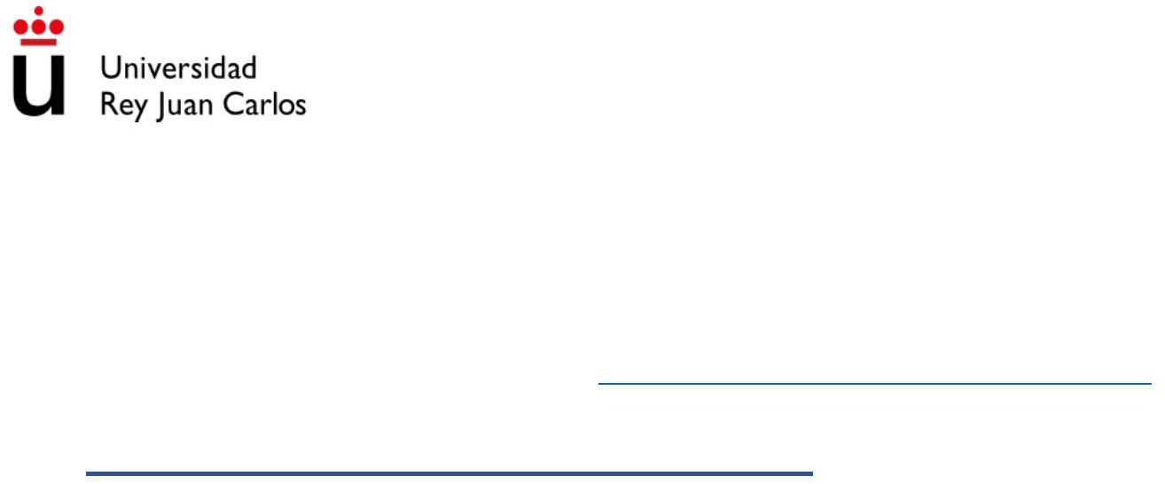
Machine Translated by Google

SUPPORT DOCUMENT (TOPIC 8)

Subject: Introduction to Physical Education Qualification: Degree in Primary Education with Mention in Physical Education

©2022 José Manuel Delfa de la Morena, Juan José Mijarra Murillo, Nuria Romero Parra and Elena María Cáceres López
De Andújar Some rights reserved This document is distributed under
the Creative Commons “Attribution-ShareAlike 4.0 International”
license, available at https:/ /creativecommons.org/licenses/by-sa/4.0/deed.es

UNIT 8. MOTOR COMPETENCIES

- PERCEPTIVE-MOTOR SKILLS

They are those that require the coordination of the sensory systems (exteroceptive and proprioceptive) with movement or neuromuscular action. This concept combines perception and motor skills, with perception being the registration by the brain of the information through the sense organs, giving meaning to it
(Matlin and Foley, 1996) and motor skills, any manifestation of the body dimension kinesic, symbolic and cognitive character (Castañer and Camerino, 2006). By Therefore, the perceptual-motor capacities include the morphological aspects, sensory and functional aspects of the body and the space-time elements in which the own body is circumscribed (Castañer and Camerino, 2006).

  - TYPES

- Body perception: Cognitive structure that provides the subject with recognition of their own body and that of others in any situation and the
information necessary to establish relationships with the environment, based on the awareness of oneself and of one's situation in space (Bascón, 2011).

- Space-time perception: Understanding and adaptation of our body to the
space and the changes that take place over time (Bascón, 2011), organizing and structuring the information in space-time coordinates (Brotons,
2015).

- Balance: Ability to control and maintain the adjustment of the different parts of the body, compensating for the action of gravity. Also, it is the ability to
orient the body in space by means of an orderly relationship between the body schema and the outside world (Limo Scholarship, 2019).

- Laterality: Functional predominance of one side of the body over the other.
It manifests with the preferential use of the hand, foot, eye and ear (Brotons, 2015).
In this concept intervenes the inherited physiological constitution of the individual and the

pressure from the cultural environment.

- Basic motor skills: Motor actions acquired innately, that is,
That is, they appear phylogenetically in human evolution, such as
marching, running, turning, jumping, throwing, receiving… learned in their action volunteer. These basic skills find support for their development in
perceptual abilities, which are present from the moment of birth at the same time that they evolve jointly and juxtaposedly (Falcon and Rivero, 2010).

  - NOTIONS TO TAKE INTO ACCOUNT

- Motor development: skills are being developed from birth

perceptual-motor. We must differentiate between perceptual and motor.

- Motor learning: they are the first to require our teaching work.

- How they work in primary education: they must be taken into account during the
three cycles being the initial ones.

- BASIC PHYSICAL ABILITIES

According to Torres (2005) in Villa (2011) they are the innate physiological predispositions of the individual, feasible to measure and improve, that allow movement and muscle tone
and that training and learning will have a decisive influence, improving inherited conditions to their full potential.

According to Gutierrez (2011), basic physical capacities are defined as the characteristics of the person, determinants of the physical condition, are based on the
mechanical actions and in the energetic and metabolic processes of performance of the voluntary muscles. In the set of components of motor skills, the
Physical capacities are the most easily observable, they are characterized by the fact that they can be

measure, since they are specified based on the anatomical-functional aspects, in addition to can develop with training and systematic and organized practice of the
physical exercise.

TYPES

- Strength: ability of the muscle to generate force or overcome resistance
(Oxford Dictionary of Sports Science and Medicine). There are different types in depending on the type of contraction (isometric, isotonic) or its manifestation (maximum, explosive, resistance, speed, dynamic, reactive…).

- Endurance: ability to withstand an effort or psychophysical load the greatest possible time (Weineck, 2005). It can be classified into different types based on of the musculature involved (general and local), of ascription to a modality (general and specific), of the energy substrate (aerobic or anaerobic…) etc.

- Speed: ability to carry out a motor action or respond to a
stimulus as quickly as possible or in the shortest time possible. can be from reaction, displacement or gesture (Villa, 2011).

- Flexibility: ability to bring the joints to their greatest range of movement and that depends on joint mobility, muscle elasticity and extensibility. You can work through static, dynamic,
assets, liabilities…etc (Villa, 2011).

  - NOTIONS TO TAKE INTO ACCOUNT

- Motor development: they are developing from birth, but not all of them are evolutionary, so it is important to investigate.

- Motor learning: should work on them equally or some before others?

- How they work in Primary Education: that they can be worked on does not mean that they have to be worked on explicitly throughout the stage. It will depend on the factors previous.

- SPORTS INITIATION

Sánchez Bañuelos (1990), understands the concept of sports initiation in a
broad, that is, "it does not consider an individual initiated until he is capable of having a basic operation, on the global set of sports activity, in the real situation
of a game or competition. It is a concept of motor operability and not of understanding and memorization of a series of data at the verbal level.

At present, two currents coexist in terms of the definition of what is the
Sports Initiation, a more traditional one, which continues to focus on the product, focusing its teaching on a single specialty and oriented in a certain way to the performance, and a second current that is more openly oriented to the process, to horizontal approaches and with more educational or recreational motor purposes (Vilora, Lopez, Jordan and Moreno, 2010).

Thus, for Hernández Moreno in Blázquez (1995), sports initiation "is the process of teaching-learning, followed by the individual for the acquisition of knowledge
and the practical execution capacity of a sport, from the moment it comes into contact with it until who is capable of practicing it in accordance with his technique, his tactics and his regulations". On the other hand, Blázquez (1995), also defends the concept of sports initiation from

the educational field contributing that it is "the period in which the child begins to learn from specifically the practice of one or several sports”. Finally, Vilora et al. (2010) the
defined as the process in which a boy or girl starts in one or several sports, recommending multi-sport training, so that in the future the young person can choose from your own criteria (example: fun, skill level,
socialization...) the sport in which he specializes, but already with a more comprehensive base solid in relation to their motor skills.
  - TYPES

Depending on the number of participants and how they interact in the space, sports can be classify in a simple way in (Hernández Moreno, 1994):
- Individual sports: those that are practiced by a single participant (or one per team).

- Collective sports: they are those that are played as a team, that is, in pairs or groups.

- Sports with opposition: those in which the opponents can hinder each other directly, influencing the opponent's game.

- Sports without opposition: they lack obstacles that could affect the game directly from the adversary, and may even participate alternatively.

  - NOTIONS TO TAKE INTO ACCOUNT

- Motor development: since they are specific skills, do you think they are acquired by themselves?

- Motor learning: they require a lot of our teaching intervention. The would you teach through global or analytic practice?

- How they work in primary education: that they can be worked on does not mean that

they have to be worked on explicitly throughout the stage. how old is he recommended sports initiation and how?

- BODY EXPRESSION

Calecki and Thévenet (1992) point out that body expression is “a form of expression which consists in saying through the body, using significant gestures born from the
feeling and spontaneity. Allows you to create your own language making it understandable, that is, communicable to others”. On the other hand, according to Piaget, bodily expression is, a total, integrated and harmonious development, which favors intellectual development, where no area of conduct is neglected and devalued.
  - TYPES

- Imitative movement: make gestures and/or body movements copying another simultaneously and as faithfully as possible. you become the shadow
of the other person, but you are still you.

- Expressive movement: it is characterized by communicating with the body emotions, feelings or moods, trying to feel it in the most realistic way
possible.

- Creative movement: it consists in innovating, in making movements with the body
of which you do not have a mental image and that arise from letting yourself go. here the Movement improvisation plays an important role.

- Interpretive movement: combines the three previous movements, but highlights the ability to perform actions or simulate characters that you do have a mental image. Here, unlike the imitative movement, you become the essence of what you have as a reference to communicate.

  - NOTIONS TO TAKE INTO ACCOUNT

- Motor development: does the child express himself from birth?

- Motor learning: what kind of expressive movement is required and/or
should be taught?

- How they work in primary education: Do you consider any type of movement

simpler than the others? Would you follow any order? How would you differentiate

cycle work?

- BIBLIOGRAPHY

Baca Limo, MA Influence of play to improve body balance in children and

- year-old girls in Montessori schools and academies-Victoria-Chiclayo district,
2019.

Bascon, M.A. (2011). Body and spatial perception. Innovation and experiences educational, 1-7.

Brotons, EB (2015). Laterality development programs, scheme improvement

body and space-time organization. intervention in learning difficulties.

Processes and programs of educational neuropsychology, 79.

Castañer, M., & Camerino, O. (2006). Basic manifestations of motor skills. University of Lleida.

Calecki and Thevenet (1992). Wellness techniques for children. Body expression and yoga. Barcelona: Paidos.

Falcon, VC, & Rivero, ED (2010). motor learning. motor skills
basics: coordination and balance. Reading Magazine: Physical Education and Sports, 1(4), 29-36.

Gutierrez, FG (2011). Concepts and classification of physical capacities. Body, culture and movement, 1(1), 77-86.

Hernández Moreno, J., in Blázquez, D (1995). The diversity of practices. analysis of the structure of sports for its application to sports initiation. initiation
sports and school sports, 287-310.

Kent, M. (2006). Oxford dictionary of sports science and medicine. OUP Oxford.

Matlin, MW, & Foley, HJ Sensation and Perception (1996). Prentice Hall Hispanic American.

Villa, CR (2011). Basic Physical Qualities. Innovation and educational experiences (40), 1-11.

Víllora, SG, López, LMG, Jordan, ORC, & Moreno, DSM (2009). The concept sports initiation today. Challenges. New trends in Physical Education,
Sport and Recreation, (15), 14-20.

Weineck, J. (2005). Entrenamiento total (Vol. 24). Editorial Paidotribo.
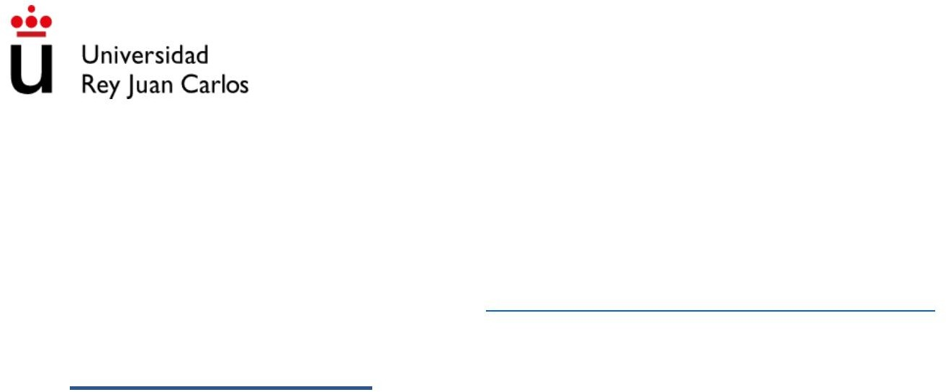
Machine Translated by Google

SUPPORT DOCUMENT (TOPIC 9)

Subject: Introduction to Physical Education Qualification: Degree in Primary Education with Mention in Physical Education

©2022 José Manuel Delfa de la Morena, Juan José Mijarra Murillo, Nuria Romero Parra and Elena María Cáceres López
De Andújar Some rights reserved This document is distributed under
the Creative Commons “Attribution-ShareAlike 4.0 International”
license, available at https:/ /creativecommons.org/licenses/by-sa/4.0/deed.es

UNIT 9. THE GAME

  - GAME CONCEPT

    - DEFINITIONS

According to the RAE, game comes from the Latin iocus (fun) and ludus (act of playing), and the The concept of playing is "doing something with joy in order to be entertained, amused or develop certain abilities.

According to the Dictionary of Educational Sciences, it is the "playful activity that involves an end in itself although sometimes it is carried out with an extrinsic motive”.

According to Huizinga (1949), the game is a "voluntary activity or occupation, which is carried out
within established limits of space and time, following rules freely accepted, but unconditionally followed, that has its goal in itself and that is accompanied by feelings of tension and joy.

In short, the game is a very useful educational tool to motivate, help structure the way of relating and developing the students in an integral way.

    - HISTORY

According to Hernando and Gómez (2018), the game has been present in the life of man. The Paleolithic men created through play manifestations or expressions of
culture and even some religious ritual, which led around 4000 BC to the use of I play as a mix of training and work. Subsequently, they began to create
toys such as clay or papyrus balls in Egypt or marbles in India, while Mayans and Aztecs even delimited the playing field in their ball games. In
Greece the game helped in physical development, and was of vital importance to achieve

a complete and moral education of the citizen and to develop his spirit
creator and promote the cooperative. On the other hand, in Rome the game had a role playful, freeing minds and rewarding for the fatigue generated during the
worked.

However, thinkers like Luis Vives in the fourteenth century, followed by the creators
of the New School of the nineteenth century such as Rousseau, Pestalozzi and Fröebel, as well as other authors such as Dewey, Montessori, Declory or Freinet attached importance to the game within education as a facilitator of learning and recognizing its potential
educational potential not only to motivate the student but also to learn and
develop skills and abilities. All of them, moreover, focus their interest on the
child and in the development of their abilities, through exploration and experimentation tation, turning it into an active subject of teaching, so that the professed
res are in charge of organizing the work of the classroom, and the children can work at the individual and group level, respecting their own learning rhythms and giving importance to meaningful learning (Hernando & Gómez, 2018).

  - FEATURES AND USEFULNESS OF THE GAME

    - GENERAL FEATURES OF THE GAME

- Pure activity that does not need an external purpose.
- Natural and spontaneous, does not need learning.
- Pleasant and leaves you a feeling of pleasure through the game activity.
- It can contain simple rules.

    - CHARACTERISTICS OF THE GAME IN THE CHILD

- Biological activity.
- Activities of quantitative presence in time.
- Activities with purpose in themselves.

- Essential activities for the integral development of the child.

23. CHARACTERISTICS OF THE GAME IN THE ADULT

- Secondary activity.

- Marginal quantitative activities in time.
- Activities with an external purpose (recreational and compensatory purposes, among others).
- Expendable secondary activities.

  - DIFFERENCES BETWEEN GAME AND SPORT

The game is a playful motor activity of short duration, which usually has rules simple and that mobilizes the child's capacities without great physical demands or technical complexities.
Sport, on the other hand, is a long-lasting playful motor activity, with rules complex that mobilizes the child's capacities agonistically and uses skills and complex tactics.
Between one and the other we find: PRE-SPORTS AND MODIFIED SPORTS

  - UTILITY OF THE GAME

- Educational value:

  - According to its quality as a means that favors comprehensive development
of the individual.

  - The child when he plays responds to the stimuli that the game itself gives him giving: experiment, discover, give correct answers or not that compares with others lived by peers or other models and thus enriches
motor level.

  - Intellectual development involves a variety of responses to stimuli
presented that become more complex, following the evolution of the individual.
  - Both free play and directed play make it possible to:


ÿ Peer interactions.
ÿ Explore and experience their possibilities and limitations.
ÿ Allows the development of adaptive, cognitive, socio-affective and motor.

- Leisure and recreation.

- Benefits at all levels of development (Chamorro, 2010): psychomotor (balance, coordination, manipulation of objects), cognitive (attention,
imagination, communication...) social (cooperation, inclusion...) and emotional (relief of anxiety and aggressiveness, stimulation of subjectivity and resolution of conflicts...)

- CLASSIFICATIONS

  - JEAN PIAGET (1961)

According to the evolutionary development of the child:

- Sensorimotor Game (0-2 years): to exercise the HMB and check the consequence of their actions. Example: Throw an object
- Symbolic Game (2-6 years): imitation game. They imagine that they are other people
and they use things as if they were others. They transform the outside world according to
your wishes.

- Regulated Game (6-12 years): period of specific operations. they already understand the points of view of others and consider them necessary (rules of play).

  - CHATEAU (1973)

- Unregulated games (they are usually found from birth to 3 years old):
  - Functional games: characterized by spontaneous movements.

  - Hedonistic games: that are combined with the previous ones and seek pleasure and sensory stimuli.
  - Exploration games: with the environment and classmates.
  - Games of destruction: characterized by disorder and chaos.

- Regulated games (they usually appear once the destruction stage is over):
  - Imitation games: they are based on copying gestures and actions of their people nearby. although at a later stage they begin to imitate characters
famous or fictional.

  - Construction Games: These games are in contrast to
games of destruction, since, to a greater extent,
characterized by the correct order and placement of objects.
  - Arbitrary rule games. They usually occur around 4-6 years of age, due to that at this stage children begin to create and use
rules that have previously purchased.

  - Wehman (1977)

Toy Play Classification:
- Exploratory Game
- Independent game.
- Symbolic Game.
- Parallel game.
- Associative game.
- Cooperative or social game.

  - BLAZQUEZ (1980)

- Energetic functional: very active games, active, of medium intensity and of little intensity.

- According to the degree of intervention: Progressive elimination games,
total participation, determined partial, total participation and free intervention determined.
- Depending on the type of movement: games of walking, running, jumping, launch, fight, balance, coordination, sensory.
- Depending on the effect to be achieved:
  - Sensory: visual, auditory, tactile, taste and smell, orientation.
  - Motors: coordination, reaction speed, locomotion, jumps, balance, throws,
  - Anatomical, organic and gestural development.
- Depending on the difficulty: games involving control of the body,
displacements, mastery of an object, collaboration and opposition relationships.
- Social dimension. Individual, group, team games.

  - COMPILATION

Next, and to finish, we propose a list of games based on different
factors and that can serve as an aid for the formulation of specific objectives of exercise:
- Chase games.
- Competition games.
- Cooperation games.
- Sensory / sensorimotor games.
- Imitation games.
- Interpretation/representation games.
- Symbolic games.
- Association games.
- Role playing games.

- Rhythmic games.
- Musical games.

- Memory games.
- Slogan games.
- Traditional/classic/popular games.

- BIBLIOGRAPHY

Blazquez (1980). Introduction to team sports. Editorial Martinez Roca. Barcelona.

Chamorro, IL (2010). The game in early childhood and primary education.

Chateau, J. (1973). Psychology of children's games. Kapelusz.

Hernando, PC, & Gomez, MDCG (2018). Learning and play throughout
History. The Historical Reason: a Hispanic journal of the history of political ideas and social, 40, 23-31.

Huizinga (1949). Homo ludens. Routledge. London.

Piaget, J. (1961). Formation of the symbol in the child: imitation, play and dream. image and representation. Economic Culture Fund of Spain. Madrid.

Wehman, P. (1977). Helping the mentally retarded acquire play skills; A behavioral approach. Springfield, Ill: Charles C, Thomas.
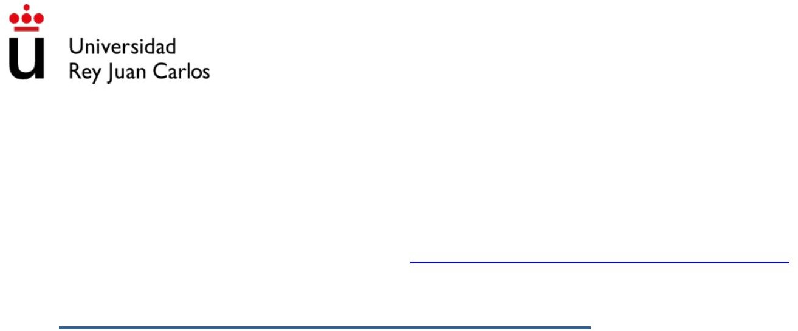
Machine Translated by Google

SUPPORT DOCUMENT (ITEM 10)

Subject: Introduction to Physical Education Qualification: Degree in Primary Education with Mention in Physical Education

©2022 José Manuel Delfa de la Morena, Juan José Mijarra Murillo, Nuria Romero Parra and Elena María Cáceres López
De Andújar Some rights reserved This document is distributed under
the Creative Commons “Attribution-ShareAlike 4.0 International”
license, available at https:/ /creativecommons.org/licenses/by-sa/4.0/deed.es

UNIT 10. ATTENTION TO DIVERSITY

- CLARIFICATION OF CONCEPTS

  - DEFINITION

Attention to diversity, according to Besalú (2002), supposes the recognition of the other person, of his individuality, originality and uniqueness, and is inscribed in a context
of vindication of the personal, of the present, of the differences. diversity is inherent to education.

For this, the centers will adopt, forming part of the educational project, the measures of attention to diversity that allow personalized attention to students in
function of their educational needs, trying not only to integrate them but also to make it an inclusive education.

  - DIFFERENTIATIONS

When we talk about attention to diversity, a series of terms appear that is important that we distinguish

Support Educational Needs / Special Educational Needs:

When we talk about students with specific educational support needs, they are those students who require support and/or special attention in the center. The different needs that we can find are students with high capacities
intellectuals, late incorporation students to the educational system, school absenteeism, students with specific learning difficulties and students with special needs
special education (SEN).

Special Educational Needs are one of the types of Support Needs Educational. “A student with special educational needs (ACNEE) is one who encounter limitations in participation or learning resulting from disability, conduct disorder or communication and language disorder. These limitations they may appear for a period of their schooling or throughout it. these students they need certain specific educational supports to overcome the objectives educational of your course” LOMLOE, 2021.
Therefore, it could be said that any student at some point in their schooling, could be ACNEE.
- If a student with intellectual disability, autism, cerebral palsy, blindness…
you need specific supports to achieve your course objectives; will be considered do ACNE.
- When a student enters primary school and has not yet acquired oral language Castilian, is considered ACNEE.
- When a student breaks a bone and must use a wheelchair for a time, it is considered ACNEE.
- When a student is going through an emotional downturn and has serious problems More than conduct, it is considered ACNEE.

Disability/handicap

According to the Juan XXIII Foundation, the concept of Disability is defined as the condition that prevents or limits the person in their daily life.
Disability is the disadvantageous situation in which a certain person finds himself, as a result of an impairment or disability that limits, or prevents, the
performance of a role that is normal for that person, based on age, sex, and social and cultural factors.
Therefore, a person with a disability, for example, may find it difficult to walk normally because he was born with a foot disorder, while the

Disabled person is one who cannot even walk, for different reasons that

they have led him to not be able to do something that is habitual and normal in the human being.

Inclusion/ Integration:

The Juan XXIII Foundation (2021), makes a distinction between inclusion and integration, emphasizing that the difference between the two terms lies in whether or not there is a previous social separation and, if so, the way in which the process of separation occurs adaptation of that population sector that has been segregated from the rest.
When we talk about inclusion, we talk about a single system for all, adapting to diversity and serving all students equally.
On the other hand, integration poses a duplicity of the educational system, being the vulnerable students who adapt to the educational system.

- TYPES OF ATTENTION TO DIVERSITY

- Students with specific educational support needs
  - Students with high intellectual abilities: they are those students who have a high level of intellectual aptitudes.
  - Students who join the educational system late: are those who, for whatever reason, join the educational center later.

  - School absenteeism: those who repeatedly miss class. o Students with specific learning difficulties: these are those
students who have a neurologically based alteration and therefore affect cognitive processes involved in reading, writing and/or calculation.

  - Students with special educational needs.
ÿ Visual, auditory, cognitive or motor alteration. ÿ
Alterations generated by multiple personality disorders
dad.
severe behavioral disturbance. severe
developmental disorder.

ÿ Communication disorder and relationship capacity. ÿ Attention deficit disorder with or without hyperactivity. o Students who have (temporarily
or not) different personal situations from their classmates:

ÿ Personality traits such as shyness, difficulty relating to nase
ÿ Physical features: sprains, small breaks. ÿ Allergies.

ÿ Difficulty in the language.
ÿ Complicated personal or family situations.

- GUIDELINES FOR ADDRESSING DIVERSITY

  - General recommendations

It is important to take into account a series of general adaptations to be able to attend to

all students with specific educational support needs. some of which

we recommend are the following:

- Use games in which no student is discriminated against due to their abilities.

of the.

- Make the appropriate modifications both in intensity and complexity of

so that everyone can achieve the goals we set for ourselves.
- Never delete or delete.

- Always use positive reinforcement.

- Use cooperative games where all students can interact with each other. they.

  - Age difference

In some places, especially rural ones where there is very little population, the classes are

mixed with different ages in the student body. So it would be recommended that the

activities that are carried out are with enough variants so that it exists,

a very remarkable way, a methodological progression.

  - Gender difference

In a class where the majority of the student body is single-sex, it will be necessary to make adaptations depending on the age with which we work. Although this topic much to talk about, it is a fact that male and female genetics are not the same
same and that each sex has different and more notable skills and abilities
than the other. Therefore, in case of having a considerable difference between one sex or the other,
When doing an activity in teams, it will be necessary to do them as balanced as possible possible. As will happen with the skills, which we will talk about next.
  - Skill level difference

Just as we have discussed with the gender distinction, in order to attend to the diversity in any aspect, it is very important to know our students from individually, a fundamental basis for correctly addressing diversity. For the Therefore, when we meet our students, we will know what skills and deficiencies has each. Thus, depending on the activity that we are carrying out, for example, of speed by groups, we will have to put the students who are faster
They run distributed by the different groups.

  - Visual impairment

It would be appropriate to enhance the rest of the senses, such as touch or hearing. In the first case, using materials with textures and reliefs and in the second, guided by the teacher or any other person or student in order to participate. must be taken into Note that, in this visual deficit, many students have lateral vision, so
when the teacher explains, it can be oriented to one side, and never against the light.

  - Hearing impairment

It would be necessary to enhance the other senses as in the previous alterations, establishing an important visual channel and enhancing the tactile channel. In addition, the hearing deficit, it does not always have to be total, so the teacher could approach
more to the student with SEN and from the side that has more hearing. The vocabulary used

It would have to be simple, pronouncing properly and gesticulating correctly.

In that case, it is recommended that body and visual language be used more intensity.

  - Motor disability

The teacher would have to adapt the materials, using larger objects or

carrying out activities in spaces without architectural barriers. The material would

to be adapted to the students and it would be convenient to make variations in the games or

activities to always seek the participation of children with SEN with the rest of the students

- BIBLIOGRAPHICAL REFERENCES

Chamizo, F.J. (1997). Physical education. Basis of Curriculum Design based on Special Educational Needs. I learn you learn Journal of Educational Communication, 3, (113-134).

Decree 61/2022, of July 13, of the Government Council, which establishes for the Community of Madrid the planning and curriculum of the Primary Education stage.

John XXIII Foundation. (September 1, 2021). Know the difference between inclusion and integration. John XXIII Foundation. https://blog.fundacionjuanxxiii.org/know-the-difference- between-inclusion-and-integration

Garcia Correa, A. and Marrero, G. (1999). Psychology and teaching of physical education. In JA Beltrán and Genovard, Psychology of instruction. Curriculum areas. (Vol. II), (pp.
97-118). Madrid: Synthesis.

Royal Decree 157/2022, of March 1, which establishes the organization and minimum teachings of Primary Education.

Ruiz-Perez, L.M. (2000). Competence and incompetence in physical education: implications for psychoeducational intervention. In D. Vence Baliñas. (Ed.), Psychopedagogical intervention and school curriculum. (205-216). Pyramid.

Ruíz Quiroga, PM (2010) The evolution of attention to the diversity of primary school students throughout history. No.8. Themes for Education. Digital magazine for teaching professionals.

Trabalon, F. (2002). Motor skills and learning styles. motor skill Journal of Physical Activity and Sports Sciences, 19, (5-11).

Winnick, J. (1995). Adapted Physical Education and sport 2nd. Champaign, III: Human Kinetics. New York.
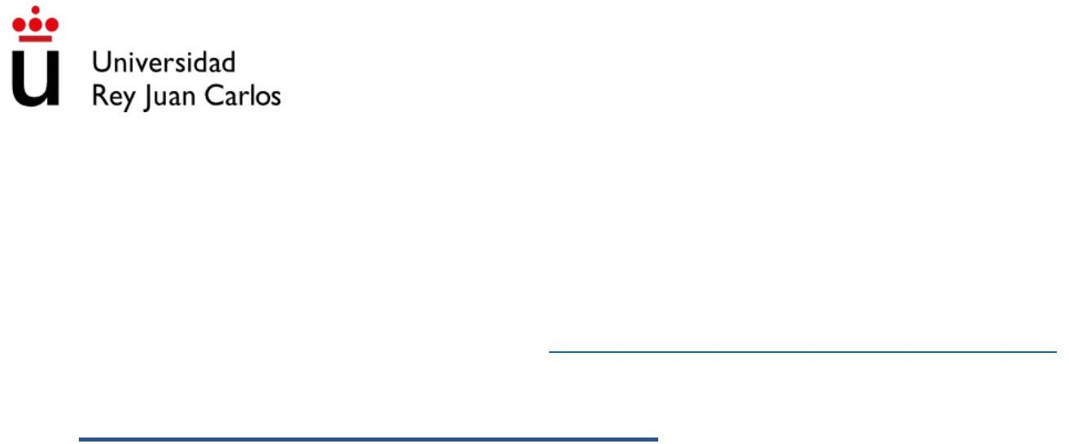
Machine Translated by Google

SUPPORT DOCUMENT (ITEM 11)

Subject: Introduction to Physical Education Qualification: Degree in Primary Education with Mention in Physical Education

©2022 José Manuel Delfa de la Morena, Juan José Mijarra Murillo, Nuria Romero Parra and Elena María Cáceres López
De Andújar Some rights reserved This document is distributed under
the Creative Commons “Attribution-ShareAlike 4.0 International”
license, available at https:/ /creativecommons.org/licenses/by-sa/4.0/deed.es

UNIT 11. EDUCATING IN VALUES
- CLARIFICATION OF CONCEPTS
  - DEFINITION

Every educational action is already an activity loaded with value, which implies some values, so it may be redundant to speak of "values education", if not because
we want to highlight the explicit education of educational values, duly
planned in conjunction with the other areas and tasks of the center. Therefore, the "values education" encompasses a broader concept than moral education and has as a priority objective to help understand others and live together in a climate of mutual respect, once each one's own being has been formed (Bolívar, 1998).

  - DIFFERENTIATIONS

Belief: cognitive component that is at the base of values and attitudes. The
Beliefs are principles of representation of the world, which are usually expressed through of opinions. They represent what a person usually considers to be true/false,
good/bad, desirable/undesirable (Bolívar, 1998)

Habit: special way of proceeding or behaving acquired by repetition of acts equal or similar, or caused by instinctive tendencies (RAE).

Value: in a more objective moral sense, it refers to the desirable forms of behavior or life. From a psychological perspective, more individual, the values
are preferential frameworks that orient and socially integrate the individual in the world, in their attitudes and behaviour. Values can have a foundation or origin
subjective (affective-emotional), social (modes of social or cultural behavior desirable), or transcend these conditions, as ideal projects of life or

moral principles (Bolívar, 1998).

Attitude: predisposition acquired in the course of learning, which drives manifest in certain ways before objects or situations. They usually have in their based on some values and beliefs (cognitive aspect) and also involve factors
affective (positive or negative feelings) with a motivational character, and tendencies to act (behavioral element) (Bolívar, 1998).

Conduct: How people behave in their lives and actions (RAE).

- PERSONAL AND SOCIAL RESPONSIBILITY PROGRAM (PRPS)
  - HISTORY

Around the 1980s, an educator at the University of Illinois (Chicago) begins to disseminate a particular method with which to work to integrate adolescents at risk social exclusion and criminal behavior. This teacher is Donald Hellison and he is the in charge of creating a program with which, through sports, it educates in the
individual and social responsibility for improving relationships between individuals, both
in the classroom and outside of it (Hellison, 2011).

  - KEY PILLARS

This model is based on the acquisition of behaviors that favor the common good, in the that the key pillars on which it is based are:
- Integration.
- Assignment of responsibility to students.
- Teacher and student relationship.
- Transfer.

- LEVELS

  - Level 0: irresponsibility (this model seeks to leave this level aside).
This level 0 is from which all human beings start and, thanks to the PRPS, it is sought overcome this and get the following ascending levels:
  - Level 1: respect for the feelings and rights of oneself and others.
This level is fundamentally based on creating awareness of the importance of taking into account the differences and points of view of everyone, including ourselves.
  - Level 2. participation and effort.
When we reach this level, it is relevant to put ourselves into action and have a certain
determination when collaborating in the development of activities or tasks

determined.

  - Level 3: personal autonomy.
Have initiative not only to participate in the activities or tasks to be carried out, but also trying to do them by oneself and with as little help as possible, favoring
the independence of the individual will create more efficient and secure human beings.
  - Level 4: help others and leadership.
Once the skills related to respect for others have been acquired, the
effort for chores and the disposition towards an initiative that favors freedom of the individual, we will find a level based on collaboration taking into account
others, favoring a more positive social climate and in which you can not only help yourself yourself, but also help others, developing a form of coexistence
integral.
  - Level 5: transfer.

This last level is characterized by the importance of taking what is learned in the classroom outside
of it and apply it on a daily basis.

4. BIBLIOGRAPHY

Bolivar, A. (1992). The attitudinal contents in the curriculum of the reform. Issues and proposals. Madrid, Spanish School.

Bolivar, A. (1998). Educate in values. An education of the citizenship. Collection
Education XXI, extraordinary issue Education. Council of Education of the Board from Andalusia. Seville.

Hellison, D. (2011). Teaching responsibility through physical activity (3ª ed.). Champaign, IL: Human Kinetics.

Johnson, D., & Johnson, R. (1994). The cooperative learning in the classroom. Editorial Paid.

Pérez-Pueyo, Á. (2013). The attitudinal style: a proposal for everyone from the inclusion in physical education. Playful Pedagogical Magazine. Physical education, Recreation and Sports, 18(2), 81-92.

