

©2023 Autora Natalia González-Benítez Algunos derechos reservados Este documento se distribuye bajo la licencia “Atribución-CompartirIgual 4.0 Internacional” de Creative Commons, disponible en https://creativecommons.org/licenses/by-sa/4.0/deed.es

**Biology Degree**

**Fisiology and microbial ecology**

**laboratory**

Natalia González-Benítez

natalia.gonzalez@urjc.es

INDEX Página

1. INTRODUCTION 2
2. EXPERIMENTAL DESIGN 3
3. ANALYSIS OF PH, CONDUCTIVITY AND GROWTH RATE 4
4. ANALYSIS OF BACTERIAL ABUNDANCE BY MOST PROBABLE NUMBER (MPN) 6
5. ANALYSIS OF BACTERIAL RESPIRATION IN SOILS 8

**1.-introduction**

Despite their small size, microorganisms are the most abundant organisms on Earth and have an excellent ubiquity that allows them to dominate virtually any environment. Microorganisms exhibit enormous functional and taxonomic diversity and can respond rapidly to biotic and abiotic environmental conditions. Microorganisms are the drivers of most biogeochemical fluxes (e.g. C, S, N) in soil and aquatic systems modulated by their wide metabolic diversity. This great diversity shown by microorganisms has resulted from more than 3.5 billion years of evolution. Due to the small size of microorganisms (~3-10 µm), studying and visualising them has been challenging. Microorganisms were not observed until the end of the 17th century when Leeuwenhoek developed simple microscopes. However, new molecular tools have recently revolutionised studying general microbiology and microbial ecology. Conventional ecology has not considered microorganisms as critical living elements of ecosystems, considering them as static elements of small size and little morphological detail (Atlas and Bartha 2002). Nothing could be further from the truth, and thanks to scientists Sergei Winogradski (1887) and Martinus Willem Beijerinck (1901) when they specifically examined the relationships between microorganisms and their biotic and abiotic environment and created the relatively recent discipline called Microbial Ecology. Although soils have been extensively studied and classified regarding physical and chemical characteristics, knowledge about soil biodiversity and functioning is still incomplete, mainly because many studies do not consider microbial communities' taxonomic and functional diversity. Therefore, in this practical, students are asked to analyse chemical and biological environmental factors to study soil microbial ecology.

**.**

**2. EXPERIMENTAL DESIGN**

A design is presented to the students to establish a hypothesis, a sample collection format, sample processing, statistical analysis, and final memory.

*Example of experimental design.*

Soil is collected from the campus and sieved through a 2 mm mesh (Figure 1). Half of the soil will be a Control sample, and the other half will be inoculated with Sahara dust.

**Factor**

* pH.
* Conductivity.
* Growth rate
* MPN
* Enzymatic activity
* Respiration rate

Soil +saharan dust

R1-R12

R1-R12

Control soil Control

Figure 1.-Sieve for soil treatment and soil homogenisation.

The following hypothesis is proposed.

H1. *Saharan dust has a high concentration of nutrients that can stimulate the metabolism of the soil microbial community*.

H0. *There is no effect of Saharan dust on microbial community.*

**3.- ANALYSIS OF PH, CONDUCTIVITY AND GROWTH RATE**

*3.1. Introduction: pH, conductivity and growth rate*

Soil pH controls many chemical and biological activities in the soil. The concentration of hydrogen ions is an important property when studying soil. The pH scale indicates the concentration of hydrogen ions in the soil. The pH is measured on a logarithmic scale and represents the negative logarithm of the concentration of hydrogen ions in the soil solution, expressed in moles/L (pH = - log [H+]). For example, a pH of 2 represents 1 x 10-2 moles/L of H+ ions, and pH 8 represents a concentration of 1 x 10-8 moles L-1 of H+ ions.

Figura 2.-pH-GLP214

Electrolytic conductivity (µS cm-1) in liquid media (solution) is related to the presence of salts in solution, whose dissociation generates positive and negative ions capable of transporting electrical energy if the liquid is subjected to an electric field. These ionic conductors are called electrolytes or electrolytic conductors.

To estimate the growth rate (µ) of the soil microbial community, the change in cell optical density (OD600nm) over time will be studied by spectrophotometry. We will measure one time per day for four days. These Absorbance measurements at 600nm are obtained in a spectrophotometer (Spectronic GenesysT; England; Figure 3) which will allow us to calculate the intrinsic growth rate.

If, during this week, the microbial community shows a curve with its phases (lag phase, exponential phase, stationary phase, including death phase), then the growth rate will only be calculated from the linear part (exponential phase). Therefore, we will apply Equation 1.



*Equation 1*

*3.2. Procedure. pH, conductivity and growth rate*

pH and conductivity will be measured on the first day. In an Erlenmeyer flask, 20 g of sieved soil is added to 100 ml of Milli-Q water (1:5). This flask (A) shall be labelled with the shift, group and type of sample. Shake in the vortex for 15 minutes. Allow the sample to stand for 2 minutes before measuring pH (pH-GLP21, Crison Barcelona) and conductivity (Crison conductivity meter, Barcelona). It is important to calibrate the pH and conductivity meters before measuring.

Growth rate. From flask A, is collected 5 ml (after 15 minutes of shaking) and made up to 50 ml (1:10) of BHB (flask B). Flask B shall be labelled with the shift, group and type of sample and shaken on the orbital shaker for 1 minute (Figure 3).

To estimate the OD600nm, 1 ml is collected from flask B for the blank and 1 ml for the sample measurement. The blank is centrifuged in a microvial at 13000 rpm for 1 minute and measured in the spectrophotometer at 600 nm. The sample is also measured in the spectrophotometer but directly without centrifugation after measuring the blank. This procedure will be done four times weekly to estimate the soil microbial growth rate.

Figure 3. Graphical design for the growth rate estimation procedure

**4.-ANALYSIS OF BACTERIAL ABUNDANCE BY MOST PROBABLE NUMBER (MPN)**

*4.1. Introduction. Bacterial abundance*

To quantify the MPN of bacteria in the soil, take 1 ml from flask A reserved on the first day and make a bank of dilutions in microvials from 100 to 10-7 (Figure 4).

*4.2. Procedure. Bacterial abundance.*

**

Serial dilutions

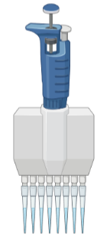Discharge the 20 µl of inoculum from each dilution by changing the hand’s position.

Load 20 µl of inoculum from each of the dilutions in this position.

After 24-48 hours of incubation

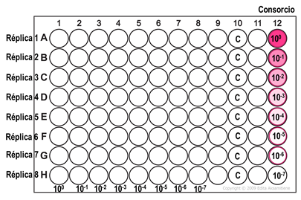

Figure 4. Graphical design for the bacteria abundance procedure

In a 96-well multiwell plate, add 180 µl of LB culture medium minus column 12 to each well. To each column (1 to 8), we will inoculate 20 µl of the microbial consortium of each dilution (serial dilution; 12 columns). The use of multichannel pipettes will help the procedure. In column 12, it will be inoculated 200 µl from each serial dilution. The first column will contain 20 µl of dilution 100, the second column will contain 20 µl of dilution 10-1 and so on up to 8th. The plates will be incubated at 28 ºC correctly labelled (turn, group and type of soil) for 1 or 2 days in dark conditions.

After 24-48 hours, the bacteria will grow, and where bacteria have fallen, you will see turbidity resulting from the growth. Each row is a dilution, so as we move to the right, there will be fewer wells with growth until the dilution where the sample is so diluted that no bacteria have fallen. Therefore, there is no turbidity in any well (in this graph, it would be the 10-7 dilution). In practice, what you have to do in each group is to indicate how many replicates have given positive results (wells in which there is growth) in each column (dilution). From these data, you calculate with a statistical programme (<https://mostprobablenumbercalculator.epa.gov/mpnForm>) the number of bacteria (MPN) in your mother dilution.

Figure 6. Programme to MPN calculations.

**5.-ANALYSIS OF BACTERIAL RESPIRATION IN SOILS.**

*5.1. Introduction. Bacterial respiration in soils.*

The decomposition of organic matter is an ecosystemic process mediated by heterotrophic organisms that use organic matter as a carbon and energy source. During this process, some carbon is returned to the atmosphere as CO2, while other carbon is transformed into simpler compounds or stored in the microbial structures themselves. About 80% of ecosystem services are related to soil and biological activity. Hence, soil respiration, which integrates this activity, is a handy indicator to assess soil functionality, health and fertility.

*5.2. Procedure. Respiration rate*

The respiration rate of the microbial community in soils is estimated by measuring the amount of CO2 produced by the microbial community during a specific period. Ten grams of soil are weighed and placed in a duchess, labelled with the shift, group and soil type with two scintillation vials, one of them containing 14 ml of 0.2 N sodium hydroxide (NaOH) so that the carbon dioxide (CO2) produced in respiration is absorbed and neutralised in the vials with NaOH in the form of sodium carbonate Na2CO3 (Figure 7). Another scintillation vial is placed in the duchess with water to keep the soil hydrated. The scintillation vials must be left open before closing the plastic vial (Figure 7). Three abiotic controls will be prepared, consisting of a plastic vial without soil (or autoclaved soil) but with a vial of NaOH and a vial of water. This control will allow us to estimate the CO2 that does not correspond to the microbial respiration of the soil (i.e., that which may enter the duchess by diffusion, that which was already inside the duchess) and will therefore be subtracted from the calculation.

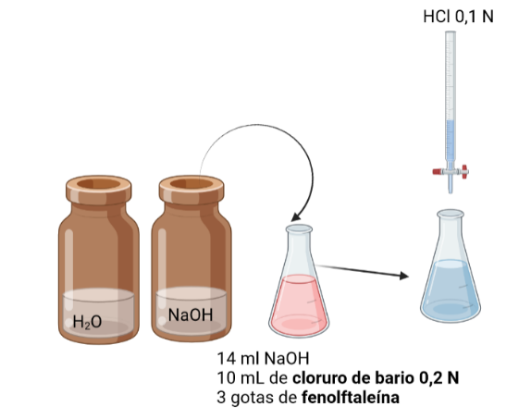

Figure 9. Graphical design for the respiration rate estimation procedure.

At the end of the incubation time (more than one month), the vial with NaOH is loaded into a glass flask. This sample contains Na2CO3 and free NaOH that have not reacted with CO2. The Na2CO3 will be removed from the sample by precipitating it with 10 ml of 0.2 N barium chloride, and the free NaOH will be titrated with 0.1N HCl. Three drops of phenolphthalein (deep pink when the pH is basic) are added so that as the (basic) NaOH is neutralised, the pH becomes more acidic, and the phenolphthalein turns from pink to no colourless.

The number of moles of carbon dioxide produced by the micro-organisms is given as:

CO2 + 2NaOH Na2CO3 + H2O

Volume (HCl) x Normality (HCl) = Volume (NaOH) x Normality (NaOH)

Nº mols HCl Nº mols NaOH