**SELECTIVE HYDRODECARBOXYLATION OF FATTY ACIDS INTO LONG-CHAIN HYDROCARBONS CATALYZED BY Pd/Al-SBA-15**

D. P. Serrano1,2*, J. M. Escola1, L. Briones1, M. Arroyo1

1Group of Chemical and Environmental Engineering, Rey Juan Carlos University, c/ Tulipán s/n, 28933, Móstoles, Madrid (Spain)

2IMDEA Energy Institute, Avda. Ramón de la Sagra, 3, 28935, Móstoles, Madrid (Spain)

* to whom correspondence should be addressed

e-mail: david.serrano@urjc.es

Tel: +34 91 488 70 50

**Abstract**

Pd/Al-SBA-15 materials, with different Si/Al atomic ratios, have been investigated as catalysts in the hydrodecarboxylation (HDC) of fatty acids for the production of long-chain paraffinic hydrocarbons. The catalytic tests were performed in a stirred batch reactor under H2 atmosphere using stearic, oleic and palmitic acids as substrates. Characterization of the catalysts indicates that the Pd nanoparticles are well distributed on the support, being partially located within their ordered mesopores. Increasing the Al-SBA-15 acidity enhances the stearic acid conversion but provokes a reduction in the selectivity towards hydrodecarboxylation versus hydrodeoxygenation (HDO). Variation of the reaction temperature within 225 - 300 ºC enhanced the catalytic activity, while the HDC selectivity remained over 90%, being just reduced when working at 300 ºC due to the occurrence of cracking reactions. The H2 pressure also increased the stearic acid conversion, in particular when passing from 3 to 6 bar, confirming the positive role of the hydrogen atmosphere in the decarboxylation process. However, when operating at 25 bar of H2 pressure, the HDC selectivity decreases, as the HDO pathway is favored. Comparing the results obtained with stearic, oleic and palmitic acids shows that the Pd/Al-SBA-15 system is an excellent catalyst for this reaction, providing in all cases a significant catalytic activity and a very high HDC selectivity. These findings can be related to the features of the Al-SBA-15 support (high surface area, uniform mesopores and mild Lewis acidity), which provides a good Pd dispersion, a high substrate accessibility and limit the extension of cracking reactions.

**Keywords:** fatty acid; decarboxylation; palladium; Al-SBA-15

1. **Introduction**

The consumption of fossil fuels has grown steadily along the years increasing the production of undesirable emissions of greenhouse gases worldwide [1]. In order to mitigate this problem, the EU has proposed to increase the share of fuels in the transportation sector proceeding from renewable feedstocks to 10 wt% in 2020 [2], as well as to limit the proportion of fuels from edible sources to just 5 wt%, avoiding undesirable effects on the food market. This has led to the incorporation of bioethanol, ETBE and biodiesel in commercial transportation fuels.

Traditionally, biodiesel is obtained by transesterification with methanol of the triglycerides present in vegetable oils and other oily fractions, giving rise to the formation of the corresponding fatty acid methyl esters (FAMEs) [10-13]. However, FAMEs show some drawbacks to be used as fuels such its lower energy density, high viscosity, poor thermal and oxidation stability and tendency to polymerize forming coke [14]. Accordingly, a high interest has arisen in recent years to convert triglycerides into hydrocarbons, which could be employed as advanced biofuels in the transportation sector. This transformation can be accomplished through different routes such as hydrodeoxygenation, catalytic cracking and decarboxylation.

Hydrodeoxygenation (HDO) has been widely applied to obtain diesel-range hydrocarbons from fatty acids, esters and triglycerides [8,15-21]. The catalysts employed initially were conventional hydrodesulphurization materials, such as Ni and Mo sulfides supported over alumina [22, 23]. However, these catalysts need the steady feeding of sulfur-containing compounds to keep their HDO activity, which is highly undesirable on environmental terms. Thereafter, catalysts based on noble metals [24] or metal phosphides [20] have been employed with remarkable results. Nevertheless, HDO processes require the use of relatively high pressures and involve large hydrogen consumption, which may limit their commercial feasibility.

On the other hand, catalytic cracking of oily feedstocks has been investigated in the past using mainly zeolite-based catalysts [25]. This process, presents the advantage of proceeding at atmospheric pressure but it is little selective since a broad product distribution is obtained due to the occurrence of a large variety of reactions (cracking, oligomerization, cyclization, aromatization, H-transfer, etc.) catalyzed by the zeolite acid sites. This fact leads to the production of significant amounts of gaseous hydrocarbons at the expense of those within the gasoline and diesel ranges. Likewise, catalytic cracking usually takes place with the formation of large amounts of carbonaceous residues, which implies a reduction in the product yield and provokes the catalyst deactivation.

Decarboxylation (DC) of fatty acids and triglycerides can be considered as an alternative and very promising route for the production of aliphatic hydrocarbons from oily feedstocks that, however, has been explored in quite lesser extension than hydrodeoxygenation and catalytic cracking. Decarboxylation of fatty acids possesses the advantage of proceeding under low pressure and with little hydrogen consumption, leading to long-chain hydrocarbons that could be employed in the formulation of advanced biofuels, in particular within the kerosene and diesel ranges [26]. Palladium-containing catalysts, in particular supported on carbon materials, have shown remarkable catalytic properties for fatty acids decarboxylation [27]. However, under inert atmosphere, severe deactivation is observed due to the accumulation of organic compounds over the catalyst [28-30], which cannot be removed by calcination due to the support nature. Ni/C catalysts also performed with high selectivity in the decarboxylation of fatty acids although the products of the competitive cracking reactions appeared when increasing the catalyst loading [31]. Likewise, other catalytic systems not using carbonaceous supports, such as Pd/Ce-ZrO2 [32], Cu-Ni alloy [33] and Pt supported over Cu, Al, Ga based metal organic frameworks [34] proved to be active in the decarboxylation of oleic acid. It is also noteworthy that catalytic systems based on zeolitic supports have led to a significant decarboxylation selectivity in the conversion of oleic acid, such as Pt supported on zeolite 5A beads and Pt/SAPO-34, avoiding the subsequent isomerization of the linear heptadecane to branched products [35, 36].

In this context, the present work discloses the excellent catalytic properties of the Pd/Al-SBA-15 system for the selective hydrodecarboxylation of fatty acids to produce long-chain hydrocarbons. It must be noted that, at least up to our knowledge, no works can be found in the literature using Pd/Al-SBA-15 catalysts in fatty acid decarboxylation reactions. The results here reported indicate that, by adjusting the Si/Al ratio of the support in the Pd/Al-SBA-15 catalyst, as well as by optimizing the main operation conditions, it is possible to reach a high fatty acid conversion simultaneously with a selectivity towards the respective Cn-1 paraffin around 90%.

1. **Experimental procedure**
   1. *Catalysts preparation*

The Al-SBA-15 supports were prepared according to the method published by Yue et al. [37]. The employed chemicals were: aluminium isopropoxide (AIP), tetraethylortosilicate (TEOS), poly(ethylene-glycol)-block-poly(propylene-glycol)-block-poly(ethylene-glycol) Pluronic© P-123 ((EO)20-(PO)70-(EO)20, Aldrich), hydrochloric acid (37 %, Scharlab), and distilled water. Firstly, Pluronic P-123 was dissolved under slow stirring in an HCl solution with a pH of 1.5 until a clear liquid was obtained. Likewise, AIP was dispersed in TEOS with the aid of a small volume of the HCl solution. Once the Pluronic P-123 was completely dissolved, the solution was heated at 40 ºC and the AIP-TEOS mixture was added and left reacting under stirring at this temperature for 20 h. The molar composition of the synthesis mixture was as follows: x Al2O3 : 60 SiO2 : 1 (EO)20-(PO)70-(EO)20 : 8 HCl : 15723 H2O, where x was modified to obtain Si/Al molar ratios of 30 and 100 in the synthesis mixture. The so obtained white gels were then aged at 110 ºC in a Teflon-lined steel autoclave reactor for 48 h. The formed solids were recovered by vacuum filtration, rinsed with distilled water, dried at 110 ºC overnight, and calcined in static air at 550 ºC for 5 h to remove the organic compounds, mainly the surfactant, contained in the as-synthesized solids. The obtained materials were named as Al-SBA-15 (X), X being the measured Si/Al molar ratio.

Palladium was incorporated on the supports by wetness impregnation with a PdCl2 (99.999 %, Aldrich) aqueous solution. The solution concentration was adjusted to achieve c.a. 1 wt % of metallic Pd in the final catalysts employing a solution volume to pore volume ratio of 1. The impregnated samples were sonicated for 30 min, homogenized in a rotary evaporator under vacuum at room temperature for 5 h, dried overnight at 110 ºC and then calcined in a muffle oven at 550 ºC for 5 h under static air. The calcined samples were subjected to reduction under 30 mL min-1 of H2 in a quartz reactor, increasing the temperature with a heating rate of 2 ºC min-1 up to 450 ºC and keeping it for 30 min. Cooling down to room temperature was carried out under N2 flow.

* 1. *Catalysts characterization*

The physicochemical properties of the catalysts were determined by means of conventional techniques. Calcined samples – Pd as PdO – were subjected to X-Ray diffraction (XRD) in a Philips X’PERT MPD diffractometer using Cu-Kα radiation. High angle XRD patterns were recorded within the 5 – 75° range using a step size of 0.1° and a counting time of 10 s to check the presence of the PdO phases over PdO/Al-SBA-15 (38 and 152) materials. Additionally, low angle XRD patterns (0.2 – 5º) were also taken to determine the mesostructure features of the PdO/Al-SBA-15 materials.

The chemical composition (Pd and Al content) of the samples was obtained by inductively coupled plasma atomic emission spectroscopy (ICP-AES) using a Varian VISTA-AX CCD spectrophotometer. The samples were digested in a H2SO4 – HF mixture prior to the analyses.

The reduced materials – Pd as Pd0 – were characterized by N2 physisorption, ammonia temperature-programmed desorption (NH3-TPD) and transmission electron microscopy (TEM).

The textural properties were determined from nitrogen adsorption-desorption isotherms at 77 K, which were performed in a Micromeritics TriStar 3000 instrument. The surface area was determined by the BET method using the relative pressures range 0.05 – 0.17. Total pore volume were determined from the N2 uptake at P/P0 = 0.98. Mesopore size distributions were obtained by the BJH method using the Harkins-Jura equation applied to the adsorption branch.

The acid properties were determined by NH3-TPD in a Micromeritics Autochem 2910 apparatus. Initially the samples were outgassed in a 50 Nml min−1 helium flow heating up to 550 ºC and keeping this temperature for 30 min. Then, the samples were cooled to 180 ºC and saturated under a 35 Nml min−1 ammonia flow for 30 min. The physisorbed ammonia was removed by flowing He (50 Nml min−1) for 90 min and the chemisorbed NH3 was desorbed by increasing the temperature up to 550 ºC with a heating rate of 15 °C min−1. The ammonia concentration in the effluent gases was determined by a thermal conductivity detector.

The morphology of the support particles as well as the size and distribution of the Pd nanoparticles were inferred from TEM micrographs collected in a Philips TECNAI 20 microscope equipped with a LaB6 filament under an accelerating voltage of 200 kV. Prior to the observation, the samples were dispersed in acetone, stirred in an ultrasonic bath and finally deposited over a carbon–coated copper grid.

* 1. *Fatty acid hydrodecarboxylation tests*

Reactions were performed in a stirred stainless-steel autoclave reactor heated by a ceramic oven. For each reaction, 2 g of the fatty acid (98%, Aldrich) and 18 g of n-dodecane (≥ 99%, Sigma-Aldrich) were mixed and placed into the reactor. Then, 0.4 g of the corresponding catalyst was added to the mixture. After removing all oxygen by fluxing a nitrogen stream through the reactor, a fixed pressure of H2 (in the range 3 – 25 bar) was cold-charged. Afterwards, the temperature was increased until reaching the set point (between 225 and 300 ºC) and the reaction was carried out for 3 h of isothermal time with a stirring speed of 700 rpm. After finishing the reaction, the reactor was cooled down to 80 ºC and the formed gases and vapors were passed through an ice-cooled trap and collected in a gases bag. The catalyst was separated from the reaction medium by filtration under vacuum at 110 ºC to avoid the solidification of the remaining fatty acids.

* 1. *Analysis of the reaction products*

Gaseous products were analyzed in a Varian CP-4900 MicroGC equipped with two separate injectors, columns (Molsieve 5 Å PLOT and ParaPLOT U/Q) and thermal conductivity detectors. Both channels were calibrated to detect and quantify H2, CO, CO2, and hydrocarbons from C1 to C4. Liquid products were analyzed in a Brucker SCIEN 456-GC gas chromatograph equipped with a fused silica BR 5 column (0.25 mm internal diameter and 30 m length) and a flame ionization detector. Previously to the analyses, samples were silylated using a procedure adapted from the EN-14105 standard. Silylation was carried out in a glass vial previously heated at 60 ºC. For each 0.86 g of sample, 30 µL of pyridine, 90 µL of N-methyl-N-(trimethylsilyl)-trifluoroacetamide (MSTFA) and 10 µL of 1,2,3,4-tetrahydronaphthalene (as internal standard) were added. The mixture was shaken vigorously and kept at room temperature for 15 min prior to analysis.

1. **Results and discussion**
   1. *Catalysts properties*

Al-SBA-15 has been selected in this work as Pd support due to its unique textural properties, originated by the presence of uniform mesopores ordered according to an hexagonal unit cell. Thereby, two Al-SBA-15 materials were synthesized having different Si/Al ratios (38 and 152, respectively) in order to vary their acidity. As shown in Table 1, the Si/Al atomic ratios of the supports are larger than those present in the synthesis medium, which is a consequence of the difficulty of incorporating Al into the SBA-15 walls. Likewise, the Pd content of the catalyst is slightly lower than the theoretically loaded (1 wt %) for both samples, denoting that some Pd is lost during the impregnation process.

As illustrated in Figure 1, the Al-SBA-15 (152) sample exhibits a low-angle XRD pattern typical of ordered mesoporous solids with an intense peak at 2θ ~ 0.85º corresponding to the (1 0 0) reflection, as well as minor peaks at 2θ ~ 1.45 and 1.68º arising from (1 1 0) and (2 0 0) planes. For the Al-SBA-15 (38) sample, those peaks are less intense and just the reflection of the (1 0 0) plane is clearly observed. This fact can be assigned to the distortion in the hexagonal mesopore array caused by the Al incorporation, leading to a material with lower mesoscopic order [38-41]. These features are maintained after the addition of Pd, which is initially present in the form of PdO. In this way, the inset in Figure 1 displays the high-angle XRD patterns of the PdO-containing samples, a broad bottom reflection centered at 23º being distinctly observed in both cases, stemming from the amorphous nature of Al-SBA-15 pore walls. Moreover, the asterisks in the inset of this figure illustrate the position of the main PdO reflections. For the PdO/Al-SBA-15 (152) sample only two peaks are distinguished in the inset, placed at 2θ ~ 33.7 and 54.8º, corresponding to the PdO (1 0 1) and (1 1 2) planes. In contrast, for the PdO/Al-SBA-15 (38) sample, in addition to the aforementioned, several peaks are also detected in the XRD pattern placed at 42.0, 60.7 and 71.4º and ascribed to the PdO (1 1 0), (1 0 3) and (2 1 1) planes, respectively. These differences may arise from the lower Pd content in the PdO/Al-SBA-15 (152) sample (Table 1), although it may suggest also the occurrence of nanoparticles with lower size.

The acid properties of the samples were measured by ammonia TPD technique, as illustrated in Figure 2. The overall acidities so obtained, as well as the position of the temperature maximum during ammonia desorption, are shown in Table 1. As expected, both Al-SBA-15 (152) and Al-SBA-15 (38) supports exhibit centers of mild acid strength, whose concentration is reduced on increasing the Si/Al ratio. Incorporation of Pd provokes in both cases a slight increase in the acid concentration, which can be assigned to the Lewis acid features of this metal. Likewise, some changes in the acid strength take place upon Pd addition as denoted by the shift towards lower temperature produced in the TPD curves. This effect is more pronounced for the Pd/Al-SBA-15 (38) sample as the temperature maximum is displaced from 256 ºC to 230 ºC after the incorporation of Pd. This fact evidences a decrease in the overall acid strength, suggesting the occurrence of interactions between Pd and Al species. In the case of the Pd/Al-SBA-15 (152) sample, while the position of the major peak in the ammonia TPD curves is just slightly shifted from 280 ºC to 276 ºC, a new one appears at lower temperature (about 215 ºC), which can be assigned to the weak acidity of the Pd sites.

Figure 3 illustrates the 27Al MAS NMR for both supports, wherein a distinct peak placed at 54 ppm, and assigned to tetrahedral Al is observed. Likewise, a second placed at about 0 ppm is present in both materials arising from extra-framework octahedral Al species. The relative area of the tetrahedral Al peak is 74 and 70% for Al-SBA-15 (38) and Al-SBA-15 (152), respectively. The high share of the octahedral Al peak in both samples is consistent with the already known difficulty of incorporating Al into tetrahedral positions of the SBA-15 walls.

Figure 4 shows the N2 adsorption-desorption isotherms of samples, as well as their corresponding BJH mesopore size distribution. Likewise, Table 1 summarizes the main textural properties of the materials derived from the N2 isotherms at 77 K. Both Al-SBA-15 supports exhibit the typical isotherm of highly ordered mesoporous materials with a sharp jump at intermediate relative pressures. This jump is more vertical in the case of the Al-SBA-15 (152) sample, which leads to a narrower mesopore size distribution in comparison with Al-SBA-15 (38). These results agree well with the higher hexagonal ordering denoted for Al-SBA-15 (152) from the low-angle XRD patterns, as above commented. Both supports present high BET surface areas, as shown in Table 1, being somewhat lower for Al-SBA-15 (38) compared to Al-SBA-15 (152). Likewise, the average mesopore size is smaller for Al-SBA-15 (38) than in the case of Al-SBA-15 (152): 8.2 vs 9.6 nm, respectively. These differences in the textural properties, being relatively small, can be assigned to the higher Al content of the Al-SBA-15 (38) material. Incorporation of Pd by wetness impregnation, followed by H2 reduction up to 450 ºC, provokes a decrease of about 10% in the values of the BET surface area and total pore volume of the supports, whereas the average mesopore size is just slightly affected. This decrease in the values of the textural properties can be related with the location of at least a part of the Pd nanoparticles within the Al-SBA-15 mesopores, as well as to effect of the reduction treatment under H2 atmosphere at 450 ºC applied to transform PdO species into Pd nanoparticles.

Figure 5 illustrates TEM micrographs of the Pd-containing catalysts. Both Pd/Al-SBA-15 materials consist of particles with a size in the 0.6 – 1.5 µm range, in which the presence of a hexagonal array of well-defined and uniform mesopores is observed. Moreover, the occurrence of Pd is clearly denoted in the form of nanoparticles located within and over those of the Al-SBA-15 support. The size distribution of the Pd nanoparticles was determined for both catalysts from more than 100 measurements in the TEM images. As shown in Figure 6, the Pd/Al-SBA-15 (38) sample possesses Pd nanoparticles with larger size than Pd/Al-SBA-15 (152), indicating that the presence of a higher concentration of Al leads to a less uniform Pd size distribution. In the case of the Pd/Al-SBA-15 (152) sample, about 70% of the Pd nanoparticles have sizes below 10 nm, which is close to the mesopore size of the support. This finding is a clear indication that a great part of the Pd nanoparticles is located within the mesopores in this material.

* 1. *Decarboxylation of fatty acids over Pd/Al-SBA-15 catalysts*
     1. *Effect of the Al-SBA-15 support acidity*

This section reports the influence of the acidity of the Al-SBA-15 support in the decarboxylation reaction using stearic acid as substrate. Thereby, the two catalysts prepared from supports with Si/Al ratios of 152 and 38 were tested in the reaction.

Figure 7A illustrates the resulting stearic acid conversion and the selectivity according to hydrocarbon fractions. A significant increase in the substrate conversion is observed with the aluminum content, passing from 48.3 to 73.2% for the catalysts with Si/Al = 152 and 38, respectively. Regarding the product distributions, both catalysts exhibit a very high selectivity towards C13 – C18 hydrocarbons, whereas the production of gaseous and gasoline range fraction is practically negligible. Within that fraction, the major components by difference are linear C17 and C18 paraffins. Therefore, in spite of the higher acid site concentration in Pd/Al-SBA-15 (38), cracking and isomerization reactions did not occur under the employed operation conditions. This fact may be ascribed to the mild strength and nature of acidity in Al-SBA-15, which is originated mostly from Lewis acid sites [42].

Figure 7B provides information about the overall selectivity towards C17 and C18 hydrocarbons, as well as the HDC / (HDC + HDO) ratio (calculated as the quotient n-C17 / (n-C17 + n-C18)). The latter can be considered a direct measurement of the relative contribution of the hydrodecarboxylation (HDC) and hydrodeoxygenation (HDO) pathways. The major product derived from the conversion of stearic acid over both catalysts was the n-C17 alkane, being obtained a very high selectivity: 83.1 and 90.6% for the materials with Si/Al = 38 and 152. This result agrees well with the high value of the HDC/(HDC+HDO) ratio, showing that under these conditions the extension of hydrodeoxygenation is small, hydrodecarboxylation being the major pathway. Nevertheless, the catalyst with the lowest Si/Al ratio leads to somewhat lower values of both C17 selectivity and HDC/(HDC + HDO) ratio.

Considering together the variation of stearic acid conversion and n-C17 selectivity, it is concluded that the heptadecane yield increases from 43.8 to 60.8 % for the catalysts with Si/Al ratio of 152 to 38, respectively. This finding evidences clearly that the presence of acidity in the support brings about a larger extent of the hydrodecarboxylation reaction. Higher acidity in supports containing oxygen atoms diminishes the electronic density of the supported metal particles and its capacity to donate electrons to the adsorbates. Thus, the stearic acid molecules are less strongly adsorbed over the metal particles, enhancing the hydrotreating activity [43]. Additionally, the charged nature of the Al-SBA-15 support surface eases the adsorption of the polar stearic acid molecules and its subsequent transfer to the Pd particles. This electron donation to the Pd moities from the acid sites of Al-SBA-15 support is likely more efficient over the more ordered mesostructure of Al-SBA-15 (152) which also facilitates Pd cluster deposition. Additionally, the higher BET surface area of this support enables the formation of smaller size Pd particles leading to enhanced dispersion. However, a high load of aluminum in the support also favors the hydrodeoxygenation reaction, which result in a reduction of the HDC/(HDC + HDO) ratio.

From these results, it is inferred that Pd/Al-SBA-15, and in particular the sample with the highest Si/Al ratio, is a remarkable catalyst for the hydrodecarboxylation of stearic acid, producing n-C17 with very high selectivity. Hence this material was selected for the subsequent study of the effect of the main reaction variables (temperature and hydrogen pressure).

* + 1. *Effect of the reaction temperature*

One of the most influencing variables in the transformation of fatty acids is the reaction temperature. Owing to this, a study of the effect of this variable in the range 225 – 300 ºC was carried out using Pd/Al-SBA-15 (152) as catalyst.

Figure 8A shows the stearic acid conversion and the selectivity corresponding to the different hydrocarbon fractions so obtained. A significant increase in the conversion can be detected on enhancing the reaction temperature, passing from 8.0% at 225 ºC to 95.8% at 300 ºC. This result denotes the strong effect of the temperature on the catalytic activity. Interestingly, a high selectivity towards C13 – C18 hydrocarbons (> 99%), formed mainly by linear paraffins, is maintained when working at temperatures in the range 225 - 275 ºC. However, for the highest temperature (300 ºC) a significant proportion of C5 – C12 compounds are formed, with a selectivity of 26.6 %, showing the occurrence of catalytic cracking reactions.

On the other hand, as shown in Figure 8B, a slight increase is observed in the selectivity towards C17 hydrocarbons when varying the temperature in the range 225 – 275 ºC , moving from 90.1% at 225 ºC to 93.8% at 275 ºC. However, this parameter decreases significantly at 300 ºC (68.7% selectivity). In the same way, the HDC / (HDC + HDO) ratio holds above 0.96 for reaction temperatures in the range 225 - 275 ºC, but is reduced to 0.71 when working at 300 ºC. This fact can be assigned also to the extension of catalytic cracking reactions rather than to a higher HDO since cracking reactions seem to affect preferentially to C17 hydrocarbons. These results indicate that it is convenient to increase the reaction temperature to enhance the substrate conversion, while maintaining a very high n-C17 selectivity, although it must be kept below 300 ºC in order to avoid the occurrence of cracking reactions.

Comparing the performance of the Pd/Al-SBA-15 catalyst with those previously reported in the literature with other catalytic materials is a difficult task due to the variety of substrates, reaction conditions and experimental sets up employed. From the results here obtained, the TOF value calculated for the stearic acid hydrodecarboxylation over the Pd/Al-SBA-15 (152) catalyst at 300 ºC is 3.02*10-4 s-1. This value compares favorably with the following ones, derived from data reported in the literature, using other types of catalysts: 1.98*10-4 s-1 (5%Pd/C, stearic acid, He, 6 bar, 300 ºC) [27], 2.55*10-4 s-1 (Pd supported onto mesocellular foams, stearic acid, N2, 1 bar, 300ºC) [28] and 1.01*10-4 s-1 (Pt/zeolite 5A, oleic acid, H2, 20 bar, 320 ºC) [35]. On the other hand, the Pd/Al-SBA-15 catalyst exhibits selectivity towards HDC products very similar or even superior than those corresponding to the above referenced catalytic systems. Considering the attained results, an optimum temperature of 250 ºC was chosen for the further catalytic studies over Pd/Al-SBA-15 (152).

* + 1. *Effect of the hydrogen pressure*

The hydrogen pressure is expected to be also a key parameter in the system here investigated that may influence both the catalytic activity and the HDC selectivity. Accordingly, the effect of this variable was studied at 250 ºC in the range 3 – 25 bar using stearic acid as substrate over the Pd/Al-SBA-15 (152) catalyst.

Figure 9A depicts the influence of the hydrogen pressure upon both the conversion of stearic acid and the selectivity per hydrocarbon fractions. It can be seen that using a H2 pressure of 3 bar in the reaction medium is not enough to promote the deoxygenation of the fatty acid over the metal centers, leading to a conversion of only 6%. However, the increase in the pressure of the reducing gas in the medium up to 6 bar favors strongly the transformation of stearic acid, obtaining a 48% conversion. A further increase of the H2 pressure up to 25 bar provoke an additional enhancement of the catalytic activity, reaching 65% conversion of stearic acid. These findings evidence the positive effect of H2 even when it is charged in the reactor at a pressure as low as 6 bar. On the other hand, all the products so obtained are comprised within the C13 – C18 range, with a very high share of linear paraffins. This finding denotes the negligible contribution of cracking reactions in the whole range of H2 pressure.

However, as shown in Figure 9B, the increase of the H2 pressure progressively decreases the n-C17 selectivity and the HDC/(HDC + HDO) ratio, favoring the formation of C18 hydrocarbons. Thus, when working at a H2 pressure of 25 bar, the HDC/(HDC + HDO) ratio decreases to a value of 0.75.

These results denote that the H2 pressure is a crucial variable in the system here investigated. A minimum value of the H2 pressure about 6 bar must be reached for the Pd/Al-SBA-15 catalyst to have a significant HDC activity, but it should not be augmented too much in order to dcosts of the process. Accordingly, it can be concluded that hydrogen is involved in the reaction mechanism of the decarboxylation reaction, confirming that the process should be considered and named as hydrodecarboxylation. Considering the obtained results, a hydrogen pressure of 6 bar was selected for the subsequent catalytic studies over Pd/Al-SBA-15 (152).

* + 1. *Effect of the fatty acid type*

In addition to stearic acid, two fatty acids (oleic and palmitic), with different features of saturation and hydrocarbon chain length, were tested over the Pd/Al-SBA-15 (152) catalyst.

Figure 10A illustrates the conversions and selectivity by hydrocarbon fractions obtained for the three fatty acids. It may be observed that the conversion in the three cases does not change too much, being somewhat higher for palmitic (52%) than for oleic (42%) and stearic (48%) acid. The transformation of the fatty acids leads to a product with a very high selectivity (~100%) to C13 – C18 hydrocarbons, pointing out again the absence of cracking reactions. Regarding the type of compounds, it can be observed that, while for the stearic acid only linear paraffinic hydrocarbons are obtained, in the products derived from the oleic and palmitic acids, a small share of branched hydrocarbons is detected.

Figure 10B shows the selectivity towards Cn-1 (derived from the HDC reaction) and Cn (formed by HDO) hydrocarbons, along with the HDC/(HDC + HDO) ratio. For the three studied fatty acids, Cn-1 compounds are the main products, showing that hydrodecarboxylation reactions are predominant. If the stearic and oleic acids are compared (hydrocarbon chain of 18 carbon atoms: saturated and unsaturated, respectively), it may be observed that similar selectivities towards C17 (~90%) and C18 (5-8%) are obtained. On the other hand, in the case of palmitic acid the reaction product presents a greater share of Cn compounds (12.5%), which is reflected also in a slightly lower value of the HDC / (HDC + HDO) ratio.

In overall, these results show that the excellent performance of the Pd/Al-SBA-15 catalyst, exhibiting very highly selectivity towards the production of the respective Cn-1 paraffin through hydrodecarboxylation, that is maintained independently of the saturation degree and chain length of the raw fatty acid.

1. **Conclusions**

Pd/Al-SBA-15 was unveiled as a remarkable catalyst for the hydrodecarboxylation of fatty acids (stearic, oleic and palmitic acids) in the presence of hydrogen at low pressure, leading to a very high selectivity towards the corresponding n-1 linear paraffin (about 90%). This remarkable performance can be assigned to the high surface area and uniform mesopores present in the support, which favor the dispersion of the Pd particles and promotes the accessibility of the fatty acid molecules to the active sites. On the other hand, the mild Lewis acidity of the support plays also an essential role influencing positively the decarboxylation activity. Thus, the increase in the acidity of the support provoked a larger extent of hydrogenation and hydrogenolysis reactions. However, a greater load of aluminum in the catalyst also enhances the interaction between Al and Pd sites, increasing the contribution of the hydrodeoxygenation route versus hydrodecarboxylation.

The variation of the reaction temperature in the range 225 – 300 ºC has a sharp positive effect on the fatty acid conversion, while the Pd/Al-SBA.15 catalyst maintains a high HDC selectivity. Just in the case of working at 300 ºC the HDC selectivity decreases significantly due to the occurrence of cracking reactions producing gasoline range hydrocarbons. The H2 pressure initially loaded in the reactor is also a crucial variable. A minimum value of the H2 pressure about 6 bar must be reached for the Pd/Al-SBA-15 catalyst to have a significant activity, but it should not be augmented too much in order to keep a high hydrodecarboxylation selectivity, as well as not to increase excessively the economic costs of the process.

The excellent performance of the Pd/Al-SBA-15 catalyst is maintained independently of the saturation degree and chain length of the raw fatty acid. Thus, a very high HDC selectivity, leading to the production of the corresponding Cn-1 paraffin, is achieved during the conversion of the three fatty acids investigated in this work.

1. **Acknowledgments**

The authors want to thank the funding received from the Spanish government through the project CTQ 2014-60209-R.

1. **References**

[1] Brochure “The EU Emission Trading System (EU- ETS), web page: ec.europa.eu/clima/publications/docs/factsheet-ets-en.pdf

[2] Amendment to the Directive 2009/28/EC on the promotion of the use of energy from renewable sources, web page: ec.europa.eu/energy/renewables/targets_en.htm

[3] J. C. Serrano-Ruiz, J. A. Dumesic, Energy Environ. Sci. 4 (2011) 83 - 99.

[4] G. W. Huber, S. Iborra, A. Corma, Chem. Rev. 106 (2006) 4044 - 4098.

[5] J. A. Melero, J. Iglesias, A. Garcia, A. Energy Environ. Sci. 5 (2012) 7393 - 7420.

[6] B. Smith, H. C. Greenwell, A. Whiting, Energy Environ. Sci. 2 (2009) 262 - 271.

[7] J. K. Satyarthi, T. Chiranjeevi, A. T. Gokak, P. S. Viswanathan, Catal. Sci. Technol. 3 (2013) 70 - 80.

[8] S. A. W. Hollak, R. W. Gosselink, D. S. van Es, J. H. Bitter, ACS Catal. 3 (2013) 2837 - 2844.

[9] I. Gelfand, R. Sahajpl, X. Zhang, R. C. Izaurralde, K. L. Gross, G. P. Robertson, Nature 493 (2013) 514 - 517.

[10] C. Zhao, T. Brück, J. A. Lercher, Green Chemistry 15 (2013) 1720 - 1739.

[11] X. Miao, Q. Wu, Bioresour. Technol. 97 (2006) 841 - 846.

[12] G. Vicente, M. Martinez, J. Aracil, Bioresour. Technol. 92 (2004) 297 - 305.

[13] D. G. Cantrell, L. J. Gillie, A. F. Lee, K. Wilson, Appl. Catal. A 287 (2005) 183 - 190.

[14] P. Benjumea, J. Agudelo, A. Agudejo, Fuel 87 (2008) 2069 - 2075.

[15] H. Zhang, H. Lin, Y. Zhang, Appl. Catal. B 160-161 (2014) 415 - 422.

[16] D. Kubička, J. Horacek, M. Setnicka, R. Bulanek, A. Zukal, I. Kubickova, Appl. Catal. B 145 (2014) 101 - 107.

[17] E. Furimsky, Catal. Today 217 (2013) 13 - 56.

[18] J. Horacek, Z. Tisler, V. Rubas, D. Kubička, Fuel 121 (2014) 57 - 64.

[19] J. C. Serrano-Ruiz, E. V. Ramos-Fernández, A. Sepúlveda-.Escribano, Energy Environ. Sci. 5 (2012) 5638 - 5652.

[20] Y. Yang, C. Ochoa-Hernández, V. A. de la Peña O´Shea, J. M. Coronado, D. P. Serrano, ACS Catal. 2 (2012) 592 - 598.

[21] C. Ochoa-Hernández, Y. Yang, P. Pizarro, V. A. De la Peña O´Shea, J. M. Coronado, D. P. Serrano, Catal. Today 210 (2013) 81 - 88.

[22] L. Boda, L., G. Onyestya, H. Solt, J. Valyon, A. Thernez, Appl. Catal. A 374 (2010) 158 - 169.

[23] D. Kubička, L. Kaluz, Appl. Catal. A 372 (2010) 199 - 208.

[24] H. Wang, J. Male, Y. Wang, ACS Catal. 3 (2013) 1047 - 1070.

[25] N. Taufiqurrahmi, S. Bhatia, Energy Environ. Sci. 4 (2011) 1087 - 1112.

[26] E. Santillan-Jimenez, M. Crocker, J. Chemical Technol. Biotechnol. 87 (2012) 1041 - 1050.

[27] M. Snare, I. Kubickova, P. Mäki-Arvela, K. Eränen, D. Y. Murzin, Ind. Eng. Chem. Res. 45 (2006) 5708 - 5715.

[28] E. W. Ping, J. Pierson, R. Wallace, J. T. Miller, T. F. Fuller, C. W. Jones, Appl. Catal. A 396 (2011) 85 - 90.

[29] A. T. Madsen, B. Rozmislowicz, I. L. Simakova, T. Kilpyö, A. R. Leino, K. Kordäs, K. Eränen, P. Mäki-Arvela, D. Y. Murzin, Ind. Eng. Chem. Res. 50 (2011) 11049 - 11058.

[30] J. G. Immer, H. H. Lamb, Energy Fuels 24 (2010) 5291 - 5299.

[31] J. Wu, J. Shi, J. Fu, J. A. Leidl, Z. Hou, X. Lu, Sci. Reports 6 (2016) 27820.

[32] J. O. Shim, W. J. Jang, K. W. Jeon, D. W. Lee, H. S. Na, H. M. Kim, Y. L. Lee, S. Y. Yoo, B. H. Jeon, H. S. Roh, C. H. Ko, Appl. Catal. A 563 (2018) 163 – 169.

[33] Z. Zhang, Q. Yang, H. Chen, K. Chen, X. Lu, P. Ouyang, J. Fu, J. G. Chen, Green Chem. 20 (2018) 197 – 205.

[34] L. Yang, G. L. Ruess, M. A. Carreon, Catal. Sci. Technol. 5 (2015) 2777 – 2782.

[35] L. Yang, K. L. Tate, J. B. Jasincki, M. A. Carreon, ACS Catalysis 5 (2015) 6497 – 6502.

[36] M. Ahmadi, A. Nambo, J. B. Jasinski, P. Ratnasamy, M. A. Carreon, Catal. Sci. Technol. 5 (2015) 380 – 388.

[37] Y. Yue, A. Gédéon, J. L. Bonardet, N. Melosh, J. B. D´Espinose, J. Fraissar, Chem Commun*.* 19 (1999) 1967 - 1968.

[38] S. Ganji, P. Bukya, V. Vakati, K. S. R. Rao, D. R. Burri, Catal. Sci. Technol. 3 (2013) 409 - 414.

[39] C. Suresh, D. Santhanaraj, M. Gurulakshmi, G. Deepa, M. Selvaraj, N. R. Sasi Rekha, K. Shanthi, ACS Catal. 2 (2012) 127 - 134.

[40] Q. Li, Z. Wu, B. Tu, S. S. Park, C-S. Ha, D. Zhao, Microporous Mesoporous Mater. 135 (2010) 95 - 104.

[41] G. M. Kumaran, S. Garg, K. Soni, M. Kumar, J. K. Gupta, L. D. Sharma, K. S. Rama Rao, G. M. Dhar, Microporous Mesoporous Mater. 114 (2008) 103 - 109.

[42] J. Čejka, G. Centi, J. Pérez-Pariente, W. J. Roth, Catal. Today 179 (2012) 2 – 15.

[43] A. Y. Stakheev, Y. Zhang, A. V. Ivanov, G. N. Baeva, D. E. Ramaker, D. C. Konningsberger, J. Phys. Chem. C 111 (2007) 3938-3948.

**Table 1.** Physicochemical properties of the Pd/Al-SBA-15 catalysts.

|  |  |  |  |  |  |  |  |  |  |
| --- | --- | --- | --- | --- | --- | --- | --- | --- | --- |
| **Sample** | **BET surface area**  **(m2g-1)a** | **Total pore volume**  **(cm3g-1)a** | **Pore size**  **(nm)** | **Pd content**  **(wt %)b** | | **Si/Al molar ratiob** | | **T max. NH3 desorption (ºC)** | **Acidity**  **(mmol NH3 g-1)** |
| **Al-SBA-15 (152)** | 948 | 1.15 | 9.6 | | --- | | 152 | 280 | 0.055 |
| **Pd/Al-SBA-15 (152)** | 846 | 1.01 | 9.3 | | 0.70 | | 152 | 276 | 0.066 |
| **Al-SBA-15 (38)** | 839 | 1.40 | 8.2 | | --- | | 38 | 256 | 0.134 |
| **Pd/Al-SBA-15 (38)** | 756 | 1.25 | 8.9 | | 0.84 | | 38 | 230 | 0.149 |

a Obtained from N2 adsorpstion-desorption isotherms at 77

b Obtained from ICP-AES.

**FIGURE CAPTIONS**

**Figure 1.** X-Ray diffraction patterns of the parent Al-SBA-15 supports (A) and PdO/Al-SBA-15 materials (B).

**Figure 2.** Ammonia TPD curves of the original Al-SBA-15 supports and Pd/Al-SBA-15 catalysts.

**Figure 3.** 27Al MAS NMR spectra of the Al-SBA-15 supports.

**Figure 4.** (A) Nitrogen adsorption isotherms at 77 K of the original Al-SBA-15 supports and their respective Pd/Al-SBA-15 catalysts; (B) Pore size distribution obtained by application of the BJH method to the adsorption branch of the isotherms.

**Figure 5.** TEM micrographs of the Pd/Al-SBA-15 catalysts.

**Figure 6.** Pd particle size distribution, obtained from TEM images, of the Pd/Al-SBA-15 catalysts.

**Figure 7.** Influence of the Pd/Al-SBA-15 acidity in the stearic acid hydrodecarboxylation: (A) Conversion and selectivity by hydrocarbon fractions; (B) Selectivity towards C17 and C18 hydrocarbons and HDC / (HDC + HDO) ratio. (T = 250 ºC, t = 180 min., P = 6 bar of hydrogen, feed = 20 g of 10 wt % stearic acid solution in n-dodecane, weight of catalyst = 0.4 g and N = 700 rpm).

**Figure 8.** Effect of the reaction temperature in the stearic acid hydrodecarboxylation over Pd/Al-SBA-15 (152): (A) Conversion and selectivity by hydrocarbon fractions; (B) Selectivity towards C17 and C18 hydrocarbons and HDC / (HDC + HDO) ratio. (T = 225, 250, 275 and 300 ºC; t = 180 min., P = 6 bar of H2, 20 g of 10 wt % stearic acid solution in n-dodecane, 0.4 g of catalyst and N = 700 rpm).

**Figure 9.** Effect of the H2 pressure in the stearic acid hydrodecarboxylation over Pd/Al-SBA-15 (152): (A) Conversion and selectivity by hydrocarbon fractions; (B) Selectivity towards C17 and C18 hydrocarbons and HDC / (HDC + HDO) ratio. (T = 250 ºC; t = 180 min., P = 3, 6 and 25 bar of hydrogen, 20 g of 10 wt % stearic acid solution in n-dodecane, 0.4 g of catalyst and N = 700 rpm).

**Figure 10.** Influence of the fatty acid type of the hydrodecarboxylation reaction over Pd/Al-SBA-15 (152): (A) Conversion and selectivity by hydrocarbon fractions; (B) Selectivity towards Cn-1 and Cn hydrocarbons and HDC / (HDC + HDO) ratio. (T = 250 ºC, t = 180 min., P = 6 bar of H2, 20 g of a 10 wt % fatty acid solution in n-dodecane, 0.4 g of catalyst and N = 700 rpm).

**FIGURE 1**



**FIGURE 2**



**FIGURE 3**



**FIGURE 4**



**a. Adsorption-desorption isotherms**

**b. Pore sizes distributions**

**FIGURE 5**

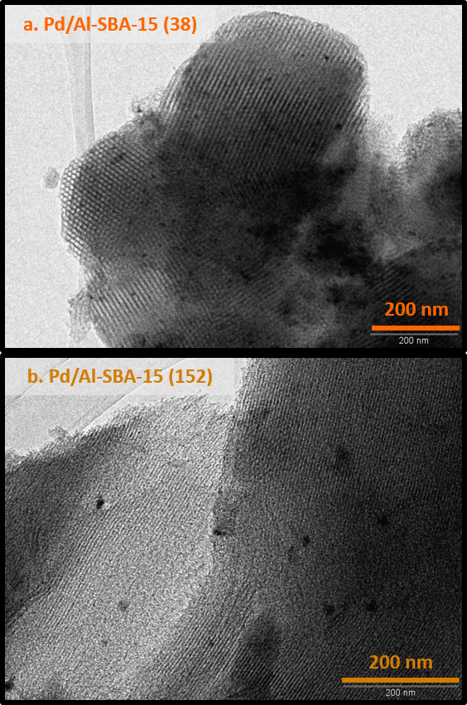

**FIGURE 6**



**FIGURE 7**

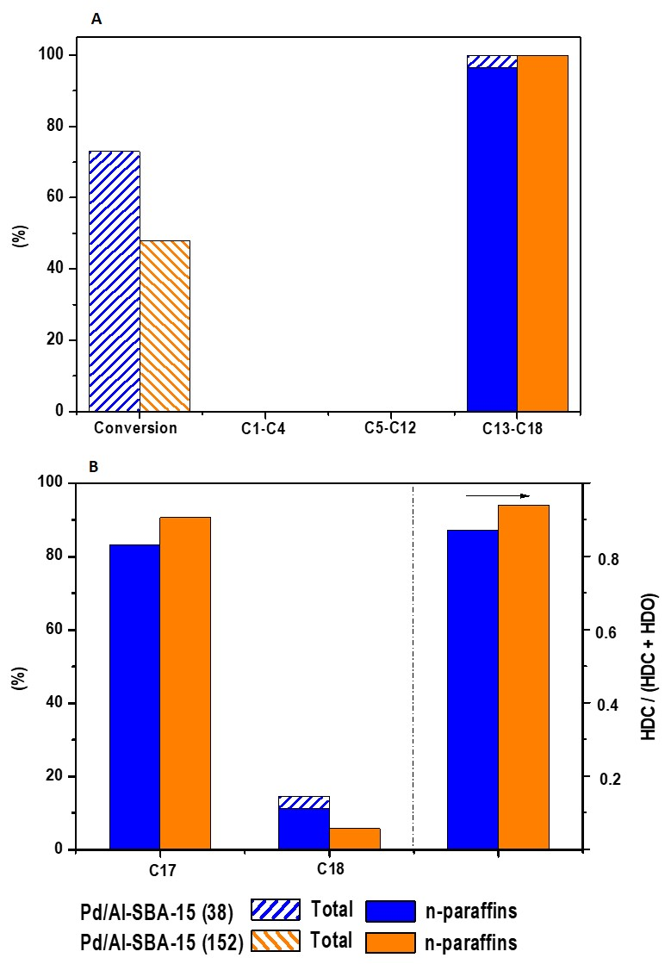

**FIGURE 8**

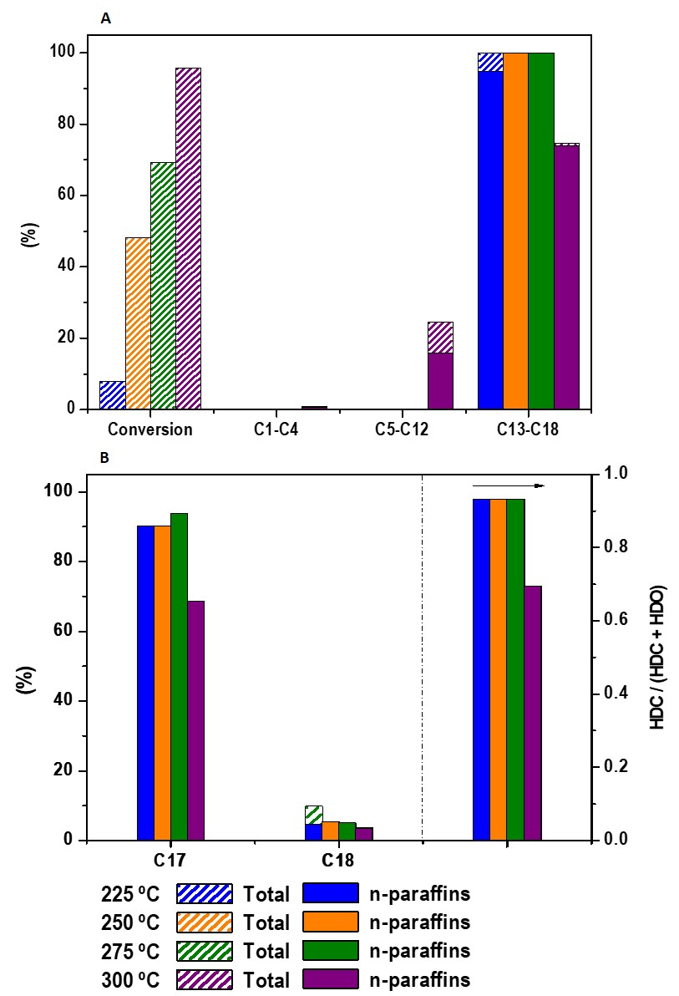

**FIGURE 9**

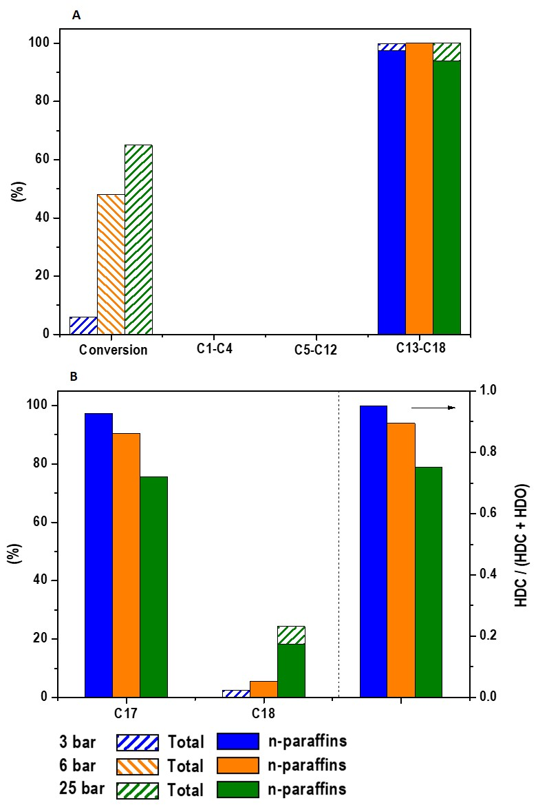

**FIGURE 10**

