Supplementary material

Fibreglass membrane chemically modified with amino-functionalised SBA-15 and its application in solid-phase extraction to determine macrolide antibiotics in eggs

Lorena González-Gómez¹, Sonia Morante-Zarcero¹, Damián Pérez-Quintanilla¹, Gema Paniagua González², Rosa M. Garcinuño², Pilar Fernández Hernando^{2,*}, Isabel Sierra^{1, 3*}

¹Departamento de Tecnología Química y Ambiental, Escuela Superior de Ciencias Experimentales y Tecnología (ESCET), Universidad Rey Juan Carlos, C/Tulipán s/n, 28933 Móstoles, Madrid, Spain.
²Departamento de Ciencias Analíticas, Facultad de Ciencias, Universidad Nacional de Educación a Distancia, Las Rozas, 28232 Madrid, Spain.
³Instituto de Investigación de Tecnologías para la Sostenibilidad. Universidad Rey Juan Carlos

* Corresponding authors:
E-mail address: isabel.sierra@urjc.es (I. Sierra) / pfhernando@ccia.uned.es (P. Fernández Hernando)

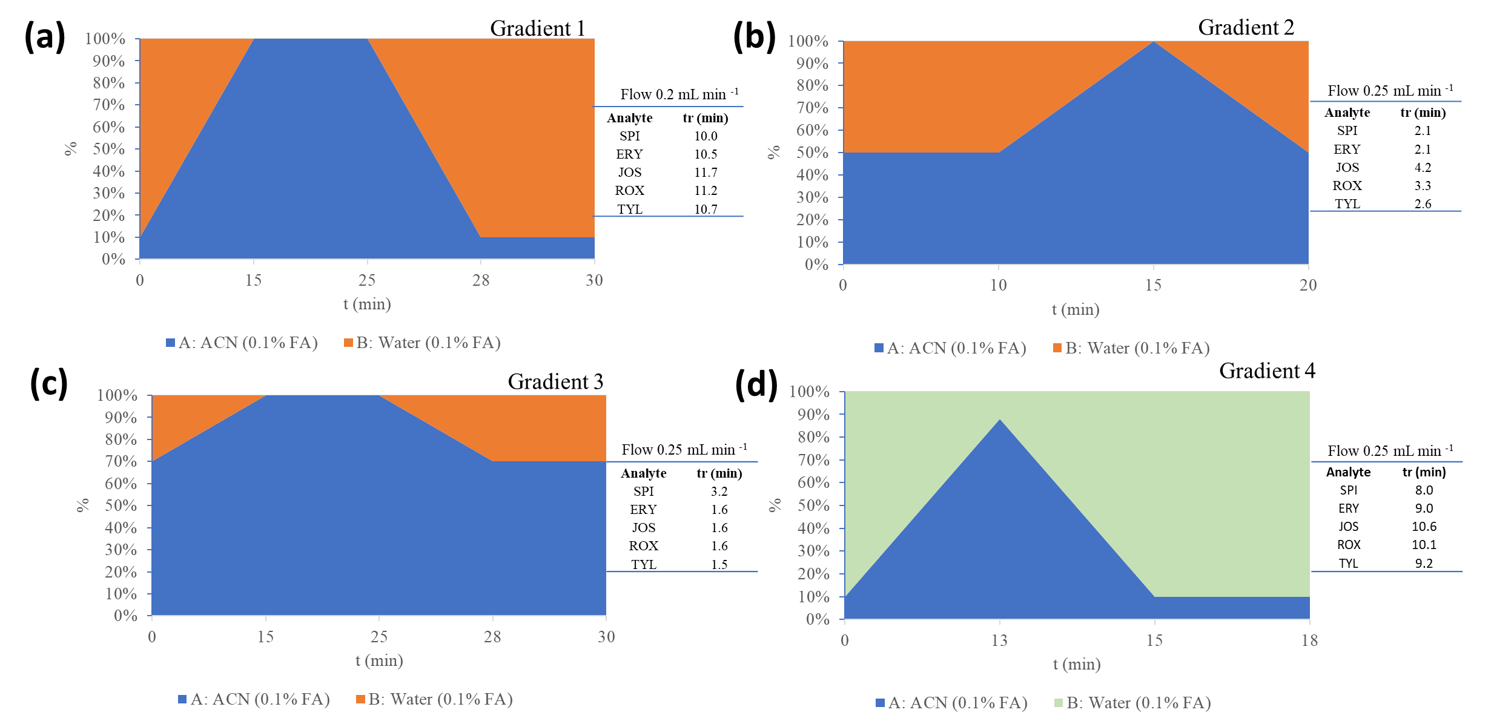
Fig. S1. Different gradients tested during the optimization of the chromatographic method and retention time of the analytes according to the gradient. (a) gradient 1, (b) gradient 2, (c) gradient 3 and (d) gradient 4 (definitive).
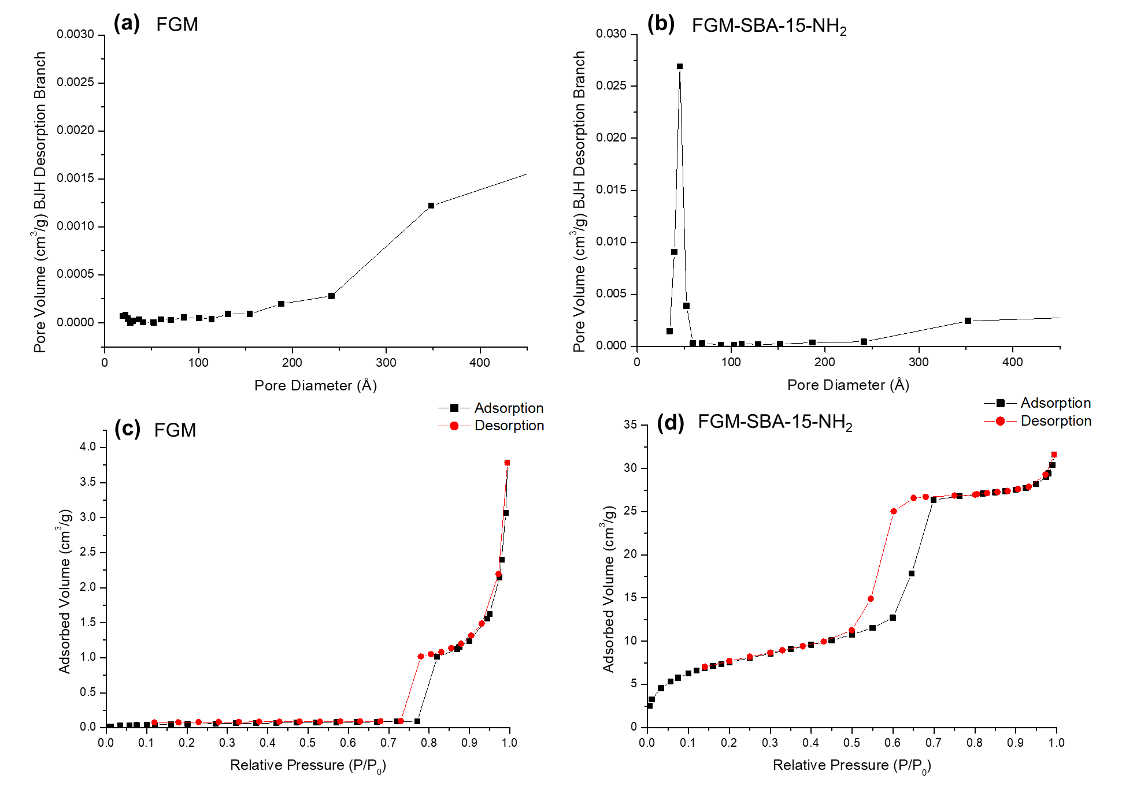
Fig. S2. Pore size distributions and nitrogen adsorption-desorption isotherms of (a, c) FGM (non-functionalised membrane) and (b, d) FGM-SBA-15-NH₂ (functionalised membrane) respectively.
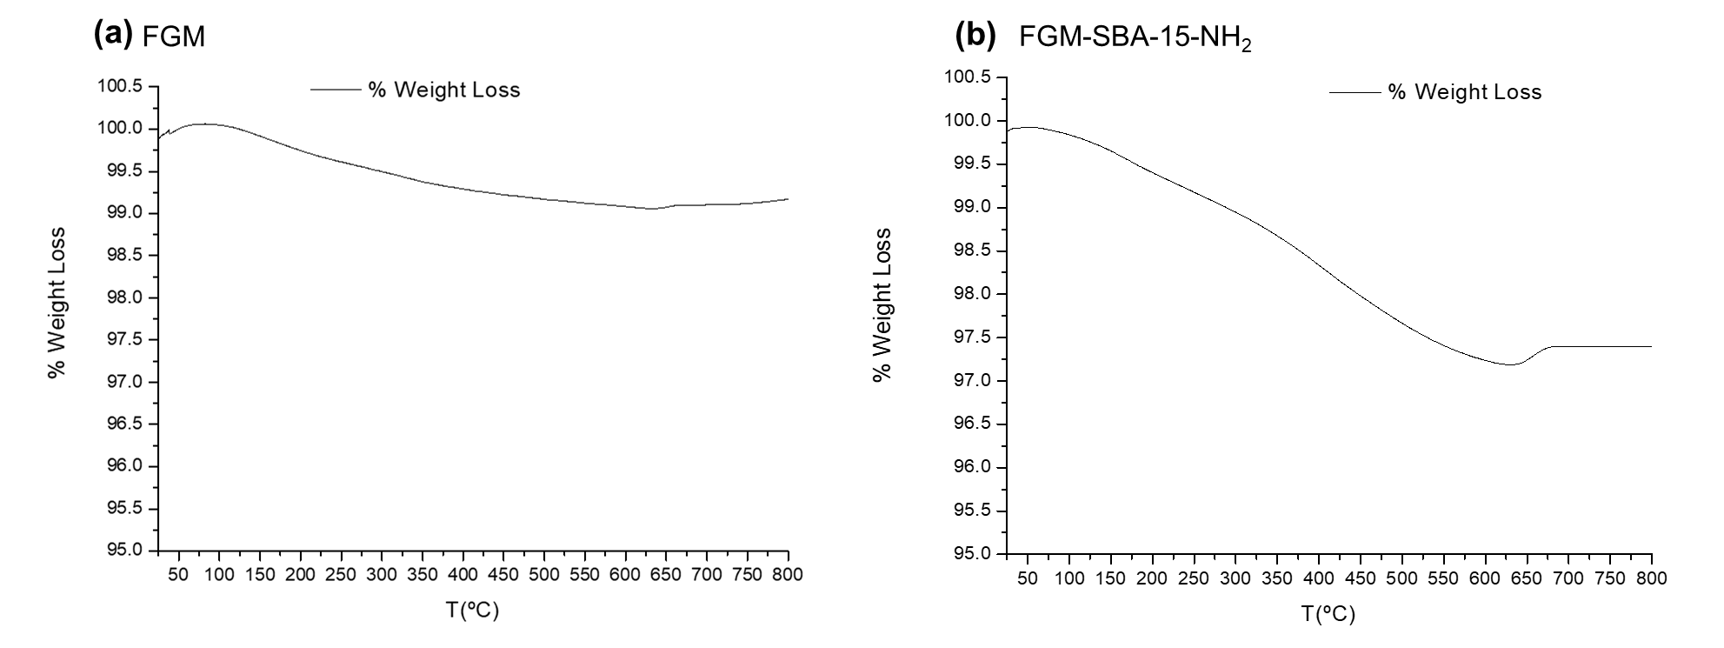
Fig. S3. Thermogravimetric analysis (TGA) of (a) non-functionalised membrane (FGM) and (b) functionalised membrane (FGM-SBA-15-NH₂).

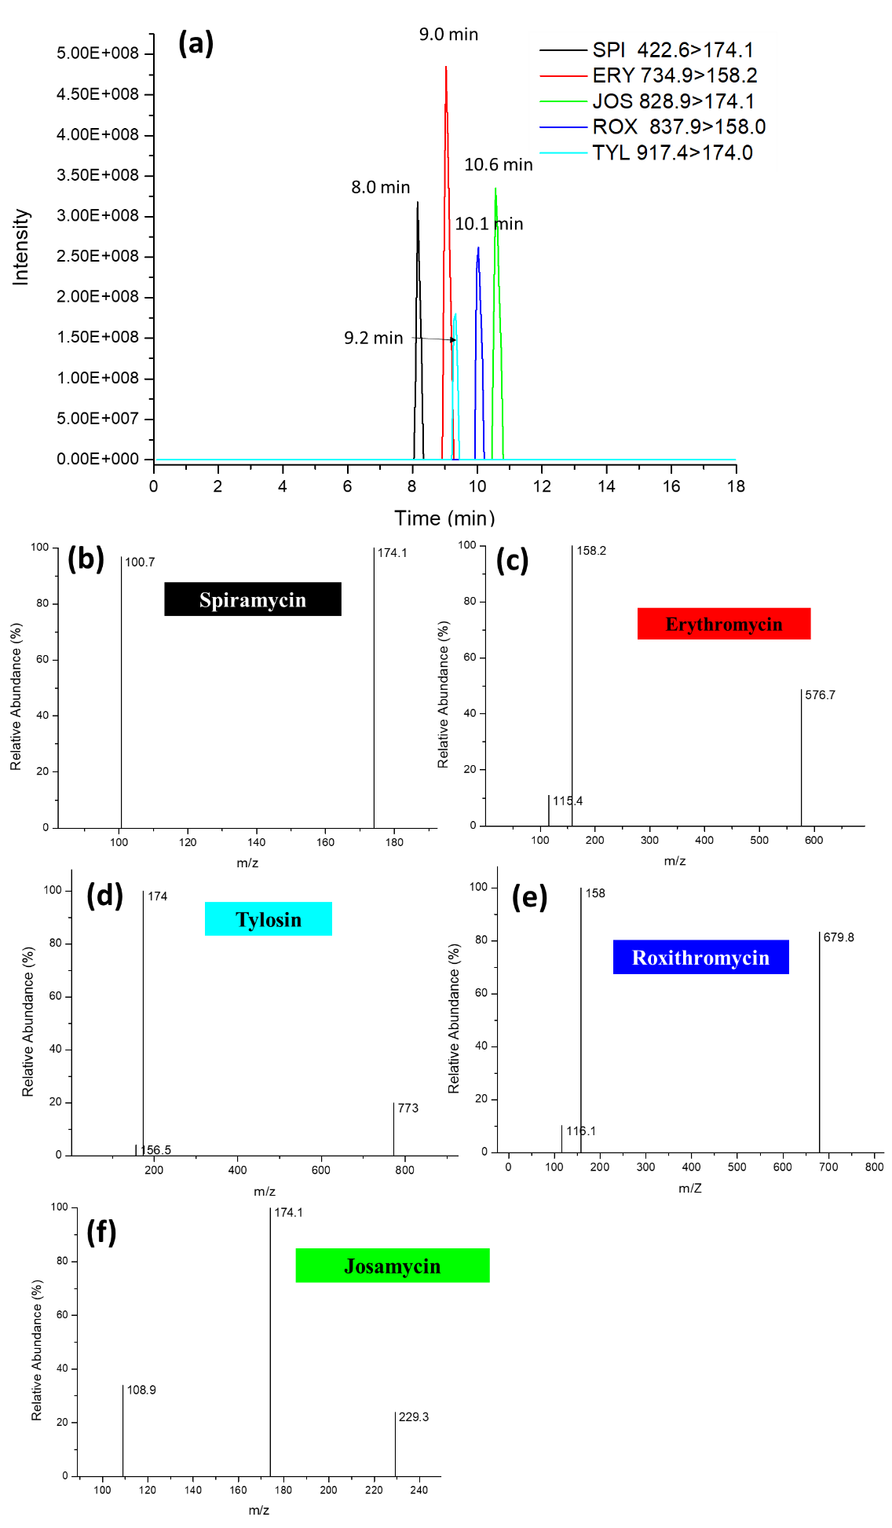
Fig. S4. (a) Extracted ion chromatogram of the five macrolide antibiotics at 150 ng mL⁻¹ with the final chromatographic method and (b, c, d, e, f) mass spectra for each analyte.

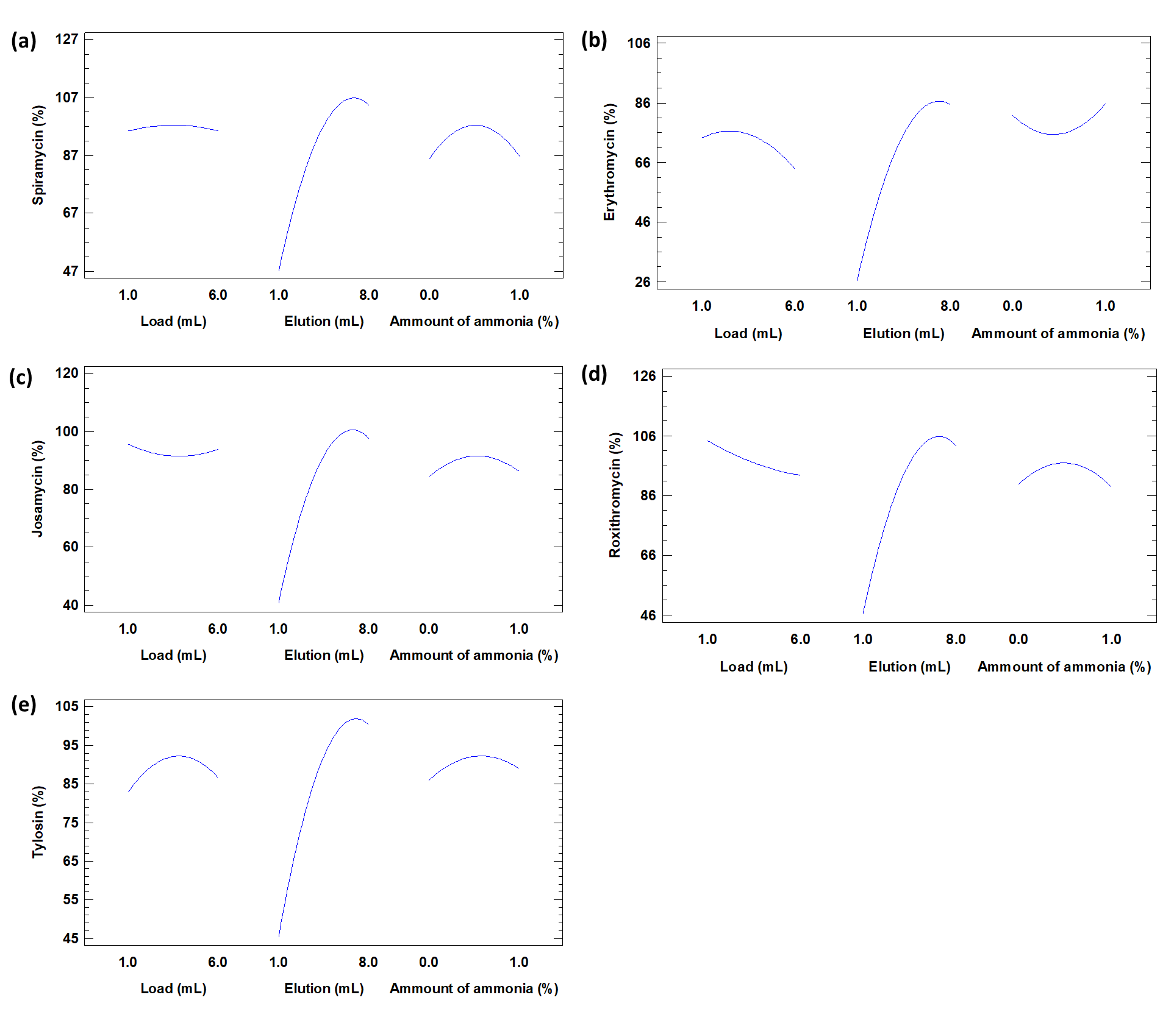
Fig. S5. Main effects plots for (a) spiramycin, (b) erythromycin, (c) josamycin, (d) roxithromycin and (e) tylosin
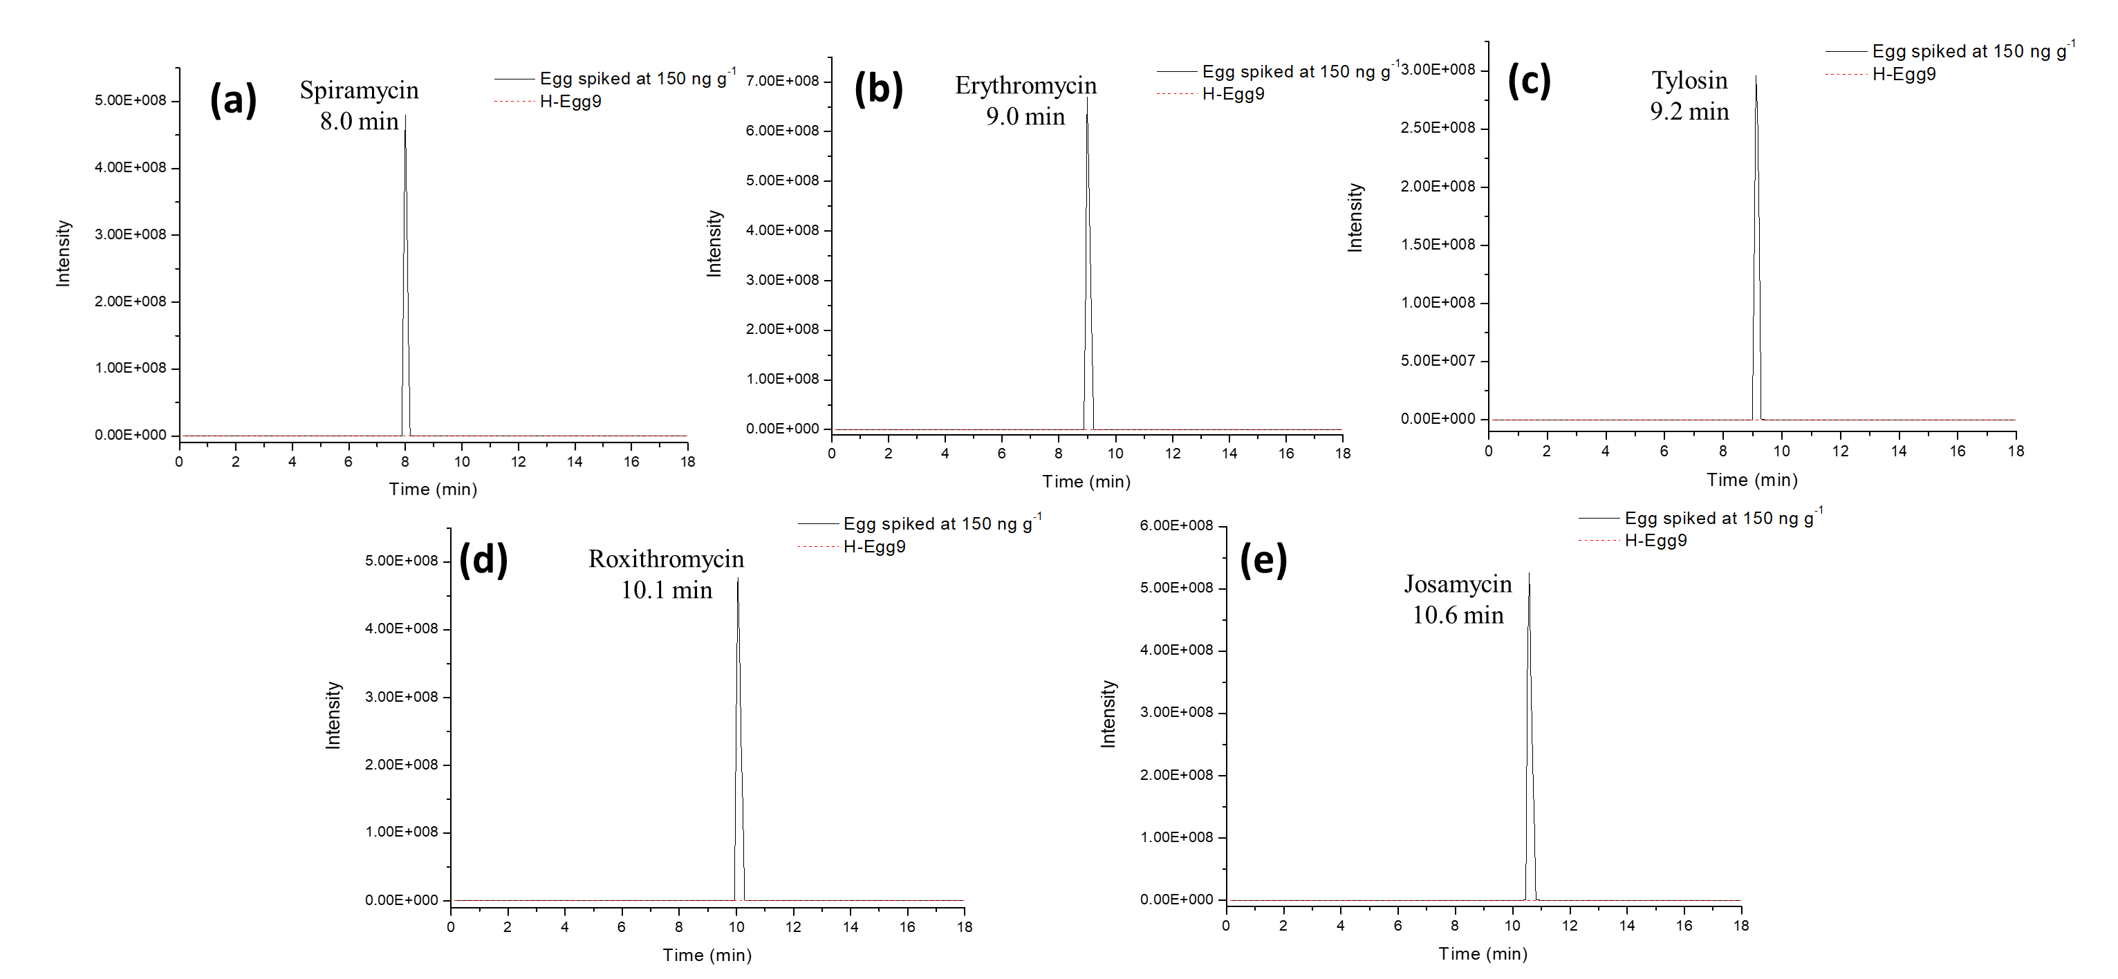
Fig. S6. Extracted ion chromatogram for (a) spiramycin (m/z 422.6 > 174.1), (b) erythromycin (m/z 734.9 > 158.2), (c) tylosin (m/z 917.4 > 174.0), (d) roxithromycin (m/z 837.9 > 158.0) and (e) josamycin (m/z 828.9 > 174.1), of an uncontaminated sample (H-Egg9) compared to a sample doped to 150 ng g⁻¹ for evaluation of the selectivity of the methodology.
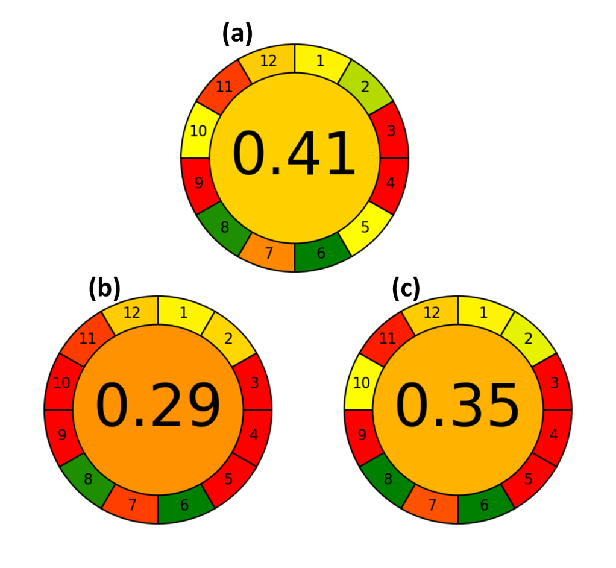
Fig. S7. Evaluation of the greenest profile using the AGREE metric of (a) the proposed methodology based on membrane-SPE compared to (b and c) two similar methodologies that apply SPE with commercial cartridges [9,24].

Table S1
Description of the analysed egg samples
Samples | Animal | Origin | Egg colour | Type of rearing
H-Egg-1 | Hen | Local market | Brown | Barn
H-Egg-2 | Hen | Smallholding | Brown | -
H-Egg-3 | Hen | Local market | Brown | Barn
H-Egg-4 | Hen | Smallholding | Brown | -
H-Egg-5 | Hen | Smallholding | Blue | -
H-Egg-6 | Hen | Smallholding | Brown | -
H-Egg-7 | Hen | Smallholding | Brown | -
H-Egg-8 | Hen | Local market | Brown | Cage
H-Egg-9 | Hen | Local market | Brown | Free range
H-Egg-10 | Hen | Local market | Brown | Cage
Q-Egg1 | Quail | Local market | Brown with spots | Free range
Q-Egg2 | Quail | Local market | Brown with spots | -
Q-Egg3 | Quail | Local market | Brown with spots | Free range
Q-Egg4 | Quail | Local market | Brown with spots | -
- It means that it was not indicated on the label or that it is from a smallholding.

Table S2
Parameters of mass spectrometry analysis in positive ionization mode and retention time with gradient 4.
Analyte | Mw  (g mol⁻¹) | Precursor ions  (Q₁, m/z, [M+H]⁺) | Capillary  (V) | MS² Product Ions  (Q₃, m/z) | CE  (V) | Dwell time  (s) | Retention time (min)
Spiramycin | 842.5 | 422.6 | 60 | 100.7 | 16 | 0.25 | 8.0
 |  |  |  | 174.1* | 20 | 0.25
Erythromycin | 733.9 | 734.9 | 60 | 115.4 | 24 | 0.25 | 9.0
 |  |  |  | 158.2* | 22 | 0.25
 |  |  |  | 576.7 | 14 | 0.25
Josamycin | 827.5 | 828.9 | 60 | 108.9 | 36 | 0.25 | 10.6
 |  |  |  | 174.1* | 24 | 0.25
 |  |  |  | 229.3 | 24 | 0.25
Roxithromycin | 836.5 | 837.9 | 60 | 116.1 | 22 | 0.25 | 10.1
 |  |  |  | 158.0* | 26 | 0.25
 |  |  |  | 679.8 | 12 | 0.25
Tylosin | 915.5 | 917.4 | 60 | 156.5 | 30 | 0.25 | 9.2
 |  |  |  | 174.0* | 30 | 0.25
 |  |  |  | 773.0 | 22 | 0.25
* Quantification ion.

Table S3
Textural properties and functionalization degree of FGM-SBA-15-NH₂ compared with SBA-15.
Material | S_{BET}ª (m² g⁻¹) | Pore volume^{b} (cm³ g⁻¹) | Pore size^{c} (Å) | L₀^{d} (mmol ligand g⁻¹) | g SBA-15-NH₂ g⁻¹ FGM
FGM-SBA-15-NH₂ | 28 | 0.045 | 45 | - | 0.17
FGM | 2 | 0.003 | NMe | - | -
SBA-15-NH₂ | 363 | 0.46 | 47 | 1.7 | -
SBA-15 | 999 | 1 | 56 | - | -
ª S_{BET}: Specific surface area calculated by Brunauer-Emmett-Teller (BET) method. ^{b} Pore volume: Total pore volume was measured at relative P/P₀=0.97. ^{c} Pore size: Pore diameter estimated by Barret-Joyner-Halenda (BJH) model applied in the desorption branch. ^{d} L₀: Functionalization degree estimated by elemental analysis. ^{e} NM: Not mesurable.

Table S4
Preliminary studies to evaluate the loading solvent at 250 ng mL⁻¹ using a peristaltic pump and tygon tubing for the dosing of solvents in the membrane-SPE protocol.
 | Recovery (% ± SD)*
Load solvent (3 mL) |  | Spiramycin | Erythromycin | Josamycin | Roxithromycin | Tylosin
ACN |  | 16 ± 2 | 9 ± 13 | 8 ± 10 | 17 ± 2 | 9 ± 12
Milli-Q H₂O |  | 41 ± 16 | 50 ± 7 | 68 ± 15 | 59 ± 9 | 60 ± 9
Milli-Q H₂O with formic acid (0.1 %, v/v) |  | 18 ± 2 | 6 ± 6 | 34 ± 14 | 34 ± 22 | 34 ± 9
* Elution with 3 mL of MeOH. n = 3

Table S5
Preliminary studies to evaluate the loading solvent at 100 ng mL⁻¹ using a Scharlab ExtraVac® vacuum manifold for the dosing of solvents in the membrane-SPE protocol.
 | Recovery (% ± SD)
Load solvent (3 mL) |  | Spiramycin | Erythromycin | Josamycin | Roxithromycin | Tylosin
ACN |  | 44 ± 11 | 18 ± 7 | 21 ± 10 | 30 ± 12 | 19 ± 10
Milli-Q H₂O |  | 51 ± 6 | 76 ± 12 | 83 ± 8 | 87 ± 3 | 89 ± 12
Milli-Q H₂O with formic acid (0.1 %, v/v) |  | 39 ± 17 | 6 ± 1 | 94 ± 7 | 81 ± 5 | 98 ± 5
Milli-Q H₂O /ACN (90/10, v/v) |  | 24 ± 6 | 17 ± 1 | 47 ± 1 | 34 ± 1 | 28 ± 4
Milli-Q H₂O /EtOH (90/10, v/v) |  | 55 ± 1 | 40 ± 2 | 109 ± 1 | 87 ± 9 | 83 ± 7
* Elution 3x3 mL of MeOH. n = 3

Table S6
Preliminary studies to evaluate the elution solvent at 100 ng mL⁻¹ using a Scharlab ExtraVac® vacuum manifold for the dosing of solvents in the membrane-SPE protocol.
 | Recovery (% ± SD)
Elution Solvent |  | Spiramycin | Erythromycin | Josamycin | Roxithromycin | Tylosin
3x3 mL MeOH |  | 51 ± 6 | 76 ± 12 | 83 ± 8 | 87 ± 3 | 89 ± 12
3 mL MeOH + 3 mL MeOH with HAc (1%, v/v) + 3 mL MeOH |  | 6 ± 1 | 124 ± 8 | 113 ± 1 | 114 ± 13 | 118 ± 6
3 mL MeOH + 2 x 3 mL ACN |  | 16 ± 11 | 88 ± 7 | 82 ± 8 | 86 ± 11 | 100 ± 1
3 mL MeOH + 2 x 3 mL MeOH with ammonia solution (1 %, v/v) |  | 102 ± 13 | 99 ± 1 | 93 ± 5 | 89 ± 1 | 94 ± 3
*Load in water (3 mL). n = 3

Table S7
ANOVA report and mathematical equations of response surface quadratic models of SLE-membrane-SPE protocol for macrolides antibiotics during Box-Behnken analysis.
Variableª | Spiramycin recovery (%) |  | Erythromycin recovery (%) |  | Josamycin recovery (%) |  | Roxithromycin recovery (%) |  | Tylosin recovery (%)
 | Regression coefficient | p -value | Regression coefficient | p -value | Regression coefficient | p -value | Regression coefficient | p -value | Regression coefficient | p-value
A | 1.5470 | 0.9964 | 4.4586 | 0.0640 | -6.3999 | 0.7698 | -4.2309 | 0.1565 | 5.7887 | 0.5363
B | 23.1942 | 0.0003* | 20.4863 | 0.0000* | 22.9592 | 0.0000* | 24.1015 | 0.0001* | 18.9003 | 0.0000*
C | 75.7875 | 0.9230 | -40.9711 | 0.3928 | 42.9485 | 0.7386 | 54.7368 | 0.8997 | 25.7430 | 0.5876
AA | -0.3249 | 0.7309 | -1.0318 | 0.0724 | 0.5188 | 0.3998 | 0.2623 | 0.7403 | -1.1889 | 0.0866
AB | 0.7008 | 0.2985 | 0.2234 | 0.5270 | 0.7489 | 0.1019 | 0.4539 | 0.4141 | 0.8805 | 0.0690
AC | -4.8356 | 0.2463 | -0.6185 | 0.7722 | -1.8827 | 0.4651 | -3.9568 | 0.2574 | -1.3615 | 0.6047
BB | -1.7739 | 0.0057* | -1.5989 | 0.0003* | -1.8822 | 0.0004* | -1.8216 | 0.0019* | -1.5783 | 0.0011*
BC | -2.9976 | 0.3107 | 3.0925 | 0.0743 | -2.1197 | 0.2649 | -2.5127 | 0.3103 | 0.1669 | 0.9289
CC | -44.5822 | 0.5397 | 33.0881 | 0.4033 | -25.0710 | 0.5875 | -30.4807 | 0.6150 | -18.7771 | 0.6920
R² | 0.9139 |  | 0.9684 |  | 0.9607 |  | 0.9357 |  | 0.9512
R² _{Adj.} | 0.8033 |  | 0.9279 |  | 0.9102 |  | 0.8529 |  | 0.8884
Equations | y = 4.99 + 1.54A + 23.19B + 75.78C – 0.32A² + 0.70AB – 4.84AC – 1.77B² – 2.99BC – 44.58C² |  | y = 15.58 + 4.46A + 20.49B – 40.97C – 1.03A² + 0.22AB – 0.62AC – 1.59B² + 3.09BC + 33.09C² |  | y = 22.23 – 6.39A + 22.95B + 42.95C + 0.52A² + 0.75AB – 1.88AC – 1.88B² – 2.12BC – 25.07C² |  | y = 22.64 - 4.23A + 24.10B + 54.74C + 0.26A²+ 0.45AB -3.96AC– 1.82B² – 2.51BC –30.48C² |  | y = 13.38 + 5.79A + 18.90B + 25.74C – 1.19A² + 0.88AB – 1.36AC – 1.58B² + 0.167BC – 18.78C²
ª A: Load Volume; B: Elution Volume; C: Amount of ammonia
y= represents the response (recovery)
*significant p < 0.05.
Table S8
Instrumental validation parameters of the HPLC/MS-MS
Parameters | Level | Spiramycin | Erythromycin | Josamycin | Roxithromycin | Tylosin
Linear range (ng mL⁻¹) |  | 5-500 | 1-500 | 1-500 | 1-500 | 5-500
Linearity |  | 1.5·10⁵x - 6.2·10⁴ | 3.2·10⁵x + 1.6·10⁶ | 2.9·10⁵x + 2.7·10⁶ | 2.5·10⁵x + 1.7·10⁶ | 1.7·10⁵x + 1.8·10⁶
R² |  | 1.000 | 0.998 | 0.995 | 0.996 | 0.998
LODª (ng mL⁻¹) |  | 1.0 | 0.5 | 0.4 | 0.4 | 0.3
LOQ^{b} (ng mL⁻¹) |  | 2.6 | 1.6 | 1.2 | 1.4 | 1.1
Repeatability, RSD%  (Intra-day, n=6) | 1 ng mL⁻¹ | 4 | 6 | 9 | 3 | 11
 | 150 ng mL⁻¹ | 7 | 5 | 4 | 4 | 4
 | 500 ng mL⁻¹ | 3 | 3 | 3 | 2 | 2
Within-laboratory reproducibility, RSD%  (Inter-day, n=9) | 1 ng mL⁻¹ | 8 | 12 | 12 | 8 | 9
 | 150 ng mL⁻¹ | 6 | 10 | 14 | 12 | 8
 | 500 ng mL⁻¹ | 8 | 9 | 16 | 15 | 16
ª Limit of detection. ^{b} Limit of quantification.

Table S9
Reproducibility studies of the FGM-SBA-15-NH₂ using standard solutions at 100 ng mL⁻¹ and egg samples doped at 150 ng g⁻¹.

 | Standard solutions at 100 ng mL⁻¹ (Recovery, % ± SD), n = 3ª
Batch | Spiramycin | Erythromycin | Josamycin | Roxithromycin | Tylosin
M1 | 75 ± 6 | 104 ± 8 | 96 ± 1 | 94 ± 1 | 96 ± 2
M2 | 102 ± 13 | 99 ± 1 | 93 ± 5 | 89 ± 1 | 94 ± 3
M3 | 69 ± 6 | 92 ± 16 | 86 ± 16 | 80 ± 13 | 82 ± 16
M4 | 87 ± 16 | 98 ± 11 | 95 ± 8 | 92 ± 6 | 96 ± 11
M5 | 73 ± 13 | 83 ± 9 | 88 ± 16 | 81 ± 17 | 91± 11
M6 | 71 ± 9 | 92 ± 9 | 92 ± 7 | 81 ± 5 | 90± 10
 ± SD | 80 ± 13 | 95 ± 7 | 92 ± 4 | 86 ± 6 | 92 ± 5
%RSD | 16 | 8 | 4 | 7 | 6
 | Egg spiked at 150 ng g⁻¹ (Recovery, % ± SD), n = 3^{b}
Batch | Spiramycin | Erythromycin | Josamycin | Roxithromycin | Tylosin
M2 | 96 ± 2 | 78 ± 8 | 95 ± 6 | 93 ± 5 | 83 ± 2
M3 | 99 ± 3 | 92 ± 5 | 96 ± 6 | 99 ± 1 | 97 ± 3
 ± SD | 98 ± 2 | 85 ± 10 | 96 ± 1 | 96 ± 5 | 90 ± 10
%RSD | 2 | 12 | 1 | 5 | 11
ªMembrane-SPE (Activation: 3 mL MeOH with 1 % ammonia solution; conditioned: 2 x 3 mL water; load: 3 mL of standard solution (100 ng mL⁻¹) containing the 5 macrolides; elution: 3 mL MeOH and 2 x 3 mL MeOH (1 % ammonia solution))
ªSLE-membrane-SPE protocol definitive for egg samples explained in section 2.6.

Table S10
Content of macrolide antibiotics in different egg samples obtained with SLE-membrane-SPE protocol validated.
Samples | Animal | Spiramycin  (ng g⁻¹) | Erythromycin  (ng g⁻¹) | Josamycin  (ng g⁻¹) | Roxithromycin  (ng g⁻¹) | Tylosin  (ng g⁻¹)
H-Egg-1 | Hen | MDL-MQL | ND | ND | ND | ND
H-Egg-2 | Hen | ND | ND | ND | ND | ND
H-Egg-3 | Hen | ND | ND | ND | ND | ND
H-Egg-4 | Hen | ND | ND | ND | ND | ND
H-Egg-5 | Hen | ND | ND | ND | ND | ND
H-Egg-6 | Hen | ND | ND | ND | ND | ND
H-Egg-7 | Hen | ND | ND | ND | ND | ND
H-Egg-8 | Hen | ND | ND | ND | ND | ND
H-Egg-9 | Hen | ND | ND | ND | ND | ND
H-Egg-10 | Hen | ND | ND | ND | ND | ND
Q-Egg1 | Quail | ND | ND | MDL-MQL | MDL-MQL | ND
Q-Egg2 | Quail | ND | ND | ND | ND | ND
Q-Egg3 | Quail | ND | ND | ND | ND | ND
Q-Egg4 | Quail | ND | ND | ND | ND | ND
MDL-MQL: Between the limit of quantification and detection of the method
MDL/MQL for Spiramycin: 0.6/2.1 ng g⁻¹
MDL/MQL for Josamycin and Roxitromycin: 0.3/1.1 ng g⁻¹
ND: Not detected

Table S11
Comparison of proposed methodology with other approaches based on SLE or SLE-SPE for macrolide analysis in egg samples.
Analytes | SLE | SPE | Analytical technique | Recovery for macrolides (%) | MDL (μg kg⁻¹)  MQL (μg kg⁻¹) | [Ref.]
SPI, ERY, TYL, TIL and oleandomycin | Egg (5 g), ACN (3 mL), vortex (15 s), ACN (9 mL), stirring (15 min) centrifugation (15 min), 2 g NaCl, hexane (10 mL), stirring (15 min) centrifugation (15 min), evaporation (only ACN) and reconstitution (7 mL) | OASIS® HLB Plus (225 mg)  Load: extract (7 mL)  Elution: MeOH (95 % v/v) (5 mL) | HPLC-MS/MS | 95-98 % | 0.1-0.9  Not shown | [9]
ERY, TYL, CLA, polyether ionophores and lincomycin | Egg (2 g), ACN (4 mL x 2), vortex (15 s), stirring (30 min) centrifugation (5 min, 4 ºC) evaporation (only 250 µL) and reconstitution (1 mL) | - | HPLC-MS/MS | 79-168% | 0.09-0.16  0.29-0.53 | [6]
ERY, TIL, TYL, JOS and 25 veterinary drugs | Egg (1 g), ACN (10 mL), citrid acid 0.5 M (1 mL) and Na₂EDTA 0.1 M (0.5 mL), vortex (1 min) | OASIS® HLB (200 mg) as clean up  Load: extract (11.5 mL)  Elution: Collect the extract only (11.5 mL) | UHPLC-MS/MS | 75-97% (at 100 μg kg⁻¹) | Not shown  1.5-5.0 | [19]
120 antibiotics including 18 macrolides | Egg (2 g), ACN:H₂O (90:10  v/v) (10 mL), UAE (10 min),  centrifugation (10 min), evaporation  to 1 mL remained, dilution and  vortex (2 min), centrifugation (10  min) | OASIS HLB® (500 mg)  Load: extract (6 mL)  Elution: FA:MeOH (5/95, v/v) (5 mL) and ethyl acetate (5 mL) | LC-MS/MS | Not shown | 0.5-3.0  1.5-10.0 | [24]
Gamithromycin | Egg (2 g), ACN (20 mL) and  Na₂SO₄ (2 g), centrifugation (5 min) | OASIS® MCX (60 mg)  Load: extract (5 mL)  Elution: 5% ammoniated ACN (3 mL) | UHPLC-MS/MS | 96 % (at 10 μg kg⁻¹) | 0.30–0.40  0.80 – 1.0 | [19]
TIL, JOS, Kitasamycin, AZI and other veterinary drugs | Egg (5 g), Na₂EDTA (0.1 mM) (5 mL), 1% HAc in ACN (20 mL), vortex (1 min) and salts (Na₂SO₄, 4 g and NaCl, 1 g), vortex (1 min), centrifugation | Silanized melamine sponge into a 2.5-mL syringe barrel  Load: Extract (1 mL)  Elution: MeOH-H₂O solvents (50/50, v/v) (1 mL) | UPLC-MS/MS | 78-90 % (at 100 μg kg⁻¹) | 0.2-2  0.5-5.9 | [8]
SPI, ERY  JOS, ROX,  TYL | Egg (1 g), ACN (2.5 mL) and MgSO₄ (0.1 g), stirring (5 min), centrifugation, evaporation and reconstitution | FGM-SBA-15-NH₂  Load: Extract (4 mL)  Elution: MeOH (0.5 % ammonia) (3 x 2.5 mL) | LC-MS/MS | 85-92 % (at 150 μg kg⁻¹) | 0.3-0.6  1.1-2.1 | This work
Abbreviations: ACN: Acetonitrile; ACE, Acetylspyramycin; AZI: Azithromycin; CLA: Clarithromycin; FA: Formic acid; HAc: Acetic Acid; ERY: Erythromycin; MeOH: Methanol; MDL: method detection limit; MQL: method quantification limit; MSPD: Solid phase matrix dispersion; QuEChERS: Quick, Easy, Cheap, Effective, Rugged & Safe; ROX: Roxithromycin; SLE: Solid-liquid extraction; SPE: Solid-liquid extraction; SPI: Spyramycin; TIL: Tilmicosin; TYL: tylosin,

