**Effect of the dual incorporation of fullerene and polyethyleneimine moieties in SBA-15 materials as platforms for drug delivery**

V. Morales, A. Martín, J. Ortiz-Bustos, R. Sanz* and R.A. García-Muñoz*

Department of Chemical and Environmental Technology, Universidad Rey Juan Carlos,

C/ Tulipán s/n, 28933 Móstoles, Madrid, Spain

* corresponding authors : [rafael.garcia@urjc.es](mailto:rafael.garcia@urjc.es), raul.sanz@urjc.es

**Abstract**

Mesostructured SBA-15 silica materials have been successfully dual functionalized with polyethyleneimine (PEI) groups and C60 fullerene moieties to allow an evaluation of their properties as nanovehicles for controlled drug delivery. Methylprednisolone sodium succinate was selected as a model drug for adsorption on the surface of functionalized SBA-15 silica materials. The resulting dual-functionalized SBA-15 silica materials exhibit mesoscopic arrangements, although with a remarkable reduction in their textural properties as compared with pure silica SBA-15.

The adsorption capacity of methylprednisolone on functionalized SBA-15-PEI improved remarkably compared with that of raw SBA-15, while the drug release rate slowed, as the amount of PEI anchored in the SBA-15 increased. The strong attractive electrostatic interactions between methylprednisolone and the silica surfaces of SBA-15-PEI materials, measured by zeta potential, accounts for these results. In a second step, wherein C60 fullerene species in combination with PEI were grafted to the silica, the results establish that the steric effects and hydrophobicity of the C60 moieties hinder methylprednisolone transport within the silica pores.

The kinetic parameters obtained from the drug release profiles, fitted to four kinetic models, show that the incorporation of C60 species yields lower methylprednisolone release rates from SBA-15-PEI-C60 materials than from SBA-15-PEI materials. Additionally, the incorporation of fullerene groups onto PEI-modified materials provides an increment on cell viability. Confocal microscopy evidences the cellular internalization of the dual-functionalized mesoporous SBA-15 materials inside the plasmatic membrane.

**Keywords:** SBA-15, polyethyleneimine, C60 fullerene moieties, methylprednisolone sodium succinate, drug delivery systems.

**1. Introduction**

In the past two decades, mesoporous silica materials have been widely used as carrier systems for drug delivery [1]. Their advantageous properties, such as large surface areas and narrow pore size distributions, high biocompatibility, and easy surface modification, make them ideal supports in this role [2–4]. In particular, the facile functionalization of the silica surface leads to the synthesis of materials with diverse surface chemistries, allowing ready adaptation of particles for specific applications [5–9]. Adsorption and release of drugs is based on physical drug–silica support interactions. In most cases, the adsorption of drugs to mesoporous silica surfaces includes hydrophobic, hydrogen-bonding, electrostatic, or covalent interactions between drugs and functionalities at the silica surface [10].

In particular, the modification of mesoporous silica surfaces with amino groups as a result of electrostatic interactions with water-soluble drugs has proved especially promising in better controlling the release of pharmaceutical moieties [11–12]. Thus, previous works [13–14] have demonstrated a high affinity between amino groups (positive charged) and the water-soluble drug methylprednisolone sodium succinate (negative charged). This glucocorticoid (Figure 1) has been chosen in this work as a representative drug with immunosuppressive and anti-inflammatory effects. This molecule also possesses hydrophilic features and therefore, high solubility in water. Its administration relieves inflammation, and it is prescribed to treat a number of different illnesses and health concerns, including arthritis, sinusitis and cancer.

The functionalization procedure followed to incorporate amino groups onto the inorganic silica framework has proven to be a determinant in the adsorption of the drug and its subsequent release [15]. Several works have demonstrated that the adsorption capacities and release behaviours of model drugs are highly dependent on functionalization route [14, 16–17]. These investigations have concluded that slower drug delivery rates are associated with the incorporation of amino groups by grafting methods.

Amino groups can be introduced into the silica surface, among others methods, by grafting [18], co-condensation [19], impregnation [20], or a hyperbranching procedure [21]. Specifically, the acid-catalysed hyperbranching polymerization route generates great amount of amino groups in the surface of mesoporous materials, promoting the development of surface polyethyleneimine (PEI) [22]. In this approach, polymerization from the surface silanol groups occurs, utilizing aziridine as a monomer. This compound is extremely reactive and small, which is a very good option for inner pores functionalization through polymerization [12, 23]. However, certain drawbacks are associated with the use of PEI for biomedical applications, as studies have shown that PEI is cytotoxic at low to medium molecular weight and presents poor biocompatibility [24–27]. Polyethyleneimine toxicity mainly derives from its cationic nature and non-cleavable molecular structure, which restrict its biomedical applications [28].

A possible alternative allowing for a reduction in PEI toxicity is the combination of its amino groups with other more biocompatible compounds. Several examples, mainly using polymeric moieties, can be found in the literature: Zhang et al. [29] have synthesized an arginine--PEI-conjugated chitosan copolymer for DNA delivery and concluded that the combination of chitosan with PEI significantly reduced the cytotoxicity of the sample. Likewise, Wong et al. [30] reported the synthesis of PEI-chitosan materials via cationic polymerization of aziridine in the presence of chitosan. Chitosan derivatives modified by PEI materials have a good DNA binding capacity and low cytotoxicity. Uritu et al. [31] have reported dendrimeric structures with cores comprising fullerenes and with linear or branched polyethyleneimine and polyethyleneglycol arms that act as effective binders of double-stranded DNA, and they have concluded that these polymeric conjugates are non-cytotoxic.

Fullerenes (C60) are a group of compounds that have attracted interest because of their technical and potentially medical applications [32–35]. C60 consists of 60 carbon atoms with C5–C5 single bonds that form 12 pentagons and C5–C6 double bonds that form 20 hexagons [36]. The incorporation of these hydrophobic and bulky molecules into drug delivery systems is expected to produce steric and hydrophobic interactions that could reduce drug release rates. High loadings of C60 have been incorporated into MCM-41 [37] and SBA-15 [10] via modification of the silica surface with amino groups.

The objective of this paper was to modify the surface of SBA-15 silica materials with two different functionalities with the purpose of allowing their use as nanovehicles to better control the release of the pharmaceutical guest species. In a first step, mesostructured silica SBA-15 materials have been functionalized with polyethyleneimine via a hyperbranching technique. Next and with the aim of exerting more control over the drug release, PEI-functionalized silicas have been modified with bulky C60 fullerene moieties. As a glucocorticoid model drug, water-soluble methylprednisolone sodium succinate was selected for loading onto dual-functionalized silica materials. The amounts of PEI, C60 fullerenes, and methylprednisolone species incorporated into the silica hosts were determined from elemental analysis and thermogravimetry.

The characterization of materials was achieved from N2 adsorption analyses, powder X-ray diffraction (XRD) patterns, and transmission electron microscopy (TEM). Zeta potential values for dual-functionalized materials were acquired to establish a relationship of the methylprednisolone guest amounts with the PEI and C60 fullerene functionalities anchoring to the silica matrix. The *in vitro* release was accomplished in a body simulating aqueous biological media. Additionally, the kinetic of the methylprednisolone release from these host dual-functionalized silica materials was also modelled. Finally, the cellular viability and the cellular uptake efficiency of the synthesized samples were evaluated using breast cancer cells MDA-MB-231 through a WST-1 essay and fluorescence confocal microscopy, respectively.

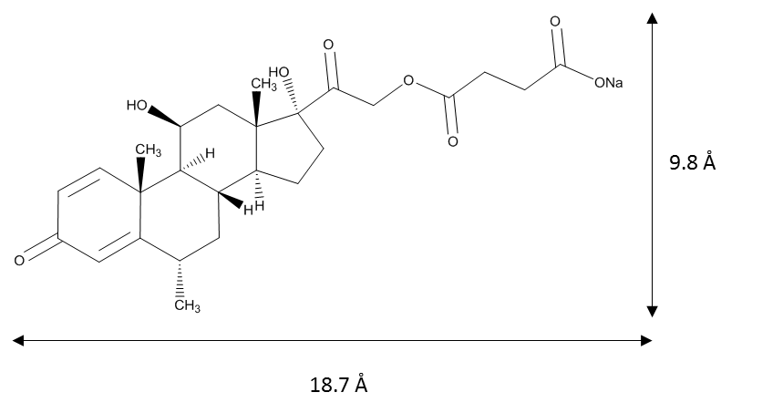

**Figure 1.** Chemical structure of the methylprednisolone sodium succinate corticoid.

**2. Experimental**

**2.1 Synthesis of pure silica SBA-15 support and functionalized mesoporous materials**

SBA-15 material was synthesized according to the route reported by Zhao et al. [38], using Pluronic 123 triblock polymer as a structure-directing agent and tetraethyl orthosilicate (TEOS) as a silica source. The molar composition of the synthesis gel was TEOS/HCl/P123/H2O = 1:6.03:0.017:145. The mixture was magnetically stirred stirred at 40 °C for 20 h, aged at 100 °C for 24 h, filtered, washed with deionized water, dried at 60 °C overnight, and finally calcined at 550 °C for 5 h (heating ramp 1.8 °C min−1) to remove the organic template.

Before PEI incorporation, with the main of increasing the number of surface silanol groups, SBA-15 silica material was rehydroxilated. Thus, 2 g of pure silica SBA-15 material were refluxed in 250 mL of hydrochloric acid (18.5% w/w) for 12 h. For PEI incorporation, 1.5 g of rehydroxilated SBA-15 silica were dispersed in 40 mL of anhydrous toluene under a nitrogen atmosphere. Then, 750 µL of aziridine and 75 µL of acetic acid or 1000 µL of aziridine and 100 µL of acetic acid were added to the mixture. In this reaction, aziridine was used as a monomer for polymerization, and acetic acid acted as a catalyst. The mixture was stirred at 75 °C for 15 h. Finally, the materials were filtered and washed with toluene and methanol. The obtained samples were named SBA-15-PEI-1 for the sample with the lowest aziridine and acetic acid volumes and SBA-15-PEI-2 for the sample with the largest volumes.

Fullerene groups were incorporated to the polyethyleneimine-SBA-15 sample following a two-step procedure. First, a solution containing the fulleride anion [C60]− was prepared by mixing 0.086 g C60 fullerene with 0.261 g tetrahexylammonium bromide in 32 mL of anhydrous tetrahydrofuran and 2−3 drops of mercury. The mixture was heated at 80 °C in an inert atmosphere for 3 h, after which the mixture became dark red in colour, characteristic of C60 radical ions. In the second step, 0.4 mg of SBA-15-PEI-1 or SBA-15-PEI-2 were added to the C60 radical ions solution. This solution was stirred for 20 h under an inert atmosphere. The solid product was then filtered and washed with toluene and acetone to extract unreacted C60 radical ions. The obtained samples (Figure 2) were named SBA-15-PEI-1-C60 and SBA-15-PEI-2-C60.



**Figure 2.** Scheme of synthesized dual-functionalized silica materials.

**2.2 Drug loading**

Methylprednisolone sodium succinate was loaded into the functionalized mesoporous materials by the solvent adsorption method from a drug solution. Pure silica SBA-15 or the functionalized materials (0.1 g) were added to a solution of methylprednisolone sodium succinate (150 mg) in water (10 mL). This suspension was stirred at 260 rpm over 24 h at 25 °C, with the evaporation of the solvent being prevented by a sealed glass tube. The suspension was centrifuged at 3500 rpm over 10 min, after which the supernatant was discarded and the drug-loaded particles were dried in a vacuum. Methylprednisolone sodium succinate loading was determined spectrophotometrically at a wavelength of 247 nm in a UV spectrometer (JASCO V-630) by comparing the initial concentration and the concentration in the supernatant after its adsorption onto the SBA-15 materials.

**2.3 Drug release studies**

Sterilized dialysis bags (molecular weight cut-off 10,000 Da) were used to carry out the methylprednisolone release experiments. Prior to use, the dialysis bags were pre-treated as described in previous works [7, 8, 13, 14]. Sterilized dialysis bags were pretreated prior to use by immersion into a boiling aqueous mixture of 50% ethanol (v/v) for 1 h. Then the dialysis bags were washed with water up to 40 °C for 1 h and then immersed in a simulated body fluid (SBF) at 37 °C for 2 h. Phosphate-buffered saline (PBS) with pH 7.4 was used as a drug release medium to simulate a normal blood/tissue environment. Methylprednisolone release from materials into SBF was monitored to understand pharmaceutical release properties of these materials. SBA-15, SBA-15-PEI1, SBA-15-PEI2, SBA-15-PEI1-C60 and SBA-15-PEI2-C60 material (50 mg) loaded with methylprednisolone species, was dispersed into 2 mL of SBF. This suspension was subsequently added to a pretreated dialysis bag, which was sealed and placed into bottles containing 100 mL of SBF (referred to as release media). The bottles were shaken at 100 rpm at 37 °C under a sealed condition. At a designated time points, an aliquot of 1.5 mL was withdrawn and its absorbance was measured by UV spectra (JASCO V-630) at 247 nm, which is the characteristic absorption wavelength for the methylprednisolone sodium succinate molecule. The concentration of methylprednisolone species in the SBF release media was calculated by applying the Beer−Lambert law to its UV absorbance intensity at 247 nm Then, this aliquot sample was then returned to the original SBF release media directly after the UV−vis measurement in order to prevent the modification of the drug concentration.

**2.4 Cell culture, viability assay, and uptake efficiency**

MDA-MB-231 breast cancer cells were seeded at 30% confluence in DMEM (Dubelcco Modified Eagle’s Medium) supplemented with 10% fetal calf serum, 2 mM L-glutamine, 100 U mL−1 penicillin, and 100 μg·mL−1 streptomycin at 37 °C in a 5% CO2, 95% O2, and 90% relative humidity atmosphere. The MDA-MB-231 cells were moved to 96-well plates (5,000 cells per well) and allowed to attach and grow to approximately 70% confluence. After the incubation, the medium was removed, cells were washed, and the new medium with pure and functionalized mesostructured materials with different compositions (10, 25, and 50 μg mL−1) in a serum-free DMEM medium was added.

When the incubation finished (72 h), 4-[3-(4-iodophenyl)-2-(4-nitrophenyl)-2H-5-tetrazolio]-1,3-benzene disulfonate (WST-1 reagent) was incorporated to the cells and further incubated for 3 h. Next, the 96-well plate was analysed at a 430 nm wavelength with a Varioskan plate reader to calculate cell viability. The cell medium without particles was selected as the control group.

For statistical analysis, multiple comparisons were performed by ANOVA using STATISTIX 9.0 software. When significant differences were found, mean values were compared by LSD-test (P < 0.05). Results are presented as mean ± SE for three replicates (n = 3). Asterisks denote the level of significance (*P < 0.05). A P value of 0.05 or less was considered statistically significant.

The MDA-MB-231 breast cancer cells were also used to evaluate the cellular uptake efficiency of the synthesized particles. In this case, fluorescein isothiocyanate (FITC) was utilized to create inherent fluorescence in the functionalized silica particles, and the uptake efficiency was analysed using a Zeiss LSM510 META microscope.

**2.5 Characterization techniques**

X-ray powder diffraction (XRD) patterns were measured on a PHILIPS X’PERT diffractometer using Cu Kα radiation. Data were acquired from 0.6 to 5° (2θ) with a resolution of 0.02°. N2 adsorption–desorption isotherms at 77K were measured in a Micromeritics Tristar 3000 system. Surface area was determinate using the BET equation (P/Po from 0.05 to 0.20), and pore size distribution was calculated from the adsorption branch by means of the BJH model, assuming a cylindrical geometry of the pores. Structural characterization was completed via transmission electron microscopy (TEM) in a PHILIPS TECNAI-10 electronic microscope operated at 200 kV.

Thermogravimetric analyses were performed under an air atmosphere with a Star System Mettler Thermobalance by heating the sample from 40 to 700 °C at 5 °C·min−1. The nitrogen content, corresponding to the amino groups incorporated with the functionalization agents, was measured by elemental analysis on a CHNOS model Vario EL III elemental analyser. A Malvern ZetaSizer Nano-ZS from Malvern Instruments was used to obtain the zeta potential values of the particle suspensions. The samples were suspended in PBS with 1 mg·mL−1 concentration.

**3. Results and discussion**

**3.1 Preparation of functionalized SBA-15 silica materials with PEI and C60 fullerenes**

SBA-15 silica materials incorporating two different amounts of PEI were prepared (SBA-15-PEI-1 and SBA-15-PEI-2). Pure silica SBA-15 was used as a reference. XRD patterns of the three materials are plotted in Figure 3. Pure SBA-15 and, to a lesser extent, SBA-15-PEI-1 and SBA-15-PEI-2 materials show three well-resolved diffraction patterns, associated with (100), (110), and (200) reflections, which indicates the formation of a typically ordered 2D hexagonal mesostructure that remains even after PEI polymerization onto the SBA-15 mesopore channels. TEM images, shown in Figure 4, corroborate the ordered arrangements.

Figure 5 displays the nitrogen adsorption/desorption isotherms of the next samples: SBA-15, SBA-15-PEI-1, and SBA-15-PEI-2 materials. All the samples exhibit the typical type IV isotherms with sharp capillary condensation steps and a type H1 hysteresis loop, indicating the existence of highly uniform mesoporosity. Table 1 summarizes the textural properties determined from the adsorption isotherms. BET surface area and pore volume progressively diminished as the PEI amount inside the pore channels increased (743–145 m2.g−1 and 1.09–0.28 cm3.g–1, respectively). The pore size decreased from 83 Å for the pure SBA-15 to about 63 Å for the SBA-15-PEI-2 material. This suggests that the PEI was successfully incorporated onto the SBA-15 matrix.

Aziridine monomer molecules are able to access the SBA-15 mesopores, further anchoring to free silanols, and are polymerized *in situ*. Moreover, the amount of PEI species anchored to the surface of the SBA-15 silica was ascertained from the TGA and elemental analyses. Thus, the organic content determined from the TGA as weight loss in the temperature interval of 110–650 °C established an organic loading of 31.4 and 36.8 wt-% for the SBA-15-PEI-1 and SBA-15-PEI-2 materials, respectively. The nitrogen content of these two samples, determined from elemental analyses, varied from 7.5 to 9.9 mmol.g−1MAT, respectively. Although a remarkable pore size reduction resulted from the incorporation of PEI onto the SBA-15, it is noteworthy that the mean pore size is higher than 60 Å, with a free pore volume of 0.28 cm3.g−1, which is expected enough for allowing further incorporation of reasonably high amounts of C60 species. TEM images clearly confirm the aforementioned observations. Figure 4 corroborates the high ordering degree of all studied materials independently of the loaded organic amount.

In a second stage of the experiment, C60 moieties were grafted to the mesoporous surface of the PEI-modified SBA-15 silicas. The amount of C60 incorporated as well as the mesoscopic ordering and textural properties after this process were established by elemental analysis, TGA, XRD, TEM, and N2 adsorption. XRD patterns show that incorporation of C60 fullerene species provokes the near-disappearance of the secondary reflections (110) and (200) (Figure 3). However, all materials exhibit the typical type IV isotherms and type H1 hysteresis loop characteristic of mesoporous silicas (Figure 5). After C60 functionalization, reductions in surface area (743−101 m2.g−1), pore volume (1.09−0.14 cm3.g−1), and pore diameter (83−33.2 Å) were observed (Table 1). Elemental analysis established a C60 loading of around 0.09 mmol.g−1MAT of SBA-15-PEI-1-C60 and SBA-15-PEI-2-C60 materials, in agreement with previous works [10].

Additionally, from TGA analyses, it was determined that the weight loss associated with the organic content increased as a result of the incorporation of C60 groups. Thus, organic loadings of 42.6 and 47.5 wt-% were calculated for the SBA-15-PEI-1-C60 and SBA-15-PEI-2-C60 materials, respectively, higher than the values obtained for materials without C60 species, which were 31.4 and 36.8 wt-%, respectively. TEM images give further evidence of the high structural ordering shown by all the C60-functionalized SBA-15-PEI materials, featuring the same uniform ordered arrangement of straight tunnels on the surface as is characteristic of pure SBA-15 (Figure 4).



**Figure 3.** XRD patterns recorded for synthesized silica materials.

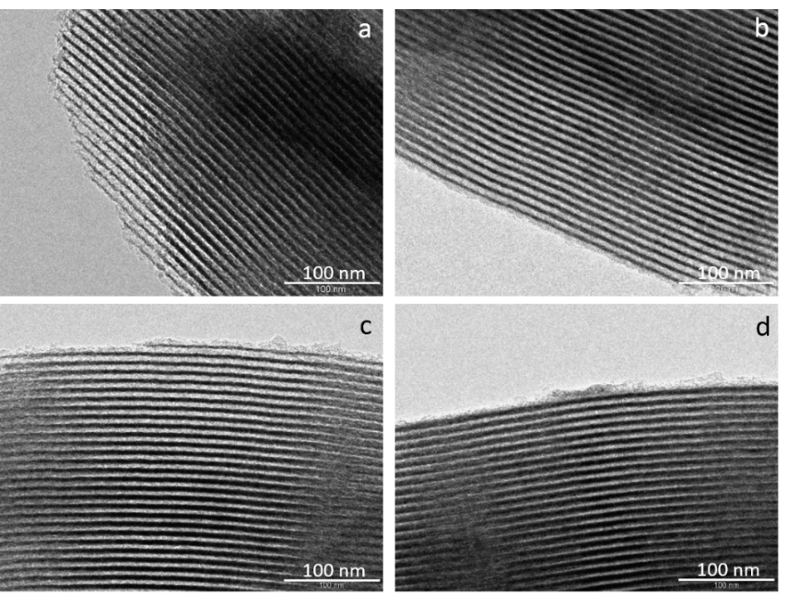

Figure 4. TEM images of (a) SBA-15-PEI-1, (b) SBA-15-PEI-2, (c) SBA-15-PEI-1-C60, and (d) SBA-15-PEI-2-C60.

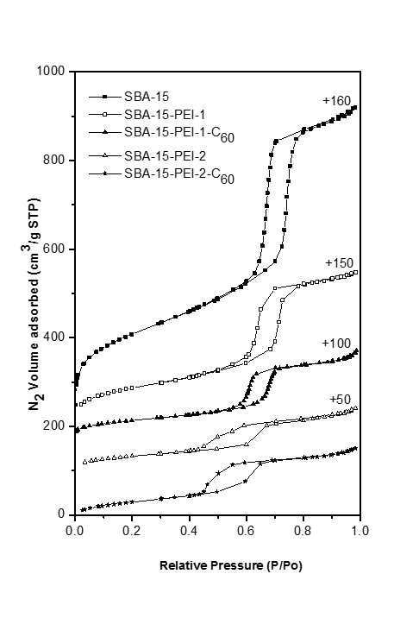

Figure 5. Nitrogen adsorption-desorption isotherms at 77 K for synthesized silica materials.

**Table 1.** Textural and organic properties of the synthesized materials.

|  |  |  |  |  |  |  |  |  |  |
| --- | --- | --- | --- | --- | --- | --- | --- | --- | --- |
| **Material** | | **SBET**  **(m2.g-1)** | | **Vpa**  **(cm3.g-1)** | **Dpa**  **(Å)** | **Organic Contentb (%)** | **N Contentc (mmolN.g-1MAT)** | **Z-Potentiald** **(mV)** | **Adsorbed drug**  **(mg drug.g-1MAT)** |
| **SBA-15** | 743 | | 1.09 | | 83.0 | - | - | -18.6 | 109 |
| **SBA-15-PEI-1** | 268 | | 0.47 | | 73.7 | 31.4 | 7.5 | 25.7 | 475 |
| **SBA-15-PEI-2** | 145 | | 0.28 | | 62.7 | 36.8 | 9.9 | 32.9 | 540 |
| **SBA-15-PEI-1-C60** | 120 | | 0.15 | | 35.6 | 42.6 | 7.3 | 8.9 | 190 |
| **SBA-15-PEI-2-C60** | 101 | | 0.14 | | 32.2 | 47.5 | 9.5 | 9.5 | 200 |
| **Methylprednisolone** | - | | - | | - | - | - | -23.0 | - |

a Total pore volume and pore size as calculated by the BJH method from the adsorption branch of the N2 isotherm. bOrganic content determined via weight loss by TGA in the range 110-700 0C. c Nitrogen content determined via elemental analysis. d at neutral pH.

**3.2 Adsorption and release behaviour of methylprednisolone in PEI-functionalized SBA-15 silica materials**

Based on the experimental procedure followed by our group in previous works [10, 13–14], the adsorption capacity of chosen drug in PEI-functionalized SBA-15 supports was ascertained (Table 1). SBA-15-PEI-1 silica material shows an adsorption capacity for methylprednisolone sodium succinate of 475 mg.g−1MAT, while the SBA-15-PEI-2 sample shows a capacity of 540 mg.g−1MAT. Taking into account the theoretical maximum adsorption capacity of the samples (600 mg.g−1MAT), according to the concentration of the methylprednisolone in the solution, it is inferred that the percentage of drug incorporated to the silica matrix attains almost 90% of this value.

These results are consistent with the strong electrostatic attractions caused by opposite charges between methylprednisolone and the PEI-functionalized SBA-15 materials, as determined by the zeta potential measurements (Table 1). As displayed in Table 1, the positive charges observed for the surface of PEI-functionalized materials exerts an ion pairing effect with the negative charges of methylprednisolone species. Additionally, the results correlate well with the nitrogen amount incorporated onto the SBA-15 silica. Therefore, the adsorption capacities on SBA-15-PEI materials are greatly improved as compared to the pure SBA-15 (109 mg.g−1MAT).

In a second step, the methylprednisolone release from raw and PEI-functionalized silica materials was calculated. Figure 6 (a) and (b) show the delivery results after exposing the different samples to simulated body fluids (SBF) under neutral conditions, corresponding to those in the blood stream at 37 °C. The drug release from the supports can be estimated using UV−visible spectroscopy to determine the absorbance intensity at 248 nm, which is associated with methylprednisolone moieties. The cumulative fractions of drug released from these materials are depicted in Figure 6 (b). Considering pure SBA-15, almost 100% of methylprednisolone species were released at times < 10 h. In contrast, the PEI-functionalized SBA-15 materials promote a sustained release over several days (6–7 days). Depending on the amount of PEI anchored to the silica support, a larger release control is noticed. As the incorporated PEI polymer enlarges, the curve slope diminishes, which means a slowing of the release rate.

For both PEI-functionalized SBA-15 materials, the fractions of drug released come close to constant values of 60–70%, lower than 100%. This result indicates that methylprednisolone species release was incomplete probably due to either diffusion resistances or sorption equilibrium of methylprednisolone moieties with the mesoporous silica surfaces, or both. This result reveals that surface PEI species significantly influence the amount of drug released from functionalized mesoporous silica materials as a result of the previously indicated strong interaction between drug adsorbates and PEI-functionalized silica adsorbents. However, as observed in Figure 6 (a), in which the methylprednisolone delivery concentration from PEI-modified silica materials is displayed, higher loadings of methylprednisolone species generate remarkably larger concentration gradients for the transport of drug from the host to simulated body fluid than those of pure SBA-15.

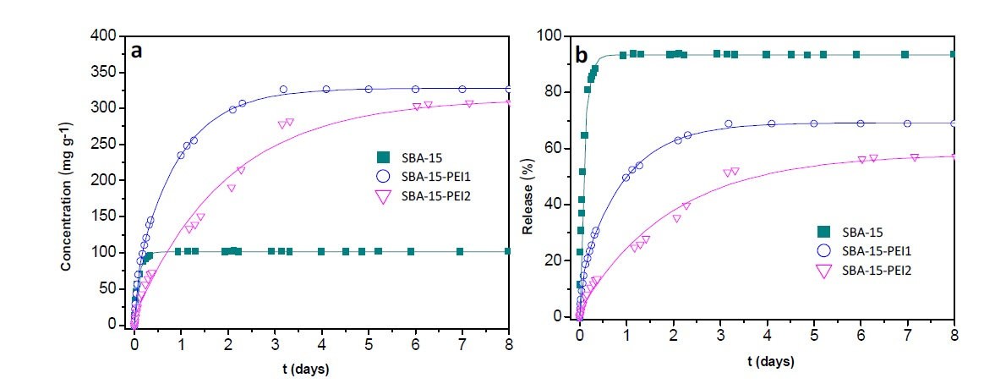

Figure 6. Drug delivery in terms of (a) concentration and (b) percentages released from the silica SBA-15 and polyethyleneimine-SBA-15 samples.

Drug release kinetic studies are essential in shedding light on strategies for drug delivery system design. Therefore, the drug release profiles were analysed according to four kinetic models: Korsmeyer–Peppas, Higuchi, first-order, and Gallagher–Corrigan. Table 2 displays the kinetic parameters corresponding to the fitting of the different models to the experimental data. The Korsmeyer–Peppas and Higuchi models obey a power law mathematical relationship between the amount of drug released and the time [13–14, 39–41], and two constants, *K* and *n*, may be obtained from the adjustment. Though both models exhibit similar kinetic parameter values, the correlation coefficients for the Korsmeyer–Peppas model indicate better fitting than for the Higuchi model. The *n* parameter in the Korsmeyer–Peppas model provides some ideas about the methylprednisolone species diffusion within mesoporous silica materials, in particular whether diffusion occurs by either Fickian or non-Fickian processes. Thus, the *n* values for PEI-modified SBA-15 materials were higher than 0.5, while the raw SBA-15 sample exhibited a value lower than 0.5. These values disclose that PEI-functionalized SBA-15 materials present a mass transfer process obeying a non-Fickian model, and therefore, suggesting that the methylprednisolone diffusion from PEI-modified silica materials is impeded or restricted by interactions between the drug and the PEI groups decorating the silica surface.

Furthermore, the pharmacological methylprednisolone species released from the modified silica hosts fits well to a first-order kinetic. In this model, the rate of drug released from the mesostructured material is proportional to the methylprednisolone concentration in the simulated body fluid, being *K* the kinetic constant of the release rate, depicted in Table 2. The *K* value for raw SBA-15 material is remarkably higher than that obtained for the PEI-modified mesoporous silica materials (13.8 versus 1.76 and 1.21 d−1, respectively), which evidences the effect of functionalization on the release of the drug species. These results establish that release rate slows as the amount of PEI anchored onto the silica surface increases.

The experimental data was fitted to the Gallagher–Corrigan kinetic model. This model represents a drug deliverance in two sequential steps, showing two different kinetics [42]. The first part involves a fast release (“burst effect”) of the externally adsorbed drug, symbolised by a kinetic constant *k1*, followed by a slower release, symbolised by a kinetic constant *k2*. Moreover, the equation rate provides another parameter, *tmax*, defined as the theoretical release time. As previously in the first-order kinetic model, the kinetic parameters *k1* and *k2* clearly diminish as the PEI moieties grafted to the silica surface strengthens (26.9 and 14.0 versus 2.4 and 1.9 d−1, respectively). Likewise, the *tmax* parameter increases as the PEI amount augments, i.e., as it takes more time to reach the theoretical maximum release. These results are accounted for by the strong electrostatic interactions between the drug molecules and the high density of the reactive amines of the PEI polymer grafted to the silica surface.

**Table 2.** Fitting parameters for Korsmeyer–Peppas, Higuchi, first-order, and Gallagher–Corrigan kinetic models for the cumulative release of methylprednisolone sodium succinate on synthesized mesoporous silica materials.

|  |  |  |  |  |  |
| --- | --- | --- | --- | --- | --- |
| **Material** | **Korsmeyer-Peppas** | | | **Higuchi** | |
| f(t) = K·tn | | | f(t) = K·t1/2 | |
| K (mg. g-1 d-n) | n | R2 | K (mg. g-1 d-1/2) | R2 |
| **SBA-15** | 206±7.7 | 0.47±0.01 | 0.997 | 227.0±2.7 | 0.994 |
| **SBA-15-PEI-1** | 265±6.3 | 0.56±0.01 | 0.996 | 241.5±3.5 | 0.991 |
| **SBA-15-PEI-1-C60** | 112±1.7 | 0.61±0.01 | 0.997 | 112.9±1.2 | 0.997 |
| **SBA-15-PEI-2** | 123±1.4 | 0.57±0.01 | 0.996 | 122.6±2.5 | 0.987 |
| **SBA-15-PEI-2-C60** | 73±0.5 | 0.69±0.01 | 0.999 | 70.1±1.9 | 0.981 |

|  |  |  |  |  |  |  |  |  |
| --- | --- | --- | --- | --- | --- | --- | --- | --- |
| **Material** | **First-order** | | | **Gallagher-Corrigan** | | | | |
| f(t) = fmax ·[1-exp(-K·t)] | | | f(t) = fmax ·[1-exp(-k1·t)]+(fmax-fB)[(exp(k2·t- k2·tmax)/(1+exp(k2·t- k2·tmax))] | | | | |
| fmax  (mg. g-1) | K  (d-1) | R2 | fmax  (mg. g-1) | K1  (d-1) | K2  (d-1) | Tmax  (d-1) | R2 |
| **SBA-15** | 101±0.7 | 13.8±0.7 | 0.985 | 58.4±4.9 | 26.9±3.7 | 14.0±1.6 | 0.1±0.0 | 0.996 |
| **SBA-15-PEI-1** | 318±5.6 | 1.76±0.1 | 0.982 | 182.4±12.4 | 3.5±0.3 | 1.9±0.2 | 1.2±0.1 | 0.998 |
| **SBA-15-PEI-1-C60** | 166±3.3 | 1.21±0.1 | 0.982 | 75.9±4.5 | 2.6±0.7 | 1.9±0.2 | 1.4±0,1 | 0.998 |
| **SBA-15-PEI-2** | 312±5.3 | 0.55±0.03 | 0.988 | 119.7±5.0 | 2.4±0.1 | 1.9±0.1 | 2.3±0.0 | 0.999 |
| **SBA-15-PEI-2-C60** | 177±3.6 | 0.52±0.03 | 0.991 | 101.5±7.8 | 1.1±0.1 | 0.9±0.1 | 3.2±0.2 | 0.998 |

Finally, the influence of the SBA-15-PEI silica materials on cell viability was tested on cultured MDA-MB-231 breast cancer cells, adopting the WST-1 assay [43–45]. Cells were exposed for 72 h to a medium containing the selected mesoporous materials in the concentration range of 10-50 μg.mL−1 (Figure 7). The results reveal that PEI-modified mesoporous materials do not alter cell viability at low concentrations in the range of 10–25 μg.mL−1 (> 80% viability) without significant differences (P > 0.05), even though a slight reduction in cell proliferation was observed as compared to the untreated cells. Nevertheless, at higher concentrations (50 μg.mL−1), the cytotoxic effect on cells was found to be remarkably influential, diminishing cell viability to values well below 80%, a difference that was statistically significant (*P < 0.05). Calcination of raw SBA-15 mesoporous silica alone did not alter cell viability after 72 h.



**Figure 7.** *In vitro* dose-dependent cytocompatibility of pure and functionalized materials after 72 h of incubation on MDA-MB-231 breast cancer cell lines. Cell viability was measured by a WST-1 assay. Values represent mean ± SE; n = 3. *p < 0.05 by ANOVA with LSD-test; *p < 0.05.

**3.3 Adsorption and release behaviour of methylprednisolone in functionalized SBA-15 silica materials with PEI and C60 fullerene species**

The recent discovery of buckminsterfullerene molecules has attracted great interest, as they have biomedical applications in photothermic therapy, as image agents [46–48], and even in controlled drug delivery [10, 49]. This feature, together with π–π hydrophobic interactions and steric hinderings due to the constraint effect exerted by C60 fullerene species size within pores, in combination with the PEI polymer grafted to the silica, is expected to favour a more controlled drug delivery.

The integration of C60 fullerene moieties onto PEI-modified SBA-15 material was performed through a radical reaction between the primary and secondary amines of PEI and the fulleride [C60]− anions, as explained in detail in the experimental section, in which TGA, elemental analysis, and nitrogen adsorption determined that the C60 moieties had been incorporated into the SBA-15-PEI silica materials, being the samples named as SBA-15-PEI-1-C60 and SBA-15-PEI-2-C60.

The amount of methylprednisolone species adsorbed onto the SBA-15-PEI-1-C60 and SBA-15-PEI-2-C60 were spectrophotometrically determined at a wavelength of 247 nm in a UV spectrometer. Silica materials were immersed into aqueous solutions containing the drug model at concentrations of 15 mg mL−1. The methylprednisolone loadings were 190 and 200 mg.g−1 for SBA-15-PEI-1-C60 and SBA-15-PEI-2-C60 materials, respectively, as summarized in Table 1. These amounts are lower than that of the PEI-modified SBA-15 materials, around 60% compared to the loading after the functionalization with PEI. Nevertheless, these drug loading values for samples SBA-15-PEI-1-C60 and SBA-15-PEI-2-C60 are within the usual drug loading values reported in literature [50-56] for functionalized mesoporous silica materials. More important, the usual dosage in clinical biomedical applications for the model drug used in this work, methylprednisolone, is around 1 mg Kg-1 d-1 [57], doses that are in the range of the loading capacities exhibited by the SBA-15-PEI-C60 materials. Differences in methylprednisolone loadings among these materials can be mainly explained by electrostatic interactions among the methylprednisolone and silica surfaces. Zeta potential values of SBA-15-PEI-C60 materials experienced a clear reduction with respect to the values shown by the SBA-15-PEI materials (Table 1), which allows to establish that the drug moieties have weaker attractive electrostatic interactions with and lower adsorption to silica surfaces. These results prove, in short, that attractive electrostatic interactions are critical for methylprednisolone adsorption.

Figure 8 displays the drug delivery from SBA-15-PEI-1-C60 and SBA-15-PEI-2-C60 materials exposed to simulated body fluids. The amounts and rates of methylprednisolone released were quantified and analysed to illustrate how PEI and C60 species influence the delivery behaviour of the drug model moieties. The amounts of methylprednisolone species guest released from the functionalized PEI-C60 silica materials were estimated in the same way as previously, using UV−visible spectroscopy to determine the absorbance intensity at 248 nm, which is associated with drug moieties. First of all, it is important to note that larger fractions of methylprednisolone were released from SBA-15-PEI-1-C60 and SBA-15-PEI-2-C60 relative to their parent SBA-15-PEI-1 and SBA-15-PEI-2 materials. The fractions of drug released from functionalized PEI-C60 silica materials at 8 days were calculated from Figure 8, considering the methylprednisolone adsorbed amount (Table 1), and approached 90%. In comparison with the values obtained for PEI-functionalized SBA-15 materials, where the methylprednisolone released fractions were closer to 60–70%, this result reflects that the incorporation of C60 groups exerts lower influence over the fractions of methylprednisolone delivered from functionalized mesoporous silica materials, probably because of the drug’s lower adsorption affinity to silica surfaces, as evidenced by the weaker electrostatic attractions.

However, the methylprednisolone adsorption capacities of SBA-15-PEI-1-C60 and SBA-15-PEI-2-C60 materials were established to be twice the value of raw SBA-15 silica, making these materials promising for the incorporation of methylprednisolone species, since despite the lower adsorbed drug amounts compared with PEI-functionalized silica materials, the SBA-15-PEI-1-C60 and SBA-15-PEI-2-C60 materials still have stronger attractive electrostatic interactions with and highly adsorption to silica materials surfaces than raw SBA-15 silica materials. Additionally, the incorporation of C60 species into the PEI-functionalized SBA-15 contributes to a better control of the methylprednisolone species release, according to the calculation of release rates as determined from the derivative of the cumulative drug release profiles, illustrated in Figure 8 (a) and (b), at specific points in time. Thus, Figure 8 (c) and (d) display lower methylprednisolone release rates from SBA-15-PEI-C60 materials than from the SBA-15-PEI parent materials. These results may account for the steric effects that imprint the surface-grafted C60 moieties, diminishing the pore dimensions, which decrease from 74 and 63 Å for PEI-functionalized SBA-15 materials to 36 and 32 Å for SBA-15-PEI-C60 materials, and therefore hindering the diffusion of methylprednisolone within the pores. Furthermore, the high hydrophobicity of C60 molecules may also inhibit the influx of simulated media into mesostructured SBA-15-PEI-C60 materials, thus diminishing methylprednisolone transport within the mesochannels.



Figure 8. Drug delivery in terms of concentration, (a) and (b), and release rate of methylprednisolone from double functionalized silica samples, (c) and (d).

Adopting a similar strategy to that used for PEI-functionalized SBA-15 materials, the drug release profiles for SBA-15-PEI-C60 materials were fitted to the same four kinetic models: Korsmeyer–Peppas, Higuchi, first-order, and Gallagher–Corrigan. Parameter fitting to the Korsmeyer–Peppas model establishes that the diffusion of methylprednisolone from C60-PEI-modified silica materials follows a mass transfer non-Fickian model, as reflected in the value of the *n* parameter in Table 2 (0.61 and 0.69 for SBA-15-PEI-1-C60 and SBA-15-PEI-2-C60 materials vs. 0.56 and 0.57 for SBA-15-PEI-1 and SBA-15-PEI-2 materials). This fact suggests that drug circulation is impeded or restricted by both the constrained pore dimensions and the interactions among the methylprednisolone species and the C60 moieties grafted to the PEI groups anchored to the silica surface.

Moreover, Table 2 shows the kinetic parameters predicted from fitting to first-order and Gallagher–Corrigan models. The results reveal kinetic parameters lower than those obtained for PEI-functionalized SBA-15 materials. Thus, the rate constant *K* is smaller for SBA-15-PEI-C60 materials (1.21 and 0.52 d−1 for SBA-15-PEI-1-C60 and SBA-15-PEI-2-C60, respectively) than for SBA-15-PEI materials (1.76 and 0.55 d−1 for SBA-15-PEI-1 and SBA-15-PEI-2, respectively), which confirms the lower release rates of methylprednisolone from C60-functionalized mesoporous silica hosts, observed in Figure 8 (c) and (d). Moreover, the same reduction is detected in the kinetic parameters predicted by the Gallagher–Corrigan model. Both kinetic parameters, *k1* and *k2*, clearly diminish as the C60 groups are incorporated onto the PEI-modified SBA-15 silica materials. This effect is more clearly evidenced in the SBA-15-PEI-2-C60 material. Additionally, the *tmax* parameter experiences a notable incremental increase in the SBA-15-PEI-2-C60 material, reaching a value of 3.2 days, corresponding to the theoretical maximum release time. These results achieve one of the expected aims, i.e., demonstrating that C60-PEI-functionalized silica materials favour longer-term delivery of methylprednisolone molecules, making them more appropriate for some biomedical applications than PEI-modified SBA-15 materials.

Next, the cell viability of C60-PEI-functionalized silica materials was examined on cultured MDA-MB-231 breast cancer cells, adopting the WST-1 assay [43–45]. For comparison, cells were exposed for 72 h to a medium containing the selected mesoporous materials in the concentration range of 10–50 μg.mL−1 (Figure 7). The results clearly reveal that the C60 fullerene species cause an overall increment on cell viability for all concentrations, although the influence is lower at 10 and 25 μg.mL-1 than at 50 μg.mL-1. For example, at that last dose, nearby the doses employed for potential applications, the cell viability of SBA-15-PEI-2 sample noticeably diminishes up to values around 60 %. However, the incorporation of C60 species in this sample provides a substantial increase on cell viability for all concentrations, especially at 50 μg.mL-1, where viability increases up to values around 70 %. This result, together with the better control of the methylprednisolone species release according to the calculation of kinetic parameters and different release rates determined from the derivative of the cumulative methylprednisolone release profiles, make these dual-functionalized materials promising for applications as nanovehicles in drug delivery.

Finally, the cellular uptake of SBA-15, SBA-15-PEI-2, and SBA-15-PEI-2-C60 materials was explored. MDA-MB-231 cells were incubated with FITC-labelled non-functionalized and functionalized mesoporous silica materials. Cellular uptake is shown by confocal imaging in Figure 9. Micrographies reveal that both non-functionalized and functionalized SBA-15 mesoporous silica materials are inside the plasmatic membrane, which proves the correct cellular internalization.

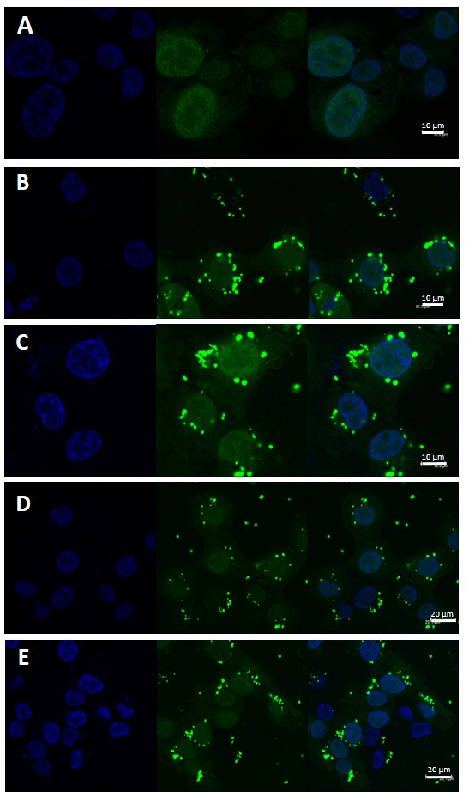

**Figure 9.** Confocal microscopy micrographies from (a) control, (b) SBA-15, (c) SBA-15-PEI-2, and (d) SBA-15-PEI-2-C60 samples.

**4. Conclusions**

Dual-functionalized mesoporous SBA-15 materials have been evaluated as drug carriers for the glucocorticoid methylprednisolone sodium succinate model drug. Specifically, mesoporous SBA-15 silica materials with polyethyleneimine surface moieties with and without C60 species were characterized and used as matrices in the adsorption and release of methylprednisolone species. The adsorption capacity and release behaviour of the model drug in these functionalized materials were shown to depend strongly on interactions among methylprednisolone species and the functionalized silica surfaces. These dual-functionalized mesoporous SBA-15 materials have displayed good mesoscopic ordering and textural properties independently of the loaded organic amount. The drug adsorption capacities of the PEI-modified SBA-15 materials were considerably higher than those of raw silica samples, consistent with the strong electrostatic attractions due to opposite charges between methylprednisolone and PEI-functionalized SBA-15 materials, determined by their zeta potential measurements. Likewise, remarkably lower drug release rates were obtained for PEI-functionalized materials compared with those of non-functionalized materials, promoting a sustained release over several days (6–7 days) as compared to a release over less than 10 h with pure silica materials. The fractions of drug released from PEI-SBA-15 materials approach constant values of 60–70 % due to diffusion resistances and strong interactions between drug adsorbates and PEI-SBA-15 silica adsorbents.

The incorporation of C60 fullerenes onto PEI-modified SBA-15 through radical reactions allowed more controlled drug delivery due to π–π hydrophobic interactions and steric hindering. The methylprednisolone adsorption capacities of SBA-15-PEI-C60 materials are notably lower than those of PEI-modified SBA-15 materials, being 200 mg g−1 and 540 mg g−1, respectively, because of weak electrostatic interactions between the drug and the silica surfaces, as is clearly observed through a reduction in the zeta potential values of SBA-15-PEI-C60 materials. The C60-PEI modified materials released larger fractions of methylprednisolone, close to 90%, likely because of the lower adsorption affinity to silica surfaces. Additionally, the incorporation of C60 species onto the PEI-modified materials contributes to better control of the drug release, according to the lower rate constants obtained with the first-order and Gallagher–Corrigan models, and favours longer-term release of methylprednisolone molecules.

Non-Fickian diffusion processes for methylprednisolone release in every functionalized material were observed under either PEI or PEI-C60 species incorporation, suggesting that drug circulation is impeded or restricted by constrained pore dimension and interaction with PEI-C60 moieties. Finally, this research has confirmed that synthesized PEI-SBA-15 materials do not alter cell viability at low concentrations in the range of 10–25 µg mL−1 (≥ 80% viability). However, at a higher concentration (50 µg mL−1), cell viability diminishes to values of 60%. Upon the incorporation of C60 moieties into PEI-SBA-15 materials, results reveal an increment in cell viability, but importantly for the highest concentration of 50 µg mL−1 their inclusion re-established the cell viability, making these dual-functionalized materials promising for applications as nanovehicles in drug delivery. Confocal microscopy showed that both PEI- and PEI-C60-modified SBA-15 materials were successfully internalized inside the cells.

**Acknowledgements**

The financial support of the Spanish government (CTQ2014-57858-R and CTQ2017-88642-R) is gratefully acknowledged. J. Ortiz Bustos thanks the Ministerio de Economía y Competitividad of Spain (BES-2012-056525) for the research internship at the Pharmaceutical Sciences Laboratory, Faculty of Science and Engineering, Åbo Akademi University, Finland.

**References**

1. Vallet-Regí M, Colilla M, Izquierdo-Barba I, Manzano (2018) Mesoporous silica nanoparticles for drug delivery: current insights. Molecules 23:1-19.
2. Diab R, Canilho N, Pavel IA, Haffner FB, Girardon M, Pasc A (2017) Silica-based systems for oral delivery of drugs, macromolecules and cells. [Adv. Colloid Interface Sci](https://www.ncbi.nlm.nih.gov/pubmed/28473052). 249:346-362.
3. Cicuéndez M, Izquierdo-Barba I, Portolés MT, Vallet-Regí M (2013) Biocompatibility and levofloxacin delivery of mesoporous materials. Eur. J. Pharm. Biopharm. 84:115-124.
4. Morales V, Gutiérrez-Salmerón M, Balabasquer M, Ortiz-Bustos J, Chocarro-Calvo A, García-Jiménez C, García-Muñoz RA (2016) New Drug‐Structure‐Directing Agent Concept: Inherent Pharmacological Activity Combined with Templating Solid and Hollow‐Shell Mesostructured Silica Nanoparticles. Adv. Funct. Mater. 26(40):7291-7303.
5. Karesoja M, McKee J, Karjalainen E, Hietala S, Bergman L, Linden M, Tenhu H (2013) Mesoporous silica particles grafted with poly (ethyleneoxide‐block‐N vinylcaprolactam). J. Polym. Sci., Part A: Polym. Chem. 51:5012-5020.
6. García R A, van Grieken R, Iglesias J, Morales V, Gordillo D (2008) Synthesis of Chiral Periodic Mesoporous Silicas Incorporating Tartrate Derivatives in the Framework and their Use in Asymmetric Sulfoxidation. Chem. Mater. 20:2964-2971.
7. [Morales](https://link.springer.com/search?facet-creator=%22V.+Morales%22) V,  [Villajos](https://link.springer.com/search?facet-creator=%22J.+A.+Villajos%22) JA.;  [García](https://link.springer.com/search?facet-creator=%22R.+A.+Garc%C3%ADa%22) RA (2013) Simultaneous synthesis of modified Binol-periodic mesoporous organosilica SBA-15 type material. Application as catalysts in asymmetric sulfoxidation reactions. J. Mater. Sci. 48:5990-6000.
8. [García-Muñoz](http://pubs.rsc.org/en/results?searchtext=Author%3AR.%20A.%20Garc%C3%ADa-Mu%C3%B1oz) RA, [Morales](http://pubs.rsc.org/en/results?searchtext=Author%3AV.%20Morales) V,  [Linares](http://pubs.rsc.org/en/results?searchtext=Author%3AM.%20Linares) M, [González](http://pubs.rsc.org/en/results?searchtext=Author%3AP.%20E.%20Gonz%C3%A1lez) PE, [Sanz](http://pubs.rsc.org/en/results?searchtext=Author%3AR.%20Sanz) R, [Serrano](http://pubs.rsc.org/en/results?searchtext=Author%3AD.%20P.%20Serrano) DP (2014) Influence of the structural and textural properties of ordered mesoporous materials and hierarchical zeolitic supports on the controlled release of methylprednisolone hemisuccinate. J. Mater. Chem. B 45:7996-8004.
9. García-Muñoz RA, Morales V, Linares M, Rico-Oller B (2014) Synthesis of Helical and Supplementary Chirally Doped PMO Materials. Suitable Catalysts for Asymmetric Synthesis, Langmuir. 30:881-890.
10. Morales V, Idso MN, Balabasquer M, Chmelka B, García-Muñoz RA (2016) Correlating Surface-Functionalization of Mesoporous Silica with Adsorption and Release of Pharmaceutical Guest Species, J. Phys. Chem. C 120:16887-16898.
11. Maria Chong AS, Zhao XS (2003) Functionalization of SBA-15 with APTES and Characterization of Functionalized Materials, J. Phys. Chem. B 107:2650-12657.
12. Rosenholm JM, Penninkangas A, Linden M (2006) Amino-functionalization of large-pore mesoscopically ordered silica by a one-step hyperbranching polymerization of a surface-grown polyethyleneimine, Chem. Commun. 37:3909–3911.
13. Martín A, Morales V, Ortiz-Bustos J, Pérez-Garnes M, Bautista LF, García-Muñoz RA, Sanz R (2018) Modelling the adsorption and controlled release of drugs from the pure and amino surface-functionalized mesoporous silica hosts. Micropor. Mesopor. Mat. 262:23-34.
14. Ortiz-Bustos J, Martín A, Morales V, Sanz R, García-Muñoz RA (2017) Surface-functionalization of mesoporous SBA-15 silica materials for controlled release of methylprednisolone sodium hemisuccinate: Influence of functionality type and strategies of incorporation. Micropor. Mesopor. Mat. 240:236-245.
15. Wang S (2009) Ordered mesoporous materials for drug delivery. Micropor. Mesopor. Mat.117:1–9.
16. Muñoz B, Rámila A, Pérez-Pariente J, Díaz I, Vallet-Regí M (2003) MCM-41 Organic Modification as Drug Delivery Rate Regulator Chem. Mater.15:500-503.
17. Song SW, Hidajat K, Kawi S (2005) Functionalized SBA-15 Materials as Carriers for Controlled Drug Delivery:  Influence of Surface Properties on Matrix−Drug Interactions. Langmuir 21:9568-9575.
18. Cuoq F, Masion A, Labille J, Rose J, Ziarelli F, Prelot B, Bottero JY (2003) Preparation of amino-functionalized silica in aqueous conditions. Appl. Surf. Sci.266:155-160.
19. Castruita de León G, Perera-Mercado YA, García-Cerda LA, Mercado-Silva JA, Meléndez-Ortiz HI, Olivares-Maldonado Y, Álvarez-Contreras L (2015) Synthesis of amino-functionalized MCM-48 silica via direct co-condensation at room temperatura. Micropor. Mesopor. Mat. 204:156-162.
20. Ojeda M, Mazaj M, Garcia S, Xuan J, Maroto-Valer M, Logar NZ (2017) Novel Amine-impregnated Mesostructured Silica Materials for CO2 Capture. Energy Procedia 114: 2252-2258.
21. Kim CO, Cho SJ, Park JW (2003) Hyperbranching polymerization of aziridine on silica solid substrates leading to a surface of highly dense reactive amine groups. J. Colloid Interface Sci. 260:374-380.
22. Rosenholm JM, Linden M (2007) Wet-Chemical Analysis of Surface Concentration of Accessible Groups on Different Amino-Functionalized Mesoporous SBA-15 Silicas. Chem. Mater. 19:5023-5034.
23. Martín A, García RA, Sen Karaman D, Rosenholm JM (2014) Polyethyleneimine-functionalized large pore ordered silica materials for poorly water-soluble drug delivery. J Mater Sci. 49:1437-1447.
24. Guo A, Wang Y, Xu S, Zhang X, Li M, Liu Q, Shen Y, Cui D, Guo S (2017) Preparation and evaluation of pH-responsive charge-convertible ternary complex FA-PEI-CCA/PEI/DNA with low cytotoxicity and efficient gene delivery. Colloids surf. B 152: 58-67.
25. Khansarizadeh M, Mokhtarzadeh A, Rashedinia M, Taghdisi S.M, Lari P, Abnous KH, Ramezani M (2016) Biodegradable nano-polymers as delivery vehicles for therapeutic small non-coding ribonucleic acids. Hum. Exp. Toxicol. 34:377-387.
26. Oskuee RK, Dabbaghi M, Gholamic L, Taheri-Bojd S, Balali-Mood M, Mousavi SH, Malaekeh-Nikouei B (2018) Investigating the influence of polyplex size on toxicity properties of polyethylenimine mediated gene delivery. Life sci. 197:101-108.
27. Remant Bahadur KC, Uludağ H (2016) PEI and its derivatives for gene therapy. Polymers and Nanomaterials for Gene Therapy 29-54.
28. Taranejoo S, Liu J, Verma P, Hourigan K (2015) A review of the developments of characteristics of PEI derivatives for gene delivery applications. ‎J. Appl. Polym. Sci. 42096:1-8.
29. Zhang X, Duan Y, Wang D, Bian F (2015) Preparation of arginine modified PEI-conjugated chitosan copolymer for DNA delivery. Carbohydr. Polym. 122: 53-59.
30. Wong K, Sun G.B, Zhang X.Q, Dai H, Liu Y, He CB (2006) PEI-g-chitosan, a novel gene delivery system with transfection efficiency comparable to polyethylenimine in vitro and after liver administration in vivo. Bioconjugate Chem.17:152-158.
31. Uritu CM, Varganici CD, Ursu L,  Coroaba A, Nicolescu A, Dascalu AI,  Peptanariu D, [Stan](http://pubs.rsc.org/en/results?searchtext=Author%3ADaniela%20Stan) D,  Constantinescu CA,  Simion V,  Calin M, Maier SS, Pinteala M, Barboiu M (2015) Hybrid fullerene conjugates as vectors for DNA cell-delivery. J. Mater. Chem. B 3:2433-2446.
32. Nielsen GD, Roursgaard M, Jensen KA, Poulsen SS, Thor Larsen S (2008) In vivo Biology and Toxicology of Fullerenes and Their Derivatives, Basic Clin Pharmacol Toxicol. 103:197-208.
33. Moussa F (2018) Nanostructured materials for biomedical applications. Nanobiomaterials 113-136.
34. Shi J, Zhang H, Wang L, Li L, Wang H, Wang Z, Li Z, Chen C, Hou L, Zhang C, Zhang Z (2013) PEI-derivatized fullerene drug delivery using folate as a homing device targeting to tumor. Biomaterials 34:251-261.
35. Goodarzi S, Da Ros T, Conde J, Sefat F, Mozafari M (2017) Fullerene: Biomedical engineers get to revisit an old friend. Mater. Today 20:460-480.
36. Kroto HW, Heath JR, O'Brien SC, Curl RF, Smalley RE (1985) C60: Buckminsterfullerene Nature 318 (6042):162-163.
37. Lee CH, Lin TS, Lin HP, Zhao Q, Liu SB, Mou CY (2003) High loading of C60 in nanochannels of mesoporous MCM-41 materials. Micropor. Mesopor. Mat. 57:199-209.
38. Zhao D, Feng J, Huo Q, Melosh N, Fredrickson GH, Chmelka BF, Stucky GD (1998) Triblock copolymer syntheses of mesoporous silica with periodic 50 to 300 angstrom pores. Science 279:548-552.
39. Korsmeyer RW, Gurny R, Doelker E, Buri P, Peppas NA (1983) Mechanisms of solute release from porous hydrophilic polymers. Int. J. Pharm. 15:25-35.
40. Bruschi ML (2015) Strategies to Modify the Drug Release from Pharmaceutical Systems, Woodhead Publishing 63-86.
41. Higuchi T (1963) Mechanism of sustained‐action medication. Theoretical analysis of rate of release of solid drugs dispersed in solid matrices. J. Pharm. Sci. 52:1145-1149.
42. Gallagher KM, Corrigan OI (2000) Mechanistic aspects of the release of levamisole hydrochloride from biodegradable polymers. J. Control. Release 69 (2000): 261-272.
43. Ishiyama M, Tominaga H, Shiga M, Sasamoto K, Ohkura Y, Ueno KA (1996) Combined assay of cell vability and in vitro cytotoxicity with a highly water-soluble tetrazolium salt, neutral red and crystal violet. Biol. Pharm. Bull 19:1518-1520.
44. Zhang J, Desai D, Rosenholm JM (2013) Tethered Lipid Bilayer Gates: Toward Extended Retention of Hydrophilic Cargo in Porous Nanocarriers. Adv. Funct. Mater. 24:2352-2360.
45. Desai D, Sen Karaman D, Prabhakar N, Tadayon S, Duchanoy A, Toivola DM, Rajput S, Näreoja T, Rosenholm JM (2014) Design considerations for mesoporous silica nanoparticulate systems in facilitating biomedical applications. Mesoporous Biomater. 1:16-43.
46. Bartelmess J, Quinn SJ, Giordani S (2015) Carbon nanomaterials: multi-functional agents for biomedical fluorescence and Raman imaging. Chem. Soc. Rev**.** 44:4672-4698.
47. Grebowski J, Krokosz A, Konarska A, Wolszczak M, Puchala M (2014) Rate constants of highly hydroxylated fullerene C60 interacting with hydroxyl radicals and hydrated electrons. Pulse radiolysis study. Radiat. Phys. Chem.103:146-152.
48. Sitharaman B, Tran LA, Pham QP, Bolskar RD, Muthupillai R, Flamm SD, Mikos AG, Wilson LJ (2007) Gadofullerenes as nanoscale magnetic labels for cellular MRI .Contrast Media Mol Imaging 2:139-146.
49. Zhang H, Hou L, Jiao X, Ji Y, Zhu X, Zhang Z (2015) Transferrin-mediated fullerenes nanoparticles as Fe2+ dependent drug vehicles for synergistic anti-tumor efficacy, Biomaterials 37:353-366.
50. Nastase S, Bajenaru L, Matei C, Mitran RA, [Berger](https://www.sciencedirect.com/science/article/pii/S1387181113003946#!) D (2013) Ordered mesoporous silica and aluminosilicate-type matrix for amikacin delivery systems, Micropor. Mesopor. Mat. 182:32-39.
51. Moritz M (2013) Solvent optimization for niacinamide adsorption onorgano-functionalized SBA-15 mesoporous silica, Appl. Surf. Sci. 283:537-545.
52. Sun J T, Piao J G, Wang L H, Javed M, Hong C Y Pan C Y (2013) One‐Pot Synthesis of Redox‐Responsive Polymers‐Coated Mesoporous Silica Nanoparticles and Their Controlled Drug Release Macromol. Rapid Commun. 34:1387–1394.
53. A. Datt, El-Maazawi I, Larsen SC (2012) [Aspirin Loading and Release from MCM-41 Functionalized with Aminopropyl Groups via Co-condensation or Postsynthesis Modification Methods](https://pubs.acs.org/doi/10.1021/jp3063959) J. Phys. Chem. C 116: 18358–18366.
54. Szegedi A, Popova M, Goshev I, Mihaly (2011) Effect of amine functionalization of spherical MCM-41 and SBA-15 on controlled drug release,J., J. Solid State Chem.184:1201–1207.
55. Brezoiu A M, Deaconu M, Nicu I, Vasile E, Mitran R A, Matei C, Berger D (2019) Heteroatom modifyed MCM-41-silica carriers for Lomefloxacin delivery systems Micropor. Mesopor. Mat. 275:214-222.
56. Zelenák V, Halamová D, Almáši M, Zid L, Zelenáková A, kapusta O (2018) Ordered cubic nanoporous silica support MCM-48 for delivery of poorly soluble drug indomethacin, Appl. Surf. Sci.443:525-534.
57. Hoffman R, Benz EJ, Silberstein LE, Heslop H, Weitz J, Anastasi J (2018) Hematology: Basic Principles and Practice Chapter 30 - Aplastic Anemia Elsevier ISBN978-0-323-35762-3